# PYNQ workshop series

## Required Hardware and Software

To complete this lab series, you will need the following Hardware

1. PYNQ-Z2
2. Micro SD Card greater than equal to 16 GB
3. Micro SD Card Adapter
4. Micro USB Cable
5. Ethernet Cable
6. Ethernet Access to your WIFI Network or Ethernet connector on PC – See Annex A.
7. Sports camera e.g. <https://www.amazon.co.uk/Crosstour-Waterproof-Underwater-Wide-angle-Rechargeable/dp/B073WWSYJK?ref_=fsclp_pl_dp_1>
8. HDMI to Micro HDMI Cable <https://www.amazon.co.uk/AmazonBasics-High-speed-latest-standard-meters/dp/B014I8TZXW>

To be able to complete these three labs you will need the following software on your development machine

1. Vivado 2019.1 – used for the development of custom overlays
2. 7 Zip - <https://www.7-zip.org/>
3. Etcher - <https://www.balena.io/etcher/>
4. TerraTerm - <https://ttssh2.osdn.jp/index.html.en>
5. Pynq-Z2 board definition files - <https://d2m32eurp10079.cloudfront.net/Download/pynq-z2.zip>
6. WinSCP - <https://winscp.net/eng/index.php>

All project files and support files can be found at <https://github.com/ATaylorCEngFIET/Element14_PYNQ>

# Pre-Lab One

### ***This lab should be completed prior to the starting the labs***

## Getting Set Up Vivado

1. Install the webpack version of Vivado
2. Once installed unzip the Pynq-Z2 board definitions

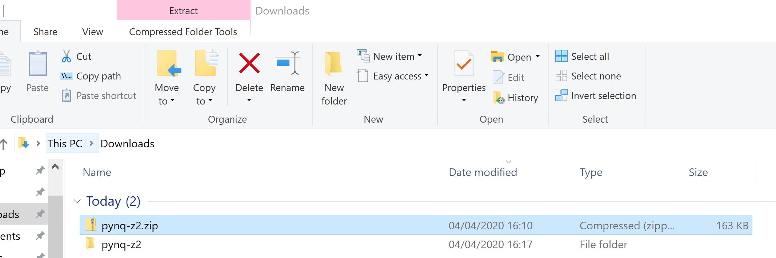

1. Copy the resulting directory into the Vivado boards directory the path for this will be

<install location>\Xilinx\Vivado\2019.1\data\boards\board_files

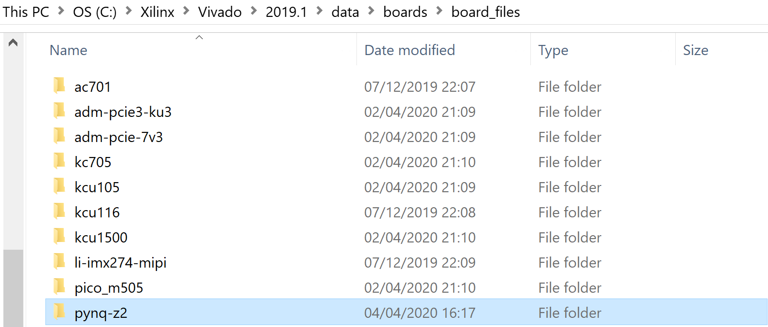

1. Ensure Vivado is declared in the path within your environment variables

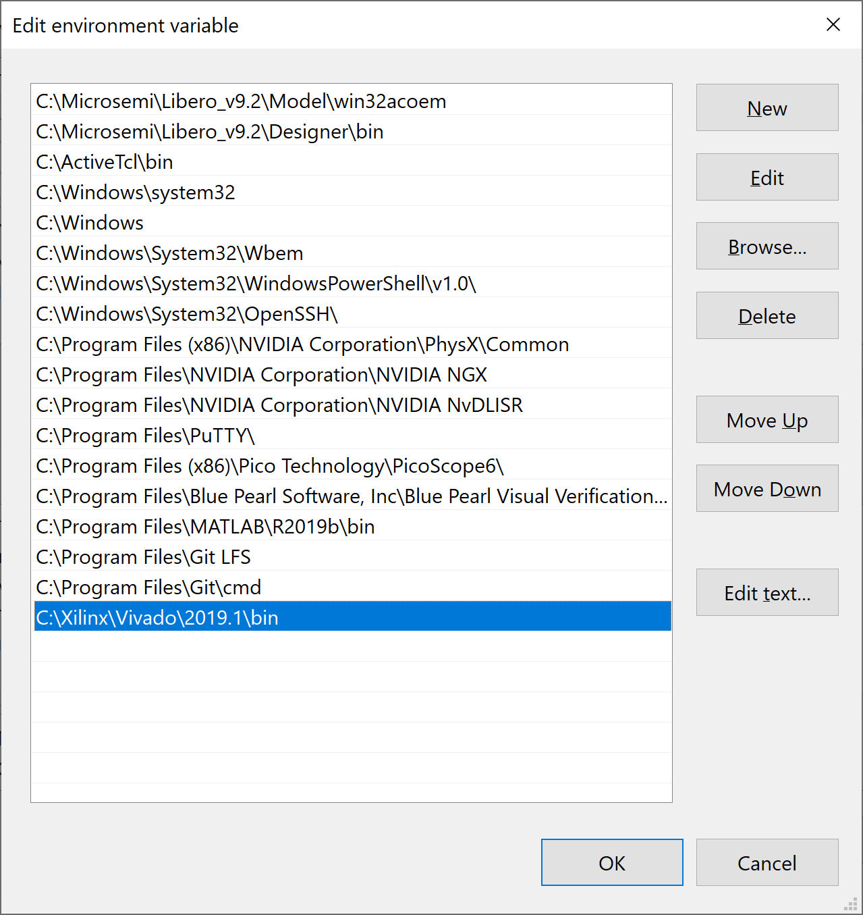

## Getting Up and Running PYNQ

To be able to get working with the PYNQ Z2, the first thing we need to do is create a SD card containing the PYNQ Image.

1. Go to [www.pynq.io/boards](http://www.pynq.io/boards) and down load the PYNQ-Z2 V2.5 PYNQ Image – To download this you will need a Xilinx account, if you do not have one already the download process will allow you to create one.

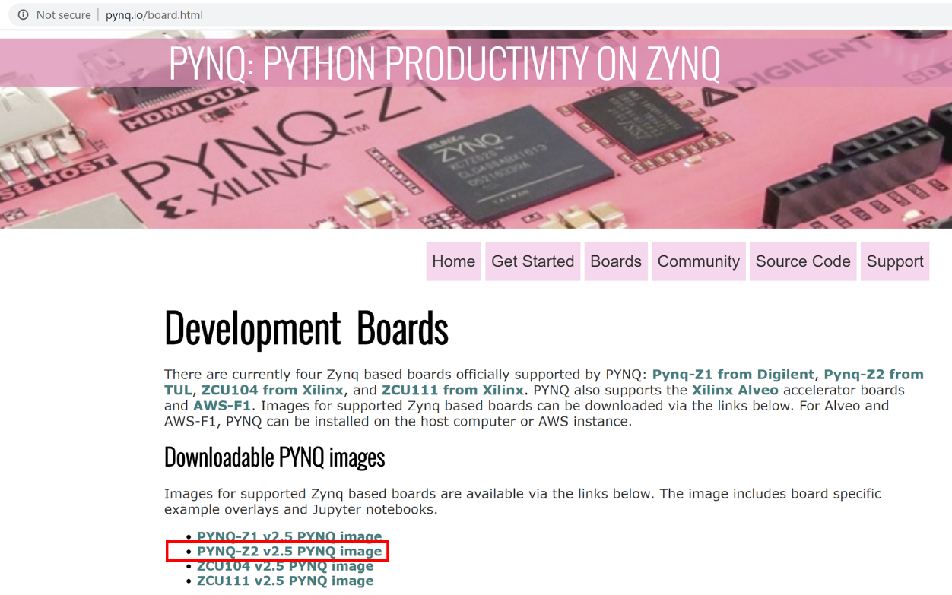

1. The file which is downloaded will be compressed

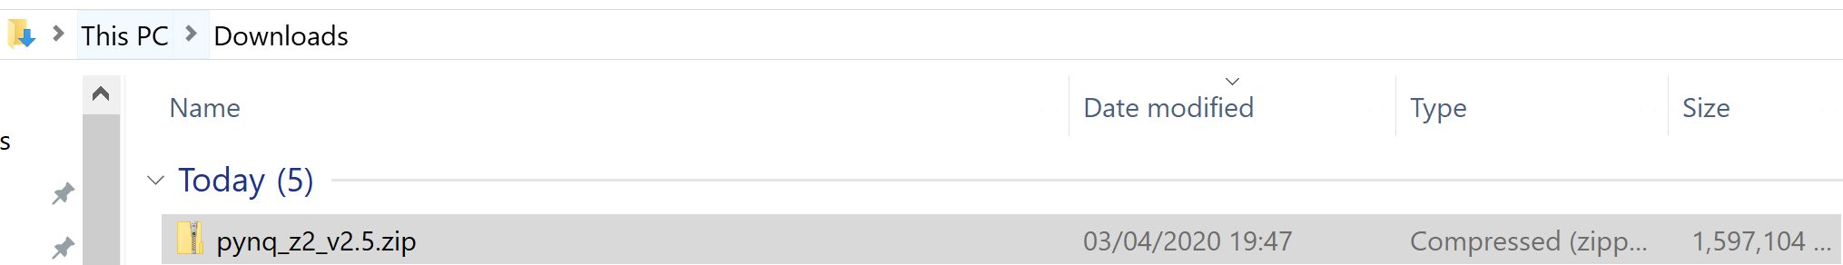

1. Using 7 Zip un-compress the image

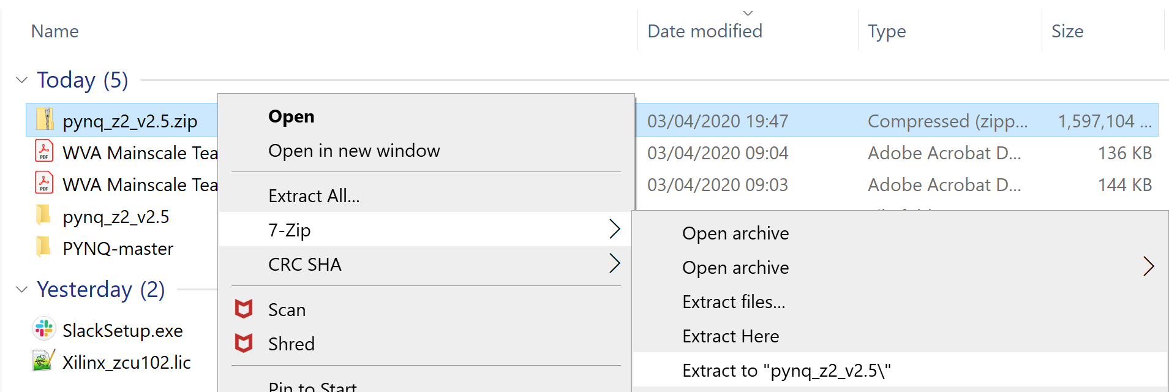

1. Insert the Micro SD Card into the Adaptor and insert into your computer

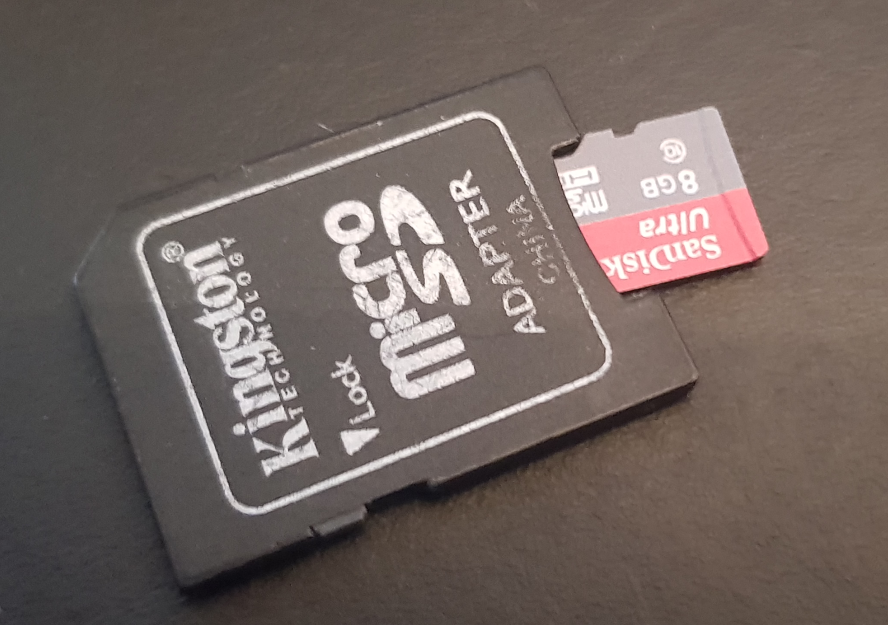

1. Open Etcher and select the PYNQ image

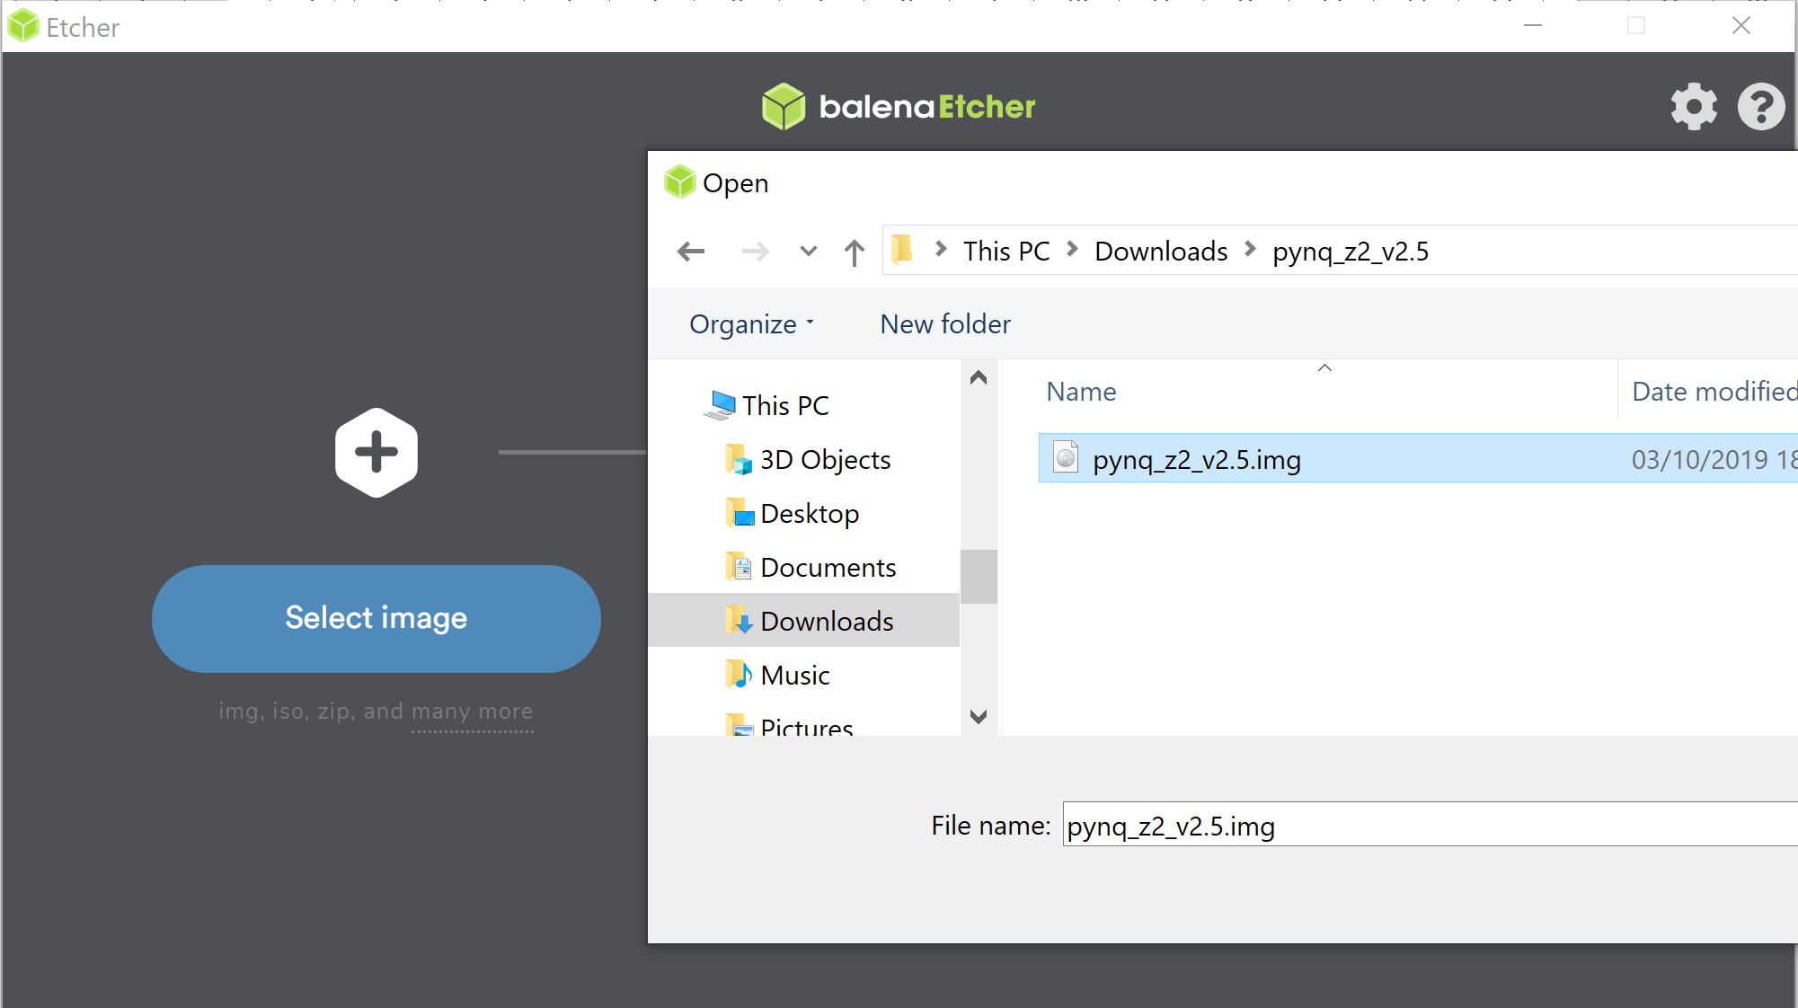

1. Select the SD Card in Etcher

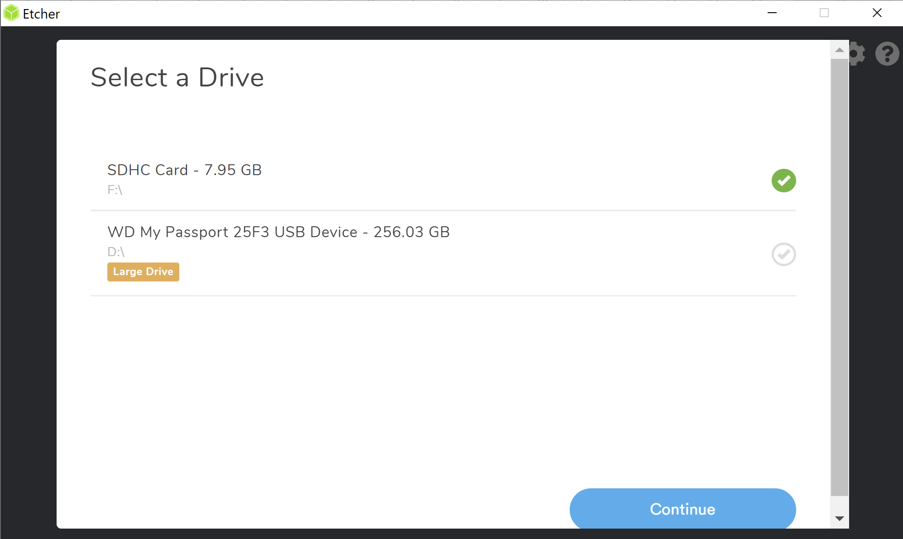

1. Start the write to the SD Card

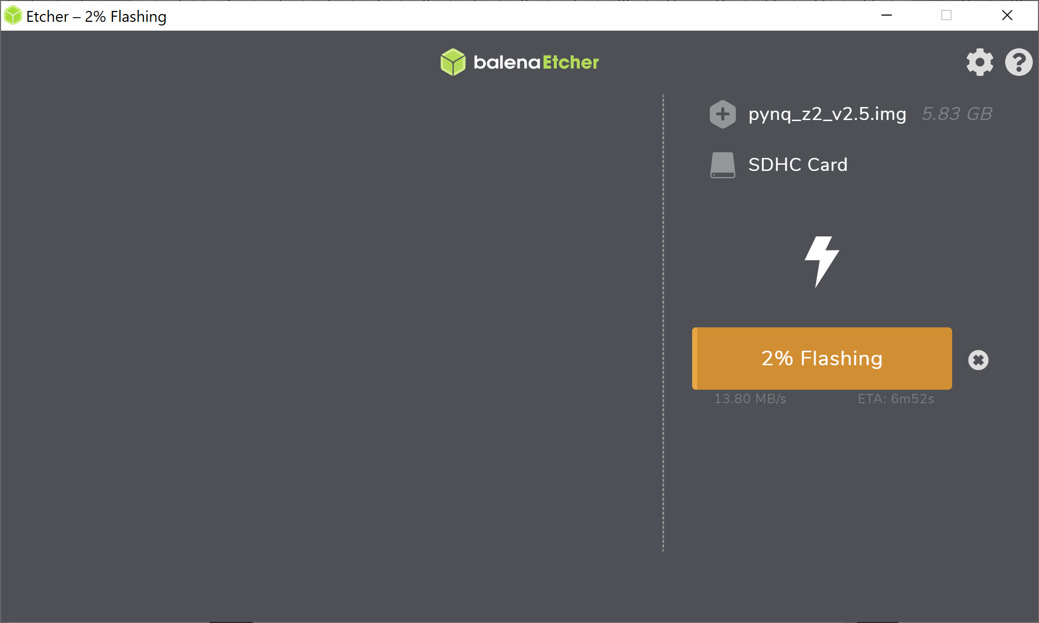

1. Once the write is completed remove the SD card from your computer and insert it into the PYNQ-Z2. ENSURE, the PYNQ-Z2 is powered off during this operation.

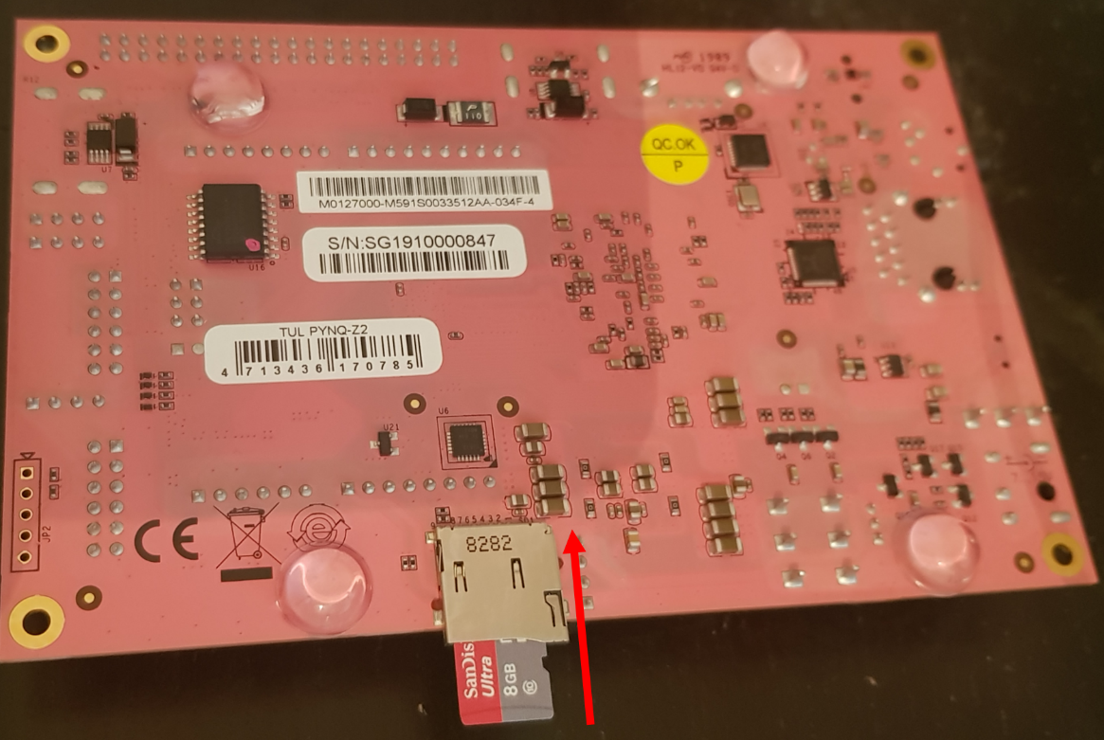

1. Connect the Micro USB cable between the PYNQ-Z2 and your laptop, also connect the Ethernet cable (See Annex A if connecting Ethernet directly to PC)

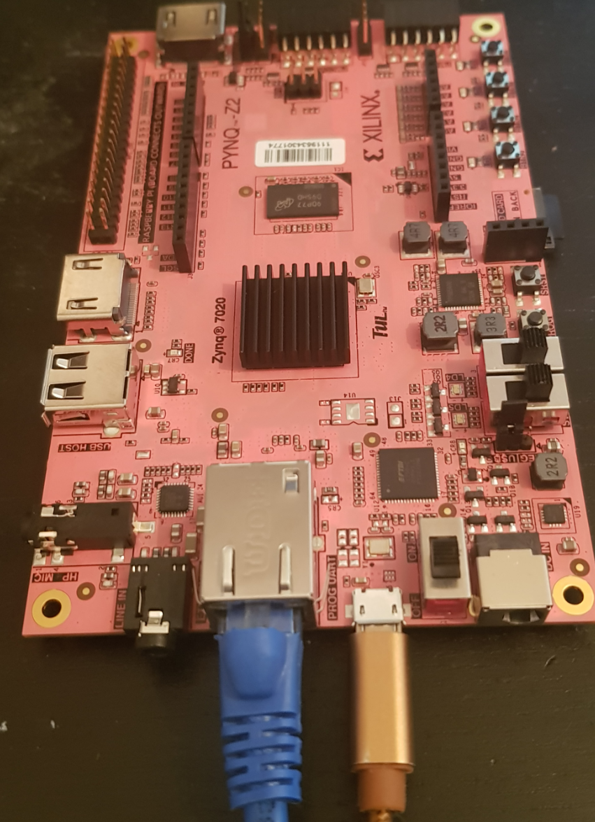

1. Power on the PYNQ-Z2, after a few seconds you will see the Done LED illuminate and the user LEDS flash and then stay lit. This indicates the PYNQ-Z2 board has completed booting PYNQ.

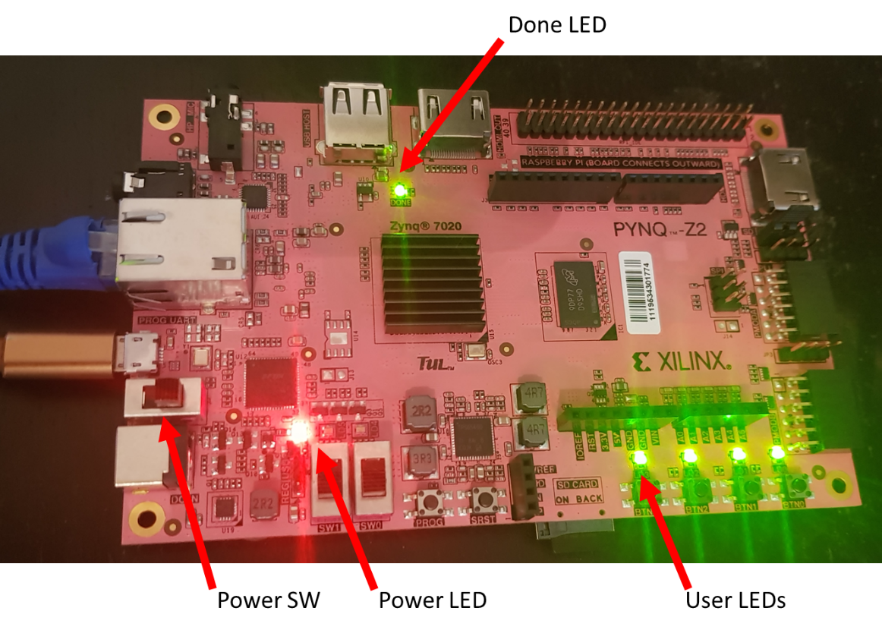

1. The next step is to check we can access the Jupyter notebooks. On your computer open a web browser and navigate to PYNQ:9090 you should see a Jupyter labs log in the password for which is Xilinx

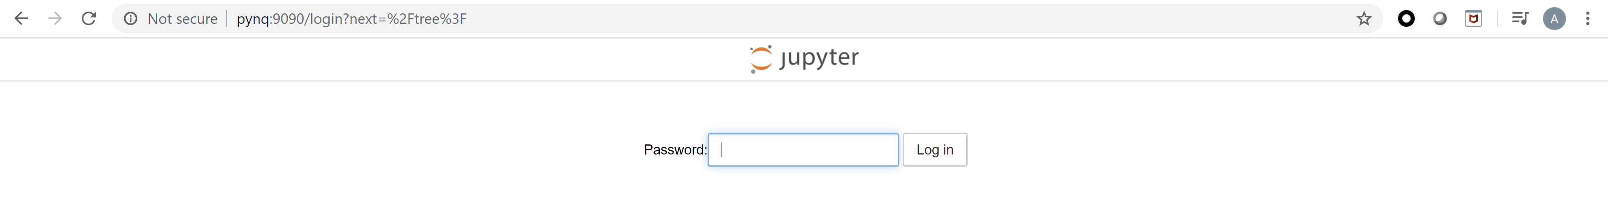

1. Logging in you will see we are ready to begin our development with PYNQ.

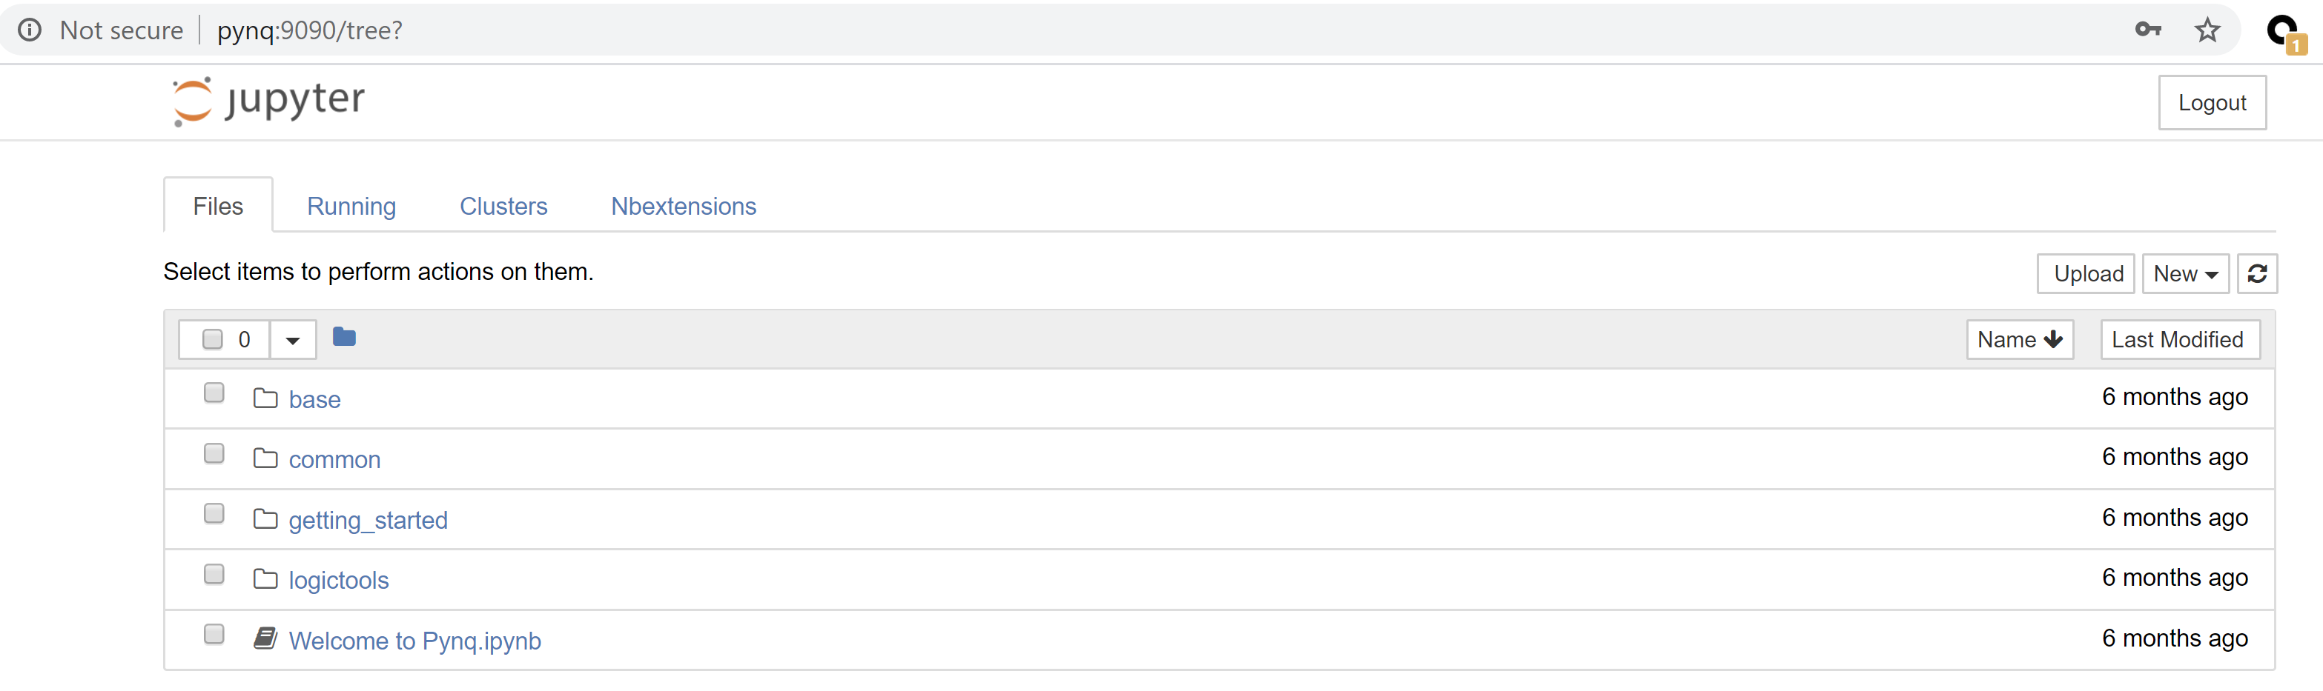

# Lab One

In this lab we are going to explore the base and logic tools overlay and look at how we can add in overlays from the PYNQ user community

1. Power up your Pynq-Z2 and log in to the Jupyter notebook environment – if this is your first time see Pre-Lab One Above.

1. Pynq works on a series of Jupyter notebooks to enable us to work with the PS and the PL of the Zynq. Notebooks can download programmable logic designs to the PL element of the design and interact with the PL using Python
2. Lets take a look at one of the base overlay notebooks. In Jupyter labs click on Base -> Board -> board_btns_leds.ipynb this will open a new browser tab which contains the notebook

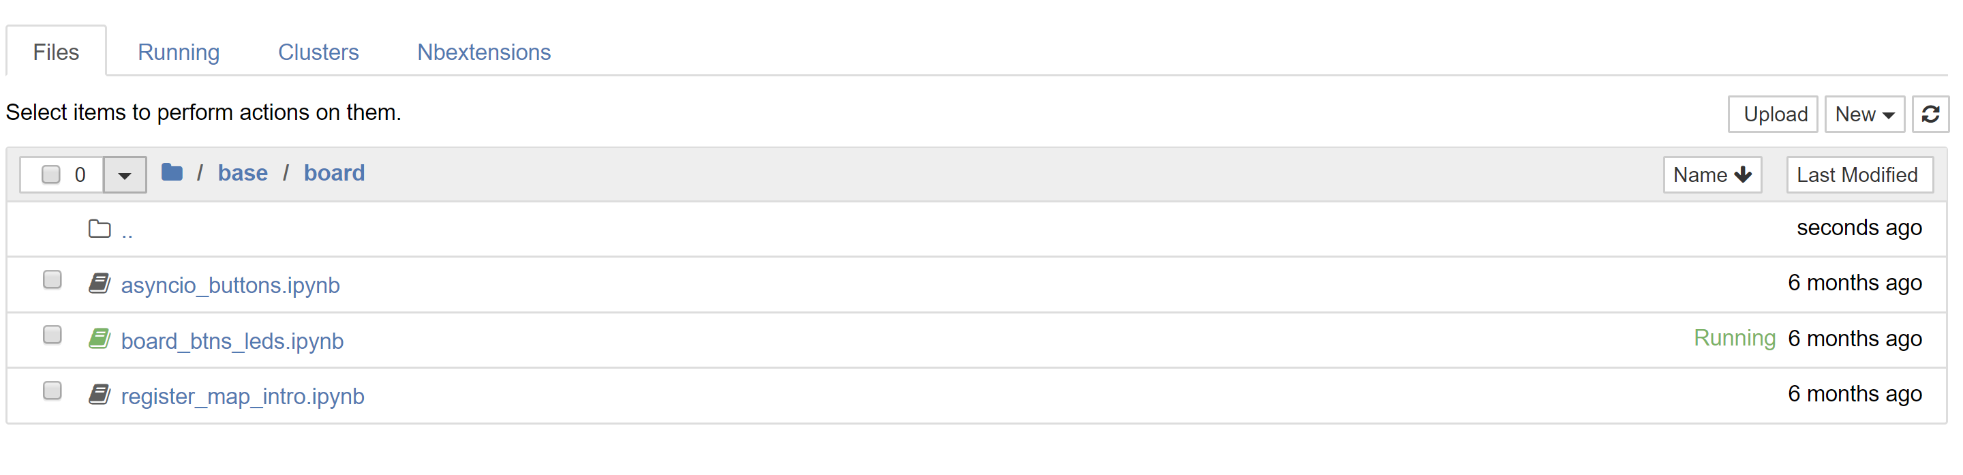

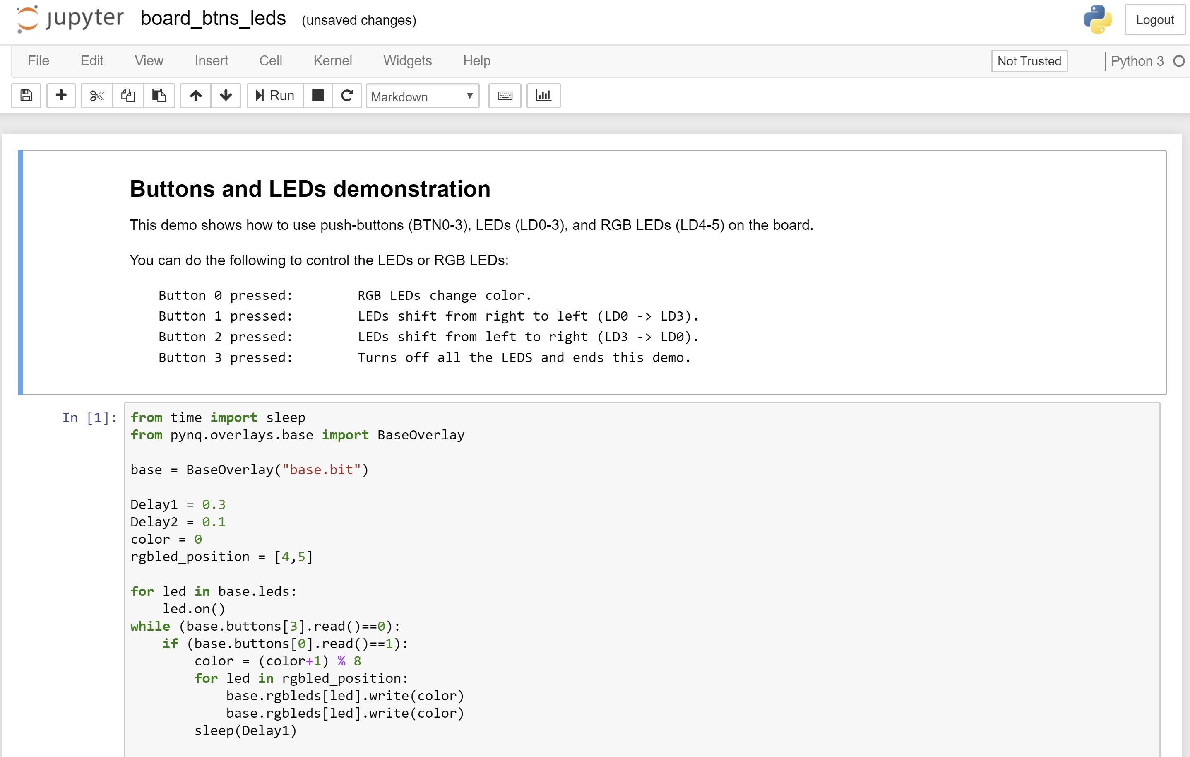

1. Run the cell of python code by clicking on it and pressing run cell

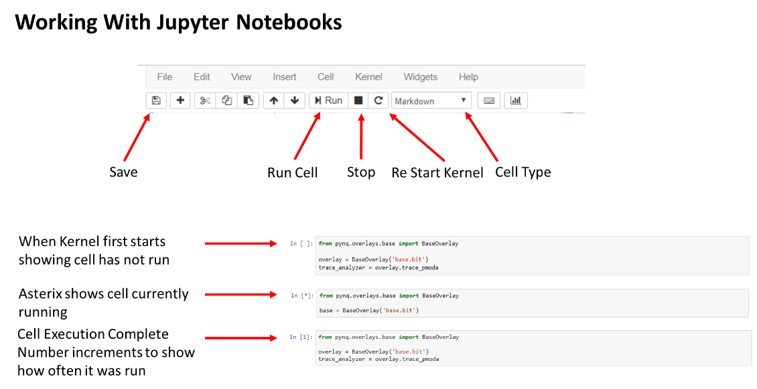

1. This will run a application which uses the LEDs and Buttons on the ZYNQ using the base overlay
   1. Press and hold button 0 you will see the tri color LED cycle around colors while being held.
   2. Press and hold button 1 you will see the LED 0 – 3 flash in a pattern right to left
   3. Press and hold button 2 you will see the LED 0 – 3 flash in a pattern left to right
   4. Press button 3 and the demonstration will end

1. Close the note book board_btns_leds.ipynb this will not stop the kernel running, on the home page click on running and you will see that it is still shown as running. Click on shutdown, this will stop the kernel from running.

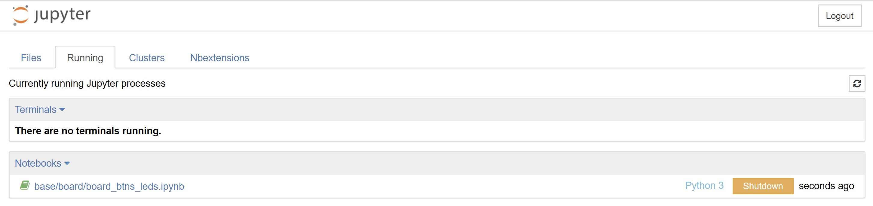

1. The base overlay provides the ability to quickly and easily interface and work with all of the interfaces on the PYNQ board. Including the HDMI, Audio, Pmod, RPI and Shield Connector.

1. From the home page open the logictools directory

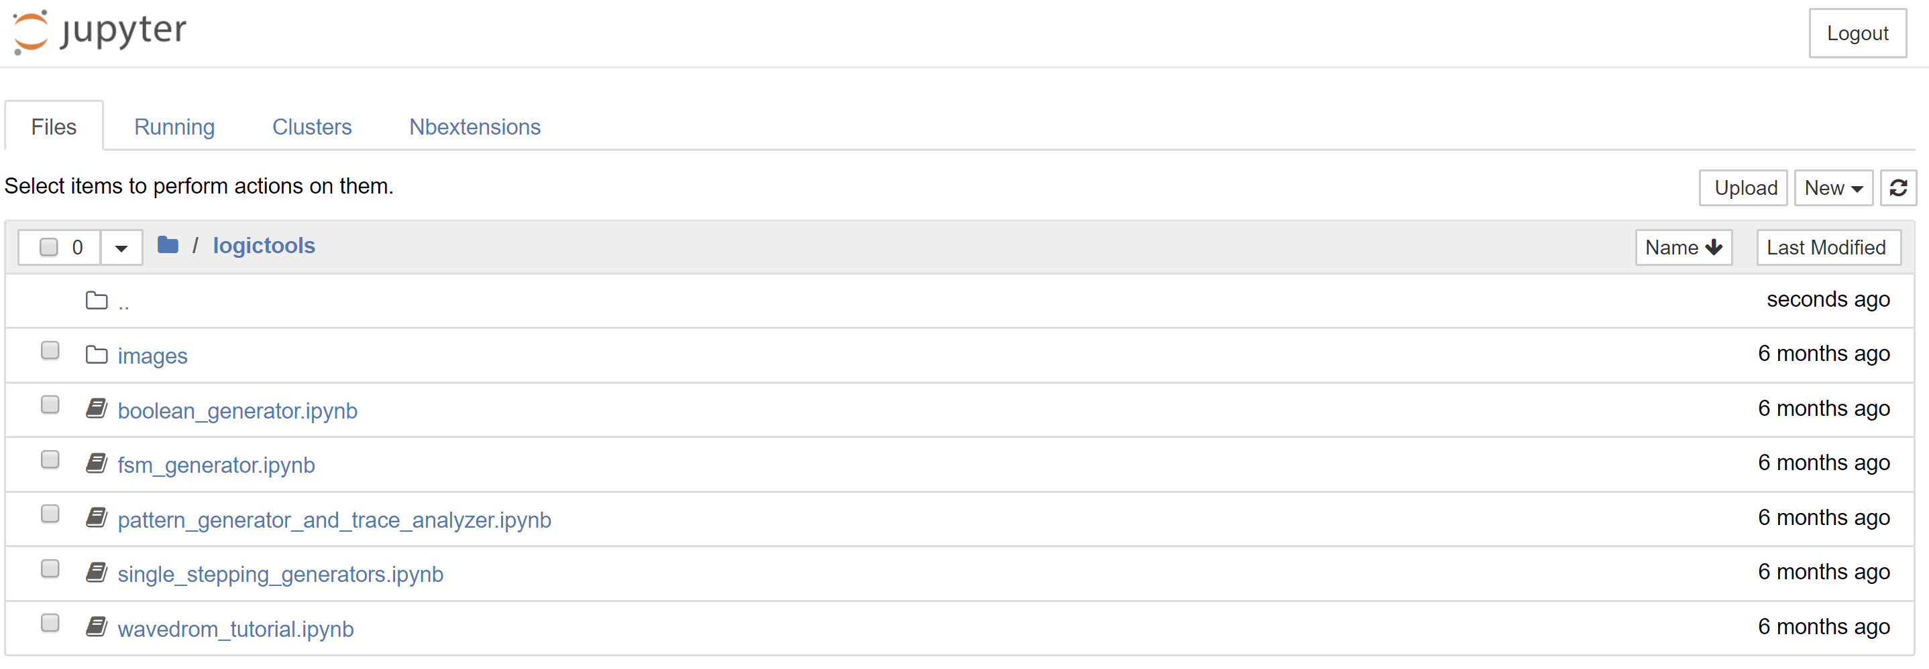

1. Create a new notebook by clicking on New->Python3

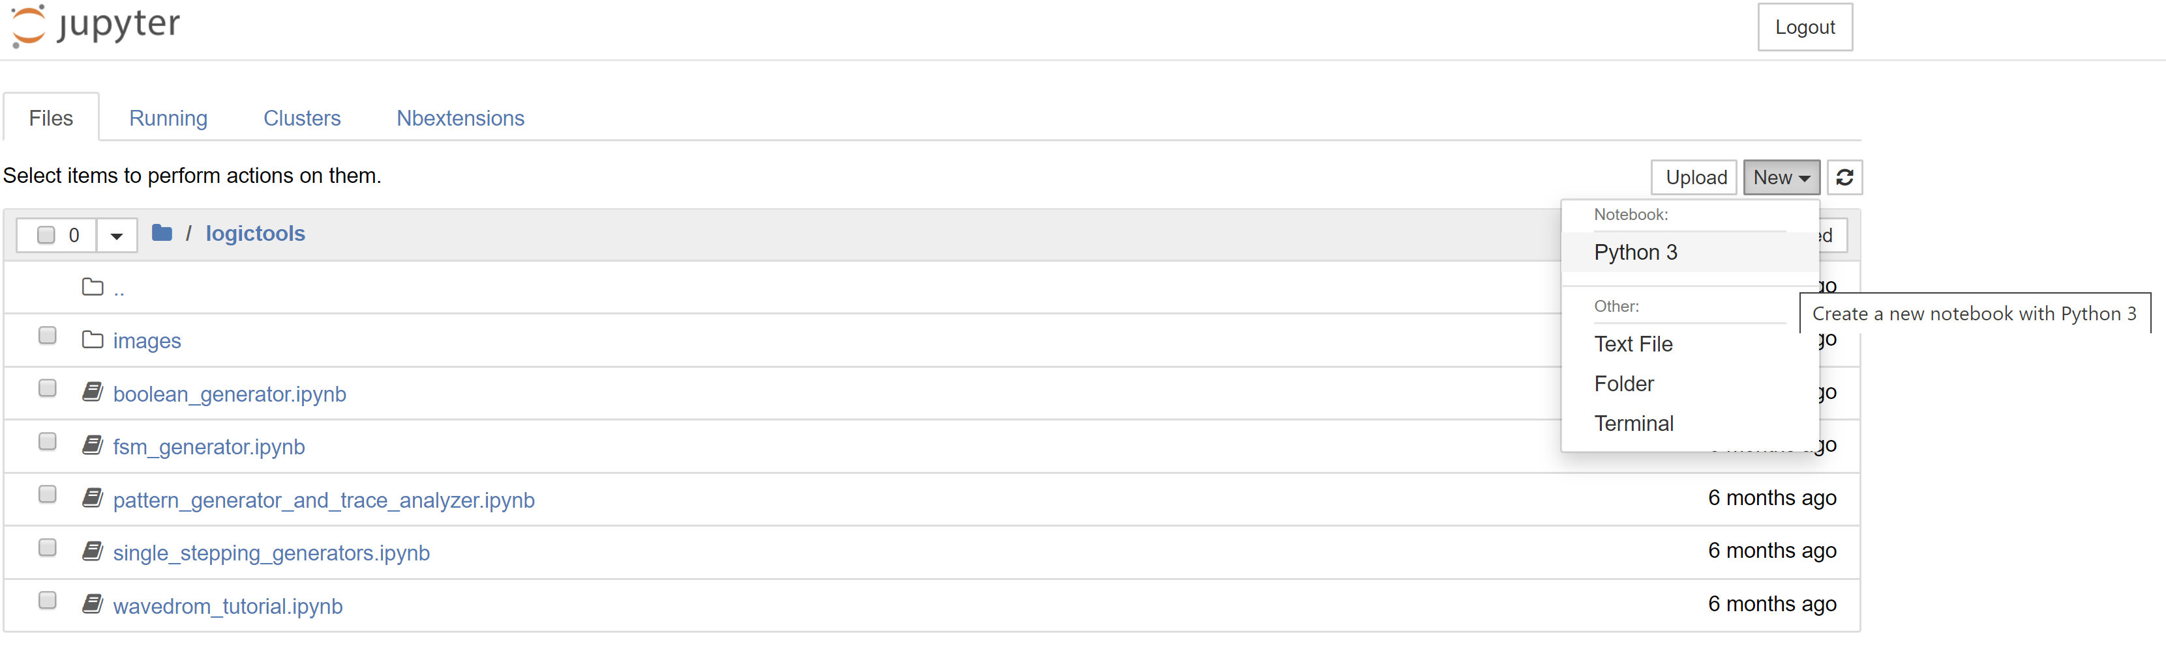

1. Change the name of the workbook by clicking on Untitled, enter the name LabOneIO

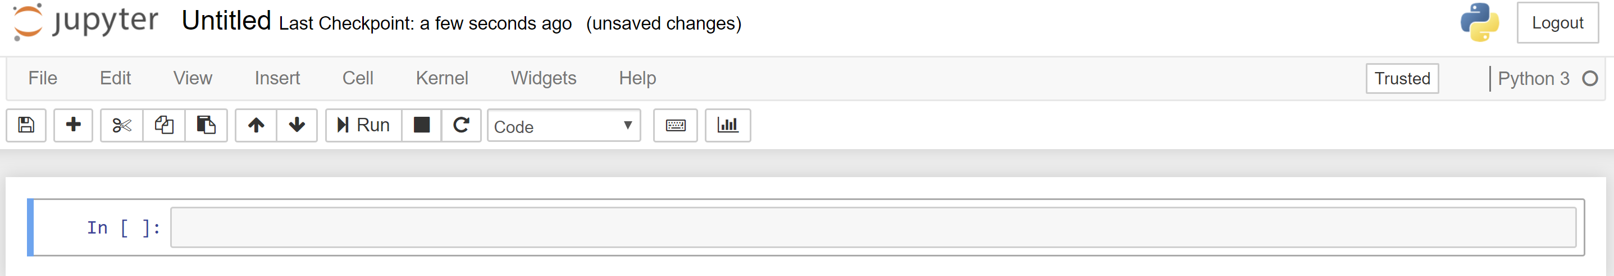

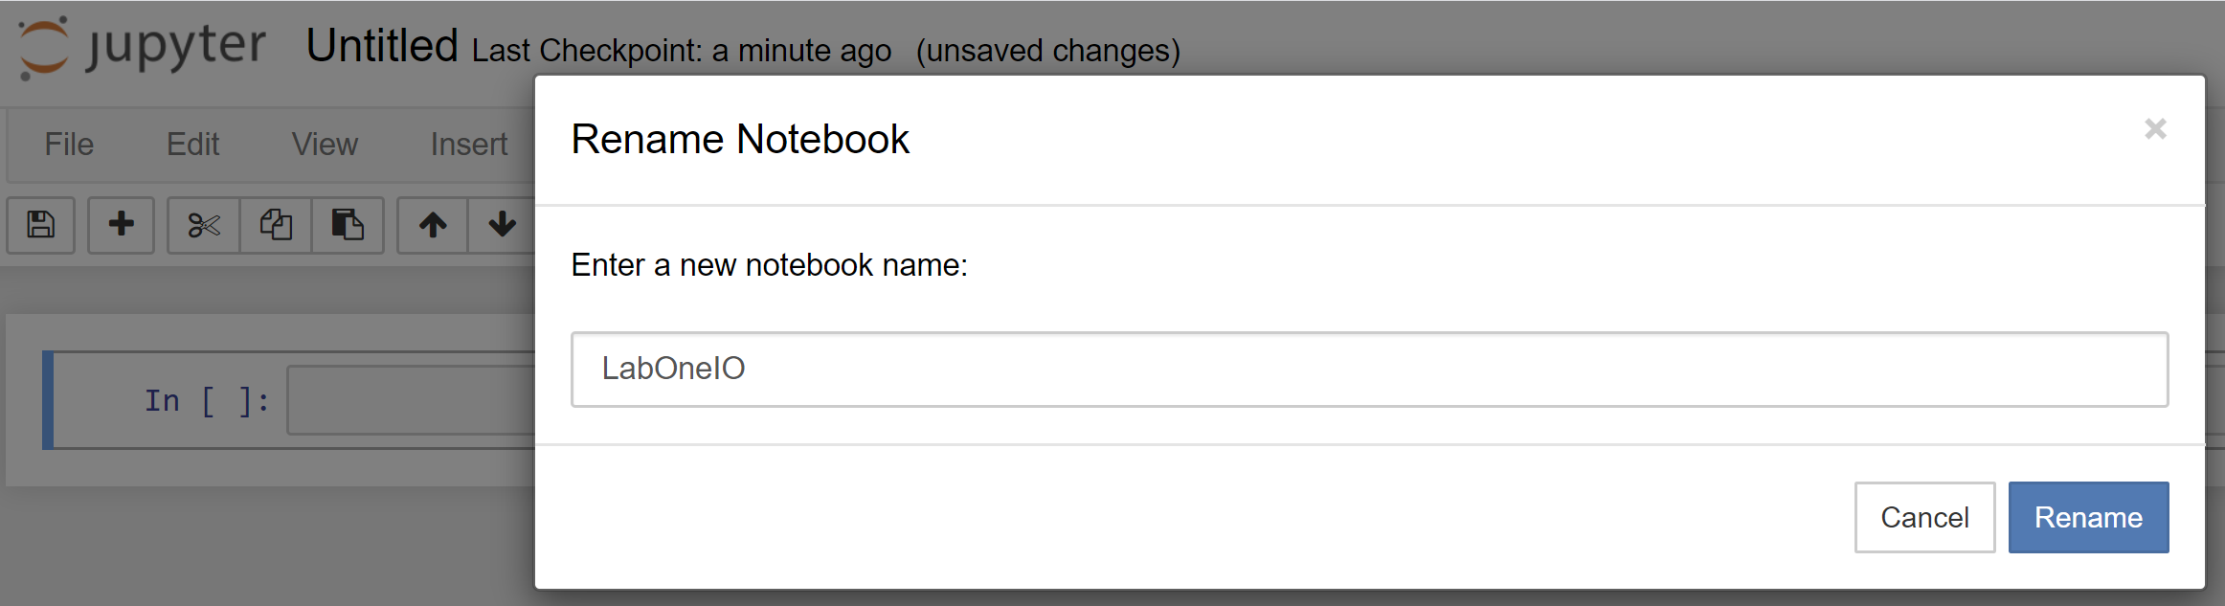

1. Enter the following code into the cell

from pynq.overlays.logictools import LogicToolsOverlay

logictools_olay = LogicToolsOverlay(‘logictools.bit’)

boolean_generator = logictools_olay.boolean_generator

function = {‘XOR_gate’: ‘LD2 = PB3 ^ PB0’}

boolean_generator = logictools_olay.boolean_generator

boolean_generator.setup(function)

boolean_generator.run()

boolean_generator.stop()

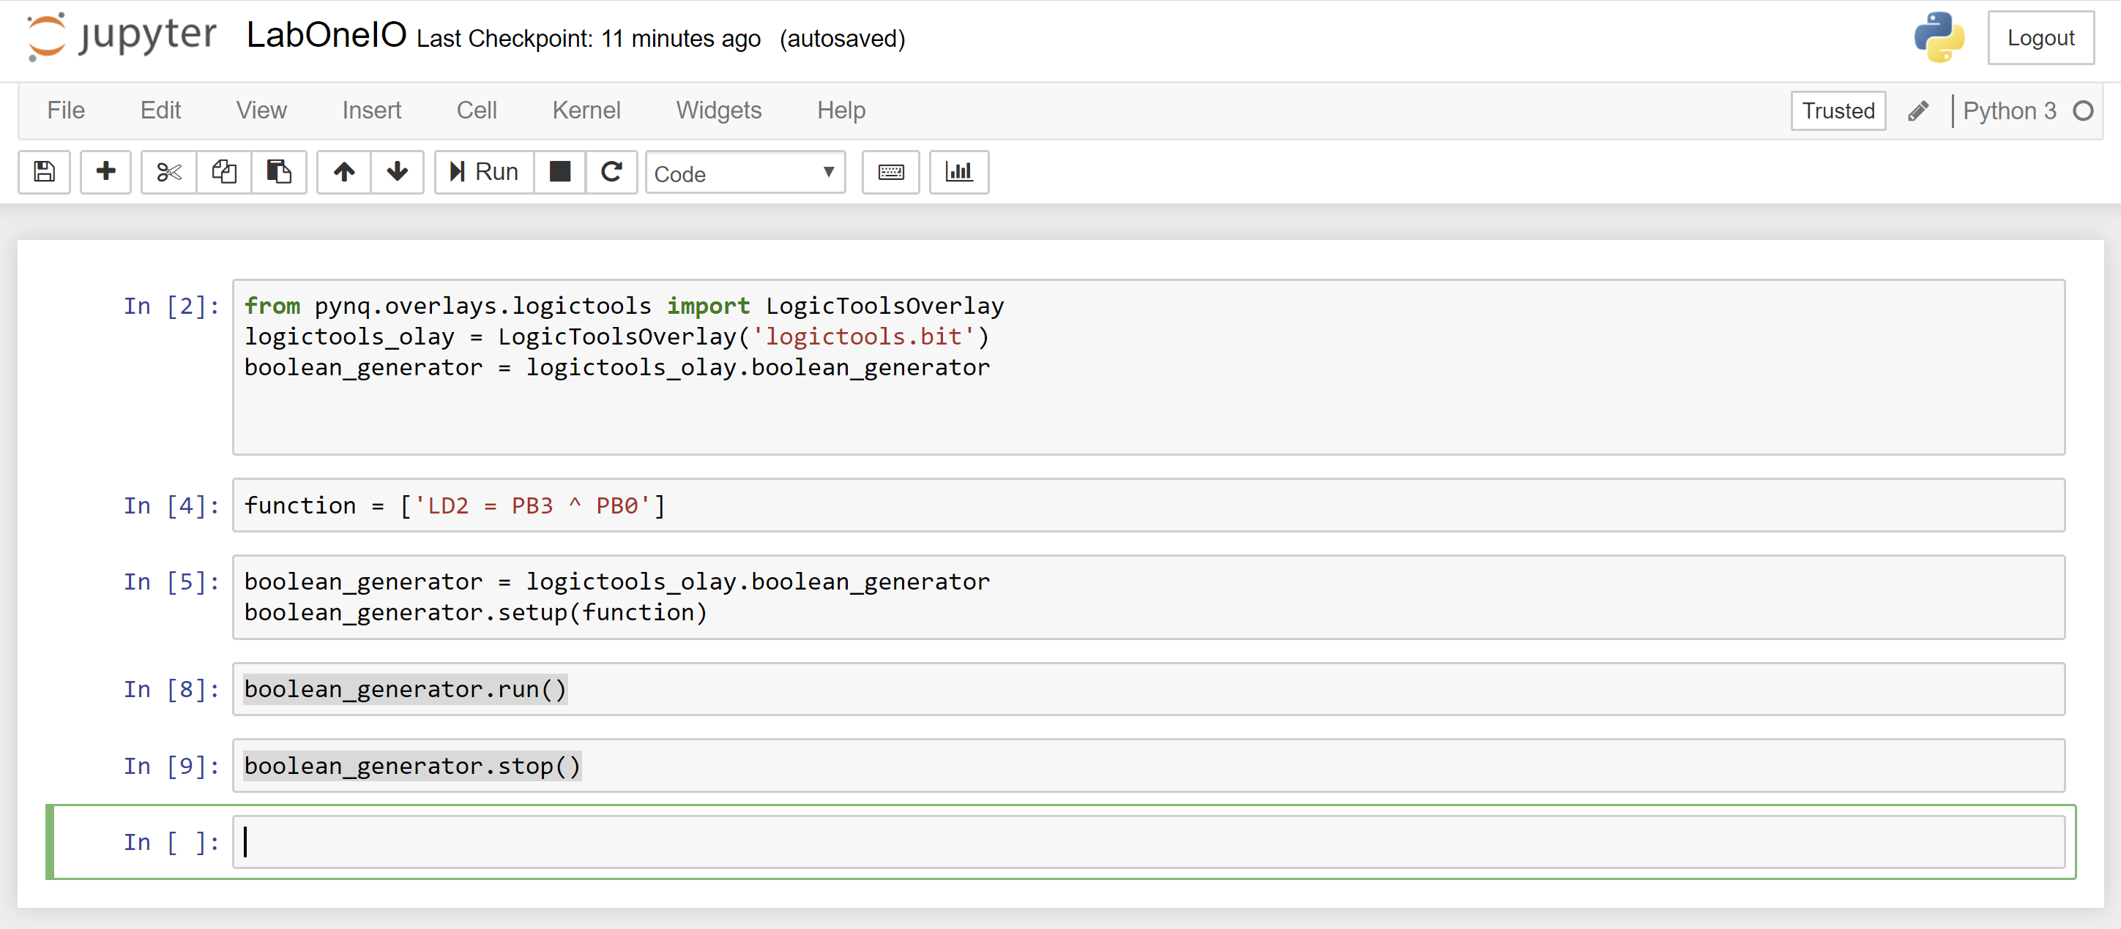

1. Press the BTN3 and BTN2 and see the implementation of a OR gate that lights up the LED 3

1. Try different logic implementations. AND = &, XOR = ^, OR = | and NOT = ~.
2. Congrats you have created your first PYNQ application – do not worry we are going to get much more complicated
3. Close the lab book and shutdown the kernel as we did in step 6
4. Create an new notebook and call it LabOneWave (steps 9 & 10 show how to do this)

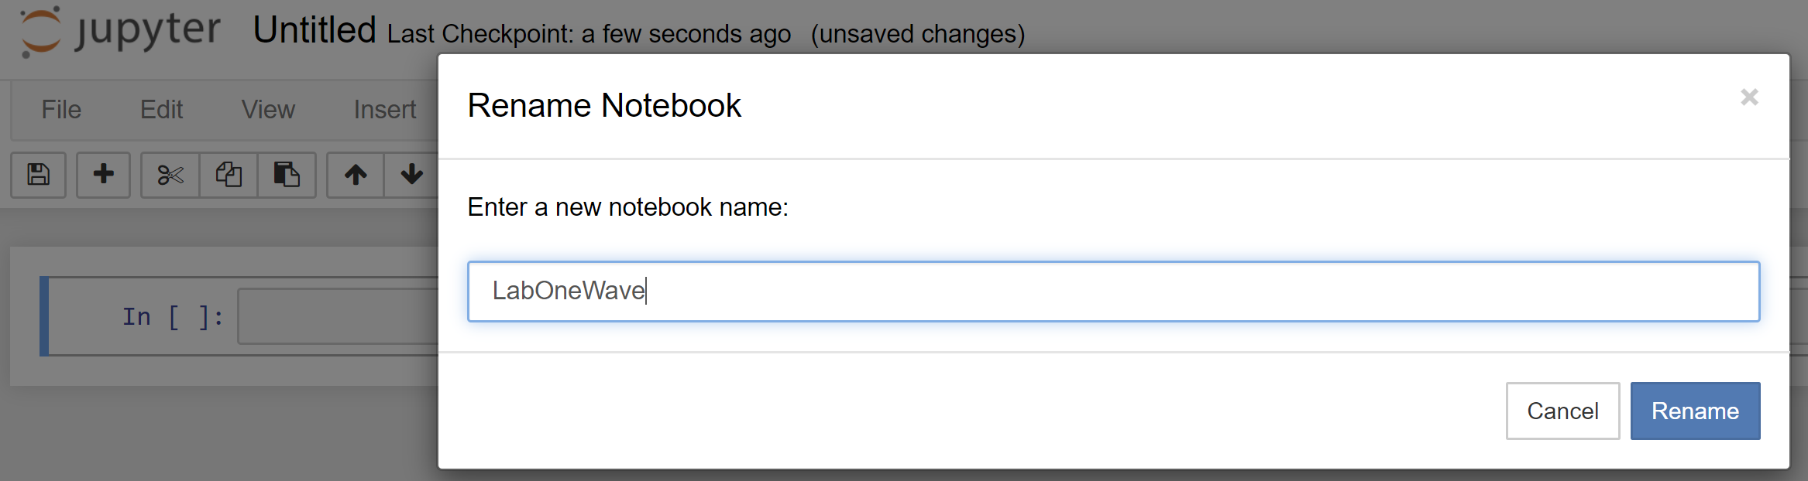

1. Enter the following code

from pynq.lib.logictools import Waveform

dwn_counter = {'signal': [

['stimulus',

{'name': 'bit0', 'pin': 'D0', 'wave': 'h...l...' * 2},

{'name': 'bit1', 'pin': 'D1', 'wave': 'h.l.' * 4},

{'name': 'bit2', 'pin': 'D2', 'wave': 'hl' * 8}],

['analysis',

{'name': 'bit2_loopback', 'pin': 'D17'},

{'name': 'bit1_loopback', 'pin': 'D18'},

{'name': 'bit0_loopback', 'pin': 'D19'}]],

'foot': {'tock': 1},

'head': {'text': 'down_counter'}}

waveform = Waveform(dwn_counter)

waveform.display()

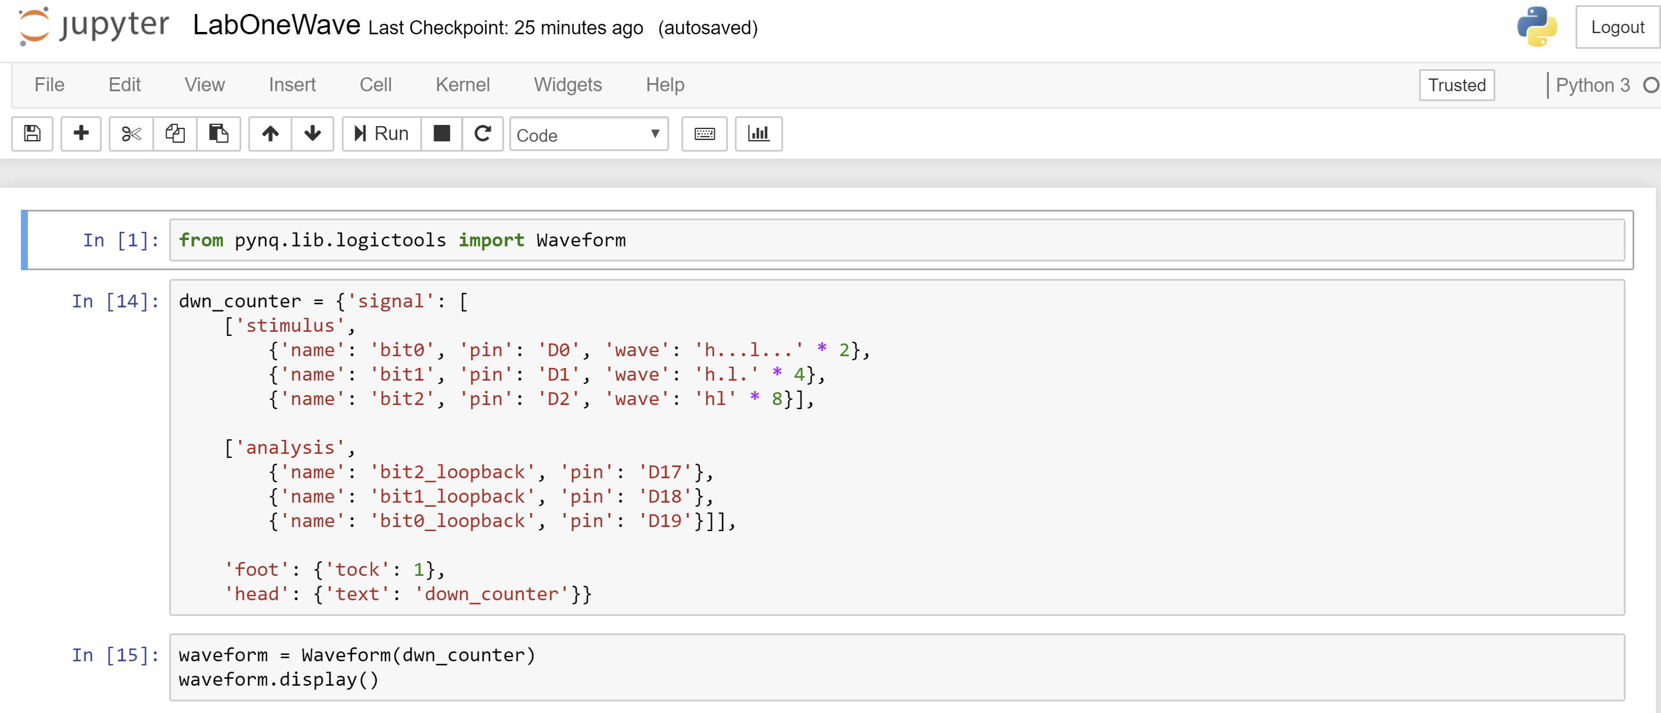

1. Run each of these cells you should see a binary down counter however, the analysis elements will be empty

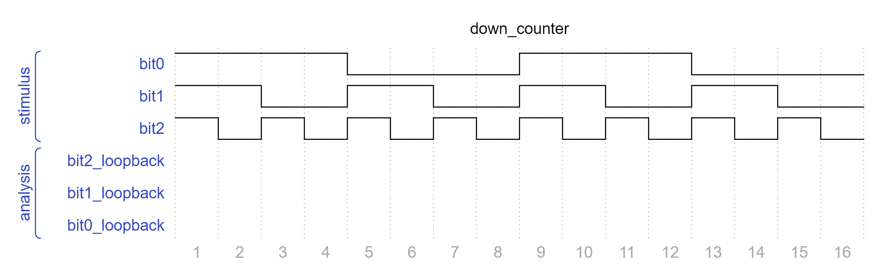

1. To be able to loop these back we need to connect the flying lead connectors between the Arduino header as shown below. Make sure the PYNQ-Z2 is powered down

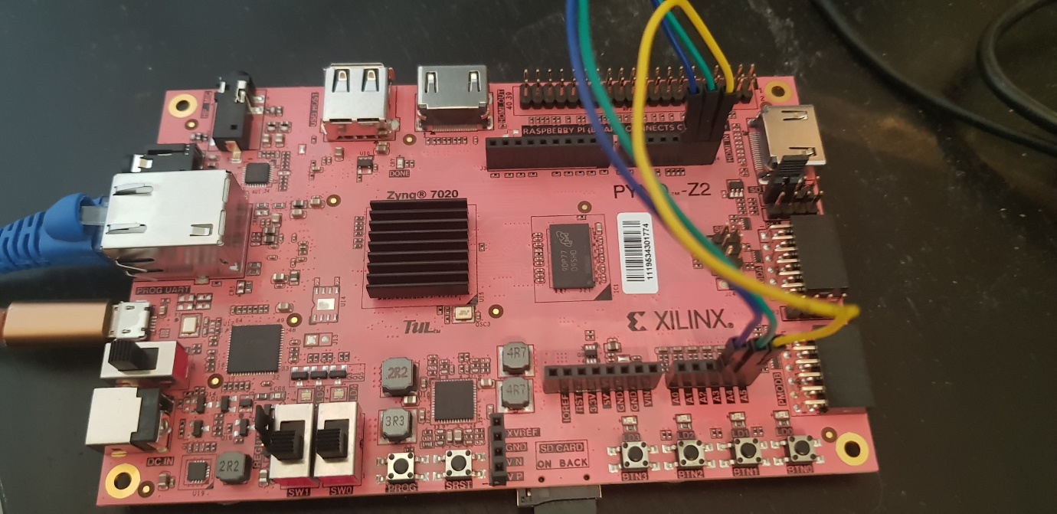

1. Power up the board and re open the LabOneWave notebook. Enter the following code in the notebook

pattern_generator = logictools_olay.pattern_generator

pattern_generator.trace(num_analyzer_samples=16)

pattern_generator.setup(dwn_counter, stimulus_group_name='stimulus', analysis_group_name='analysis')

pattern_generator.run()

pattern_generator.show_waveform()

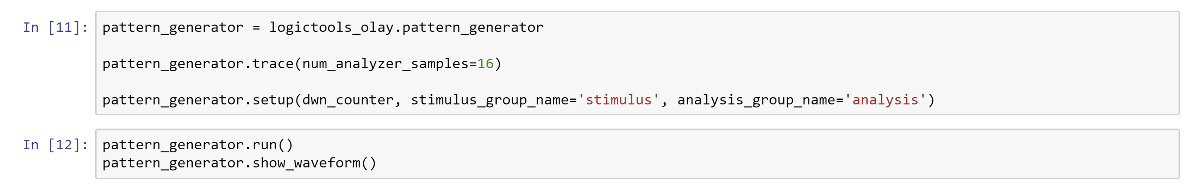

1. Run the notebook cells and you should see the received patterns as output.

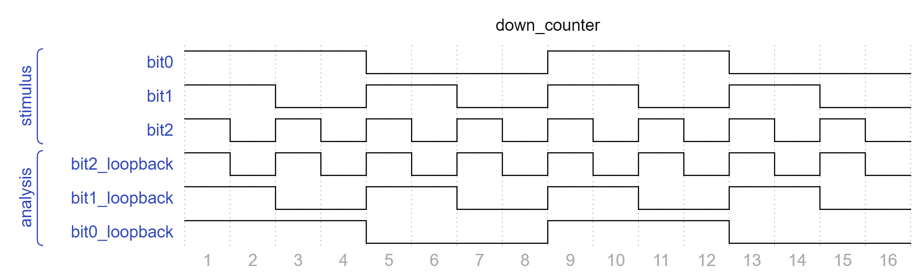

This ability to generate and capture waveforms really helps when we want to quickly and easily interface and test with sensors.

1. Close the notebook and shut it down as we have in the previously

1. From the home screen open a new terminal window

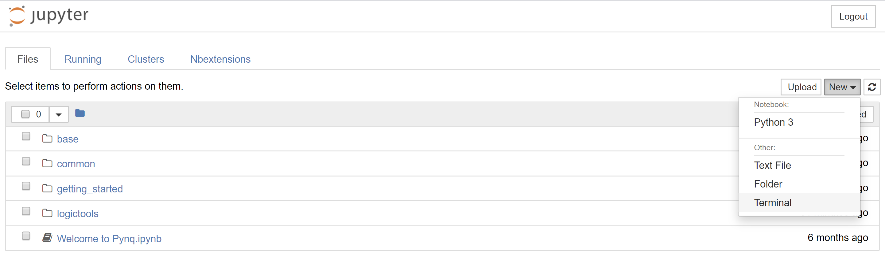

1. We are going to use this terminal to install a new overlay
2. In a browser on your computer open <http://www.pynq.io/embedded.html>

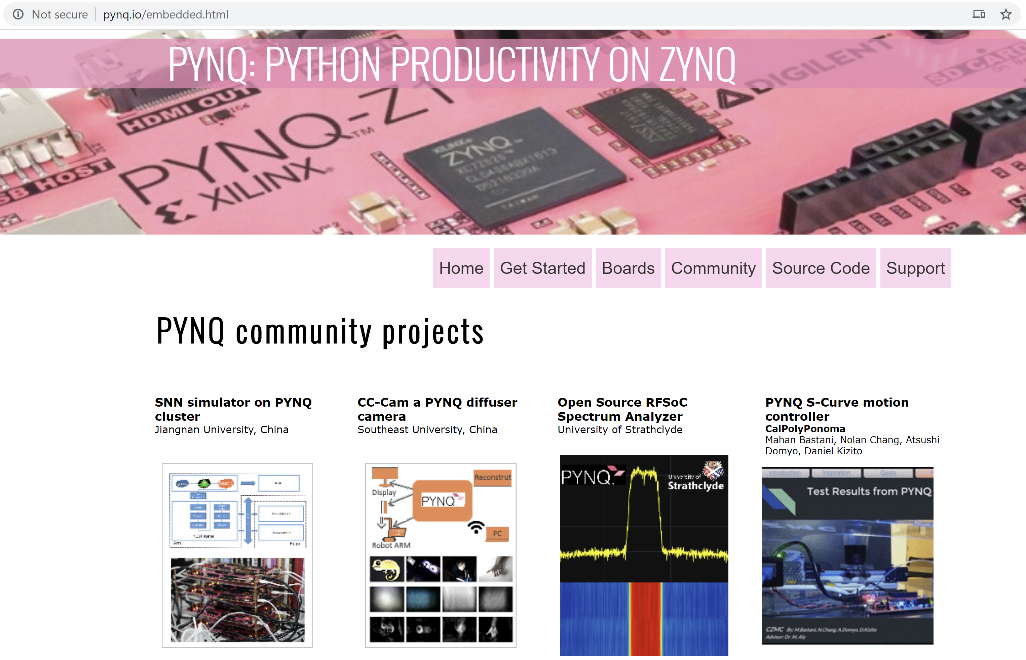

1. Scroll down until you find the QNN Xilinx Labs

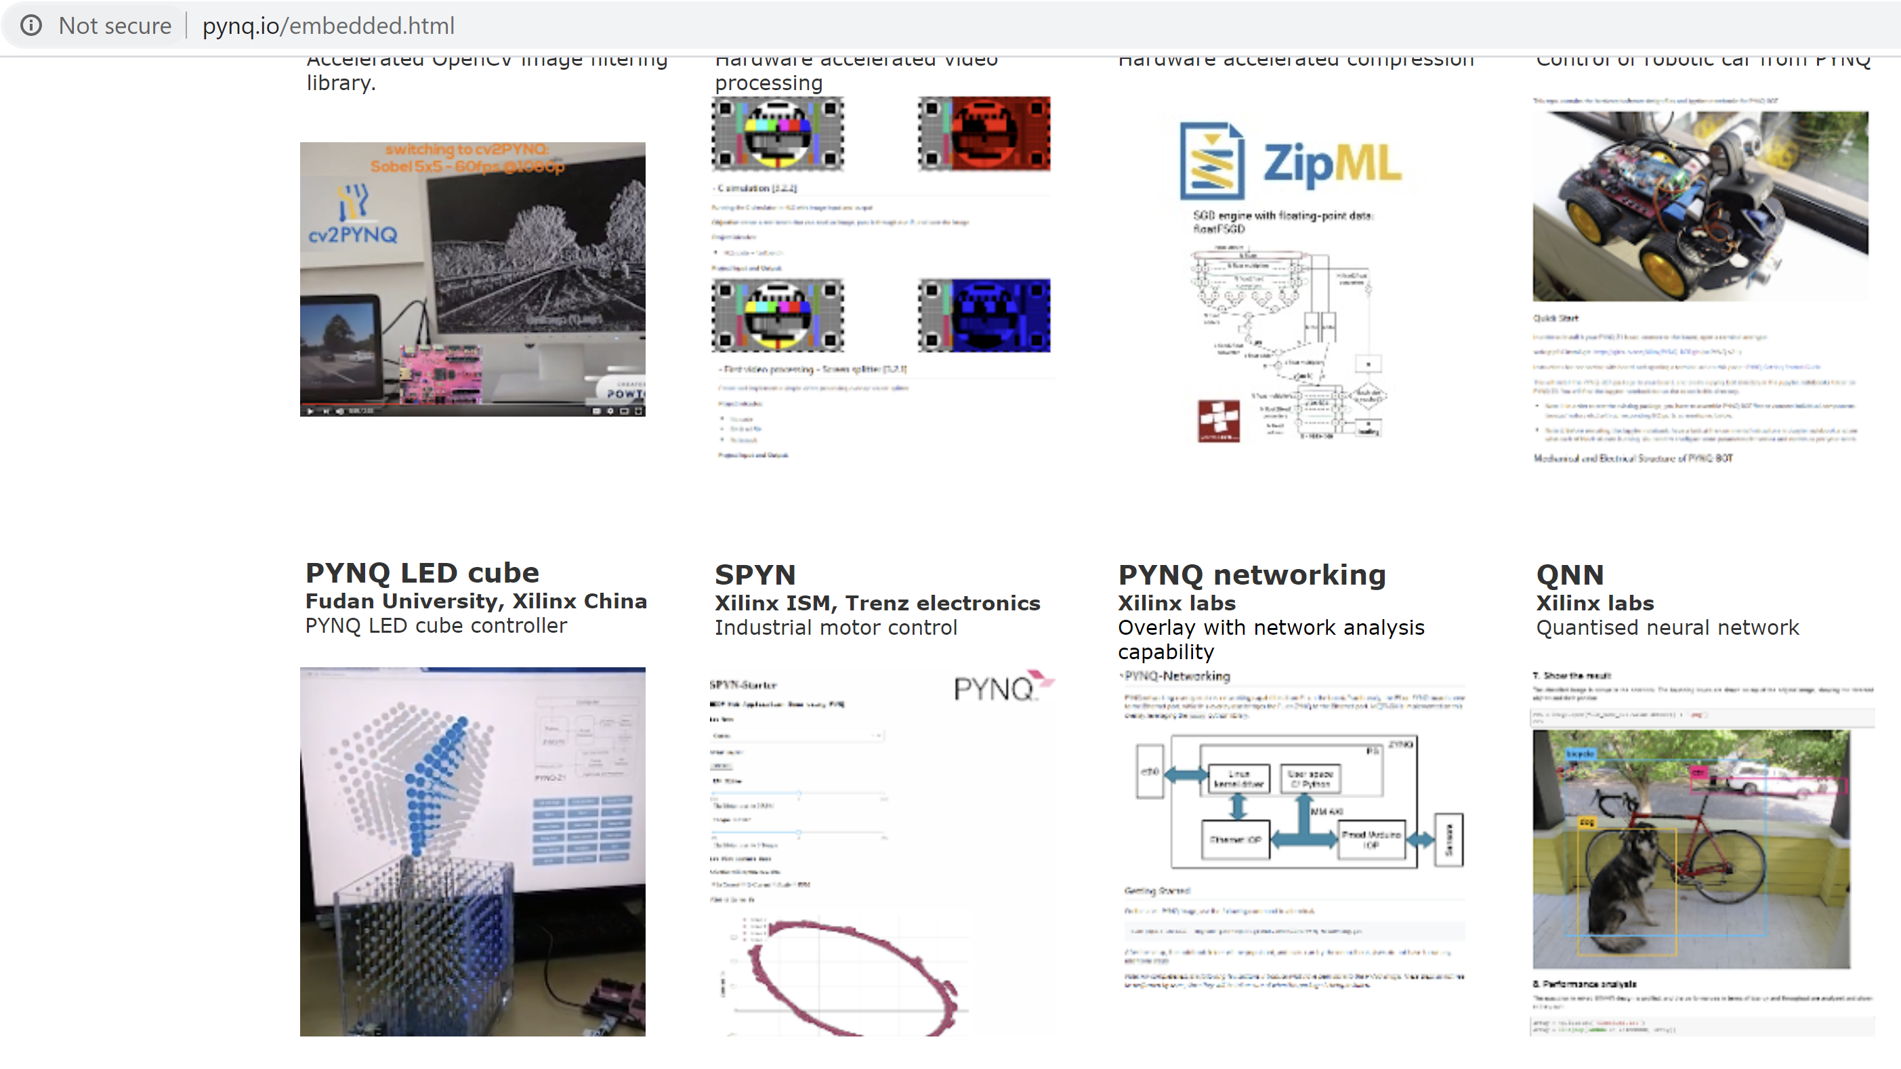

1. Click on the QNN overlay, this will take you to the GitHub for the overlay

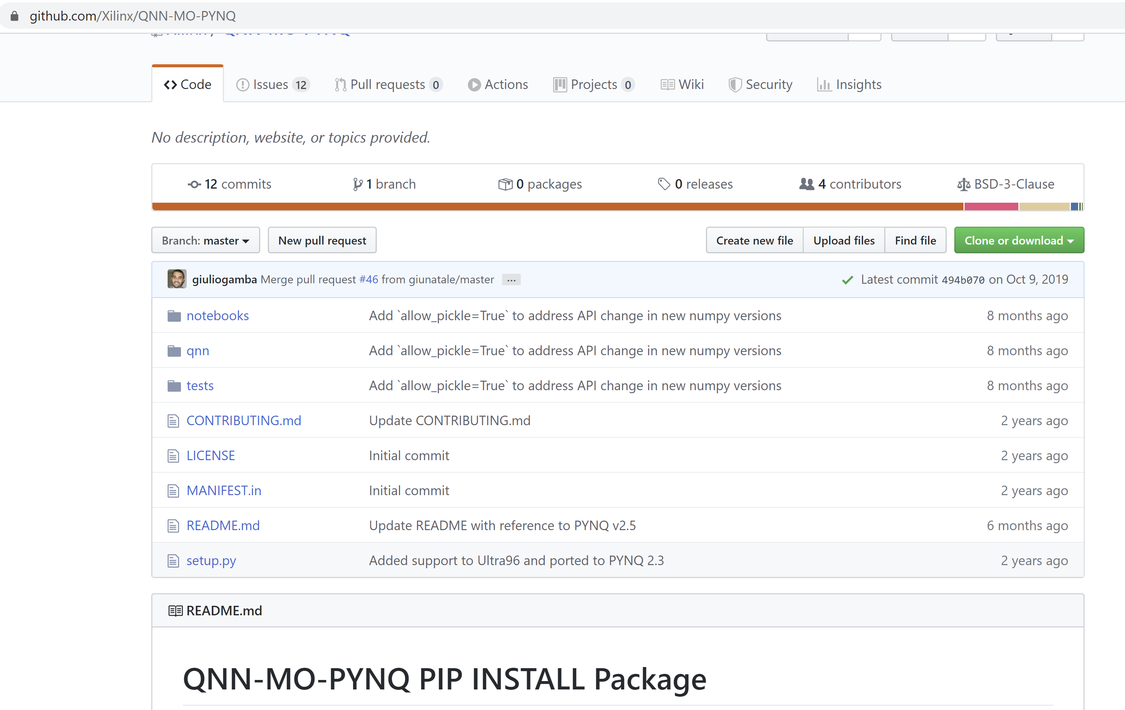

1. Copy the installation code from the Git Hub and paste it in the terminal and press enter

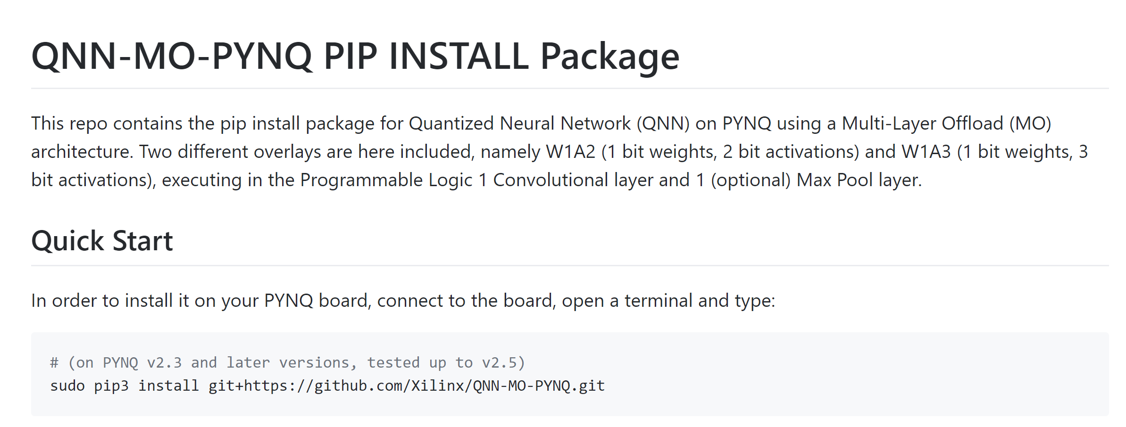

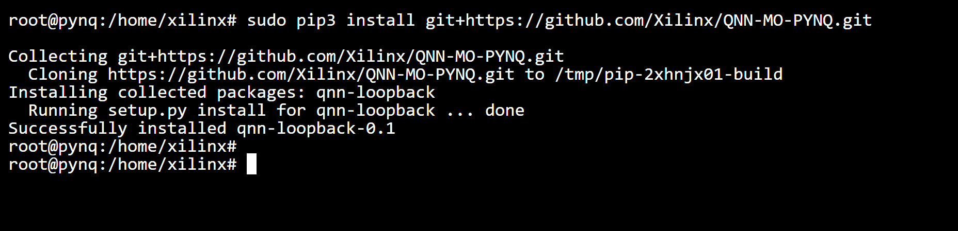

1. On the home page you should see a new directory called QNN open it

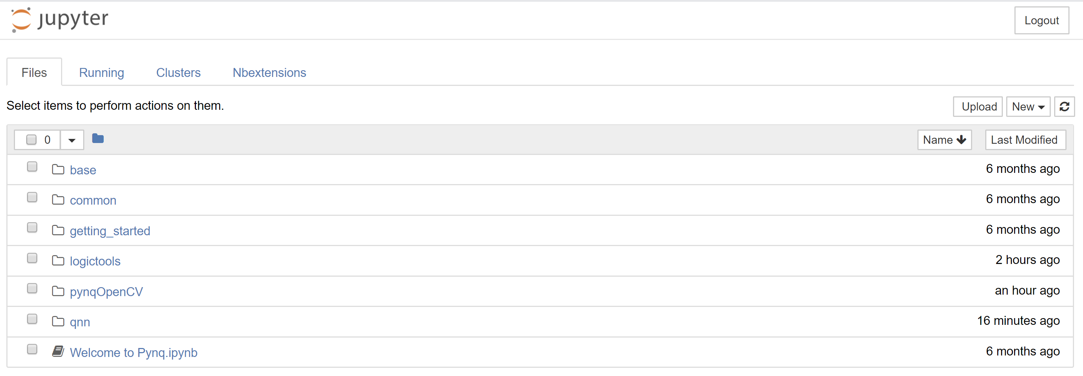

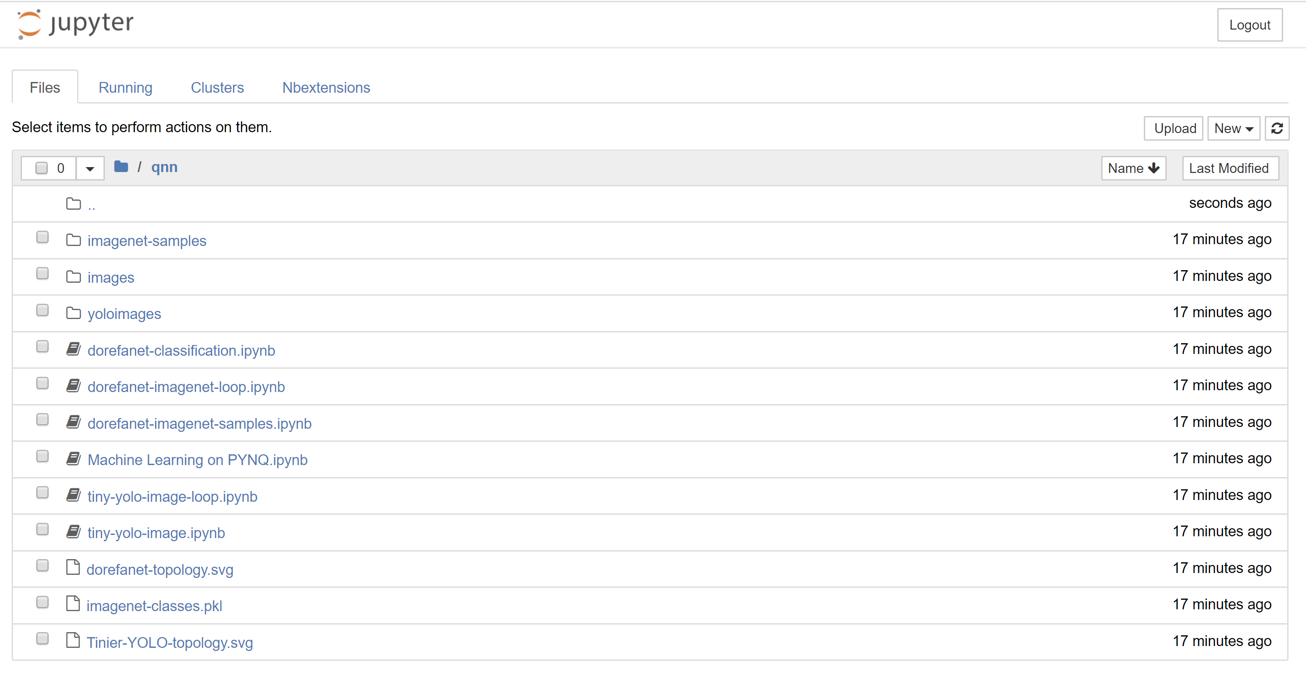

1. Open the dorefanet-classification.ipynb and run each of the cells

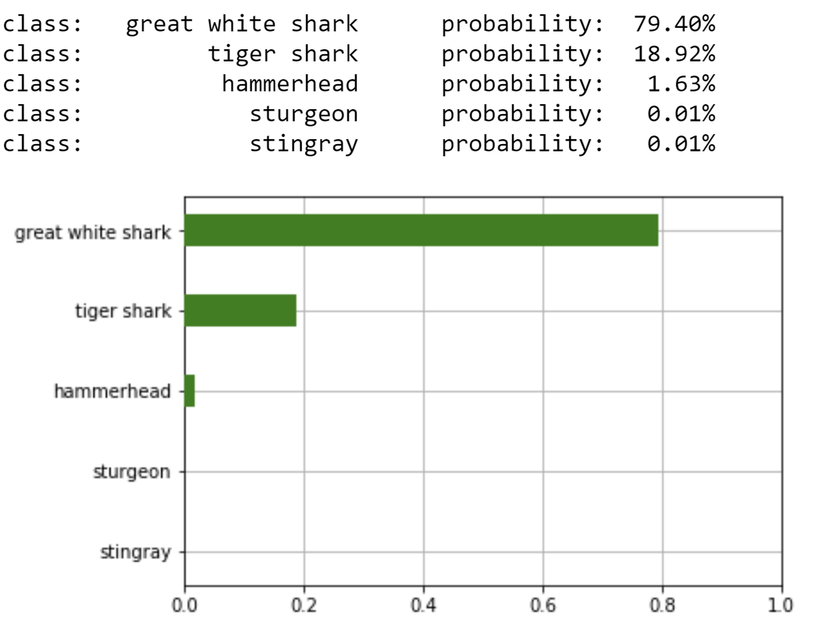

This demonstrates not only the ease with which overlays can be added to the system but also how complicated functions can be implemented which use the programmable logic and controlled from Python to give a significant acceleration.

In the next lab we will look at how we can develop our own overlay!

# Lab Two

1. Open Vivado 2019.1

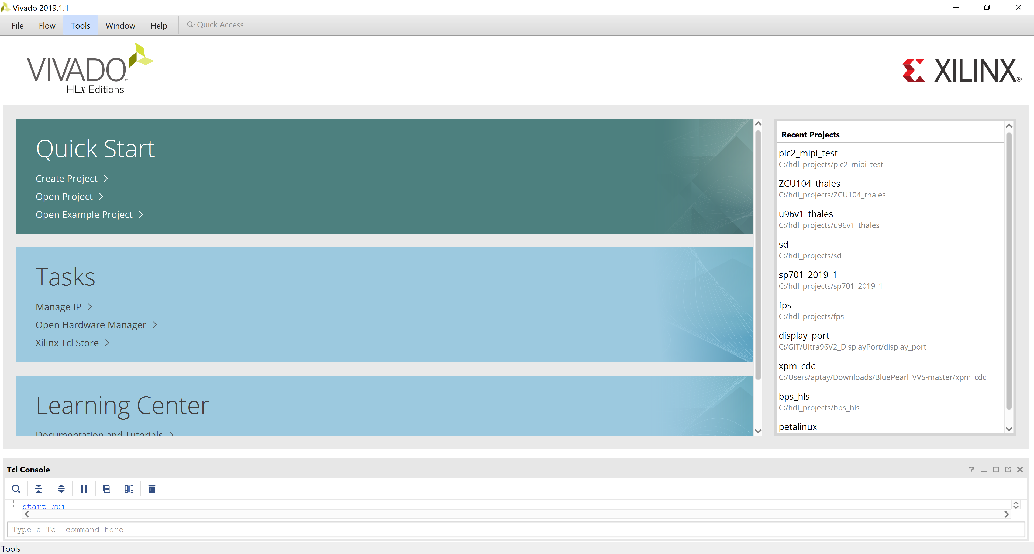

1. Click Create Project, click next on the dialog which opens

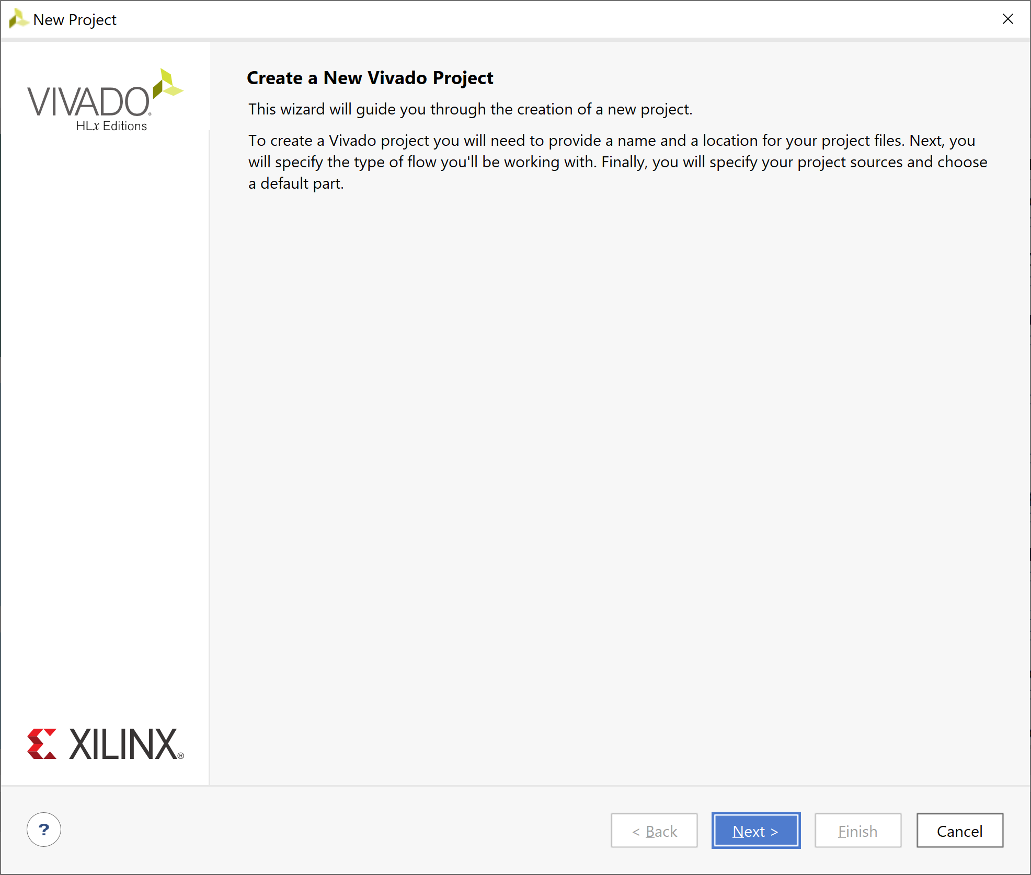

1. Enter the project name as pynq_z2_overlay and select a directory to save the project in

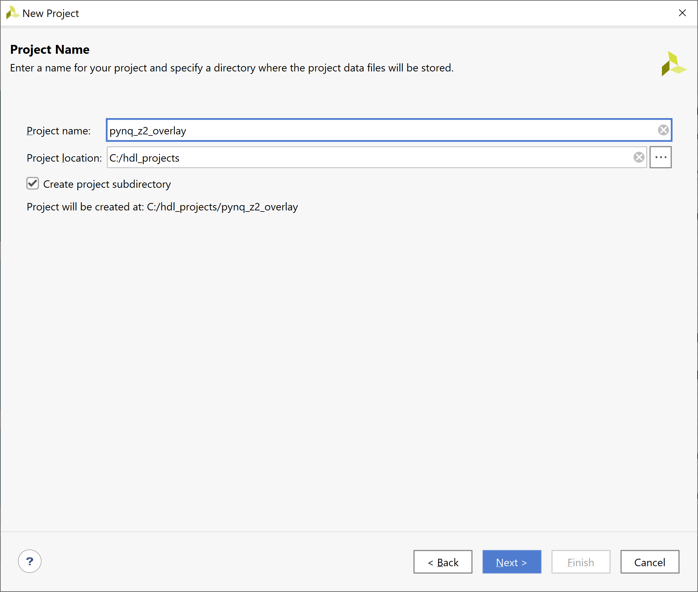

1. Select RTL Project

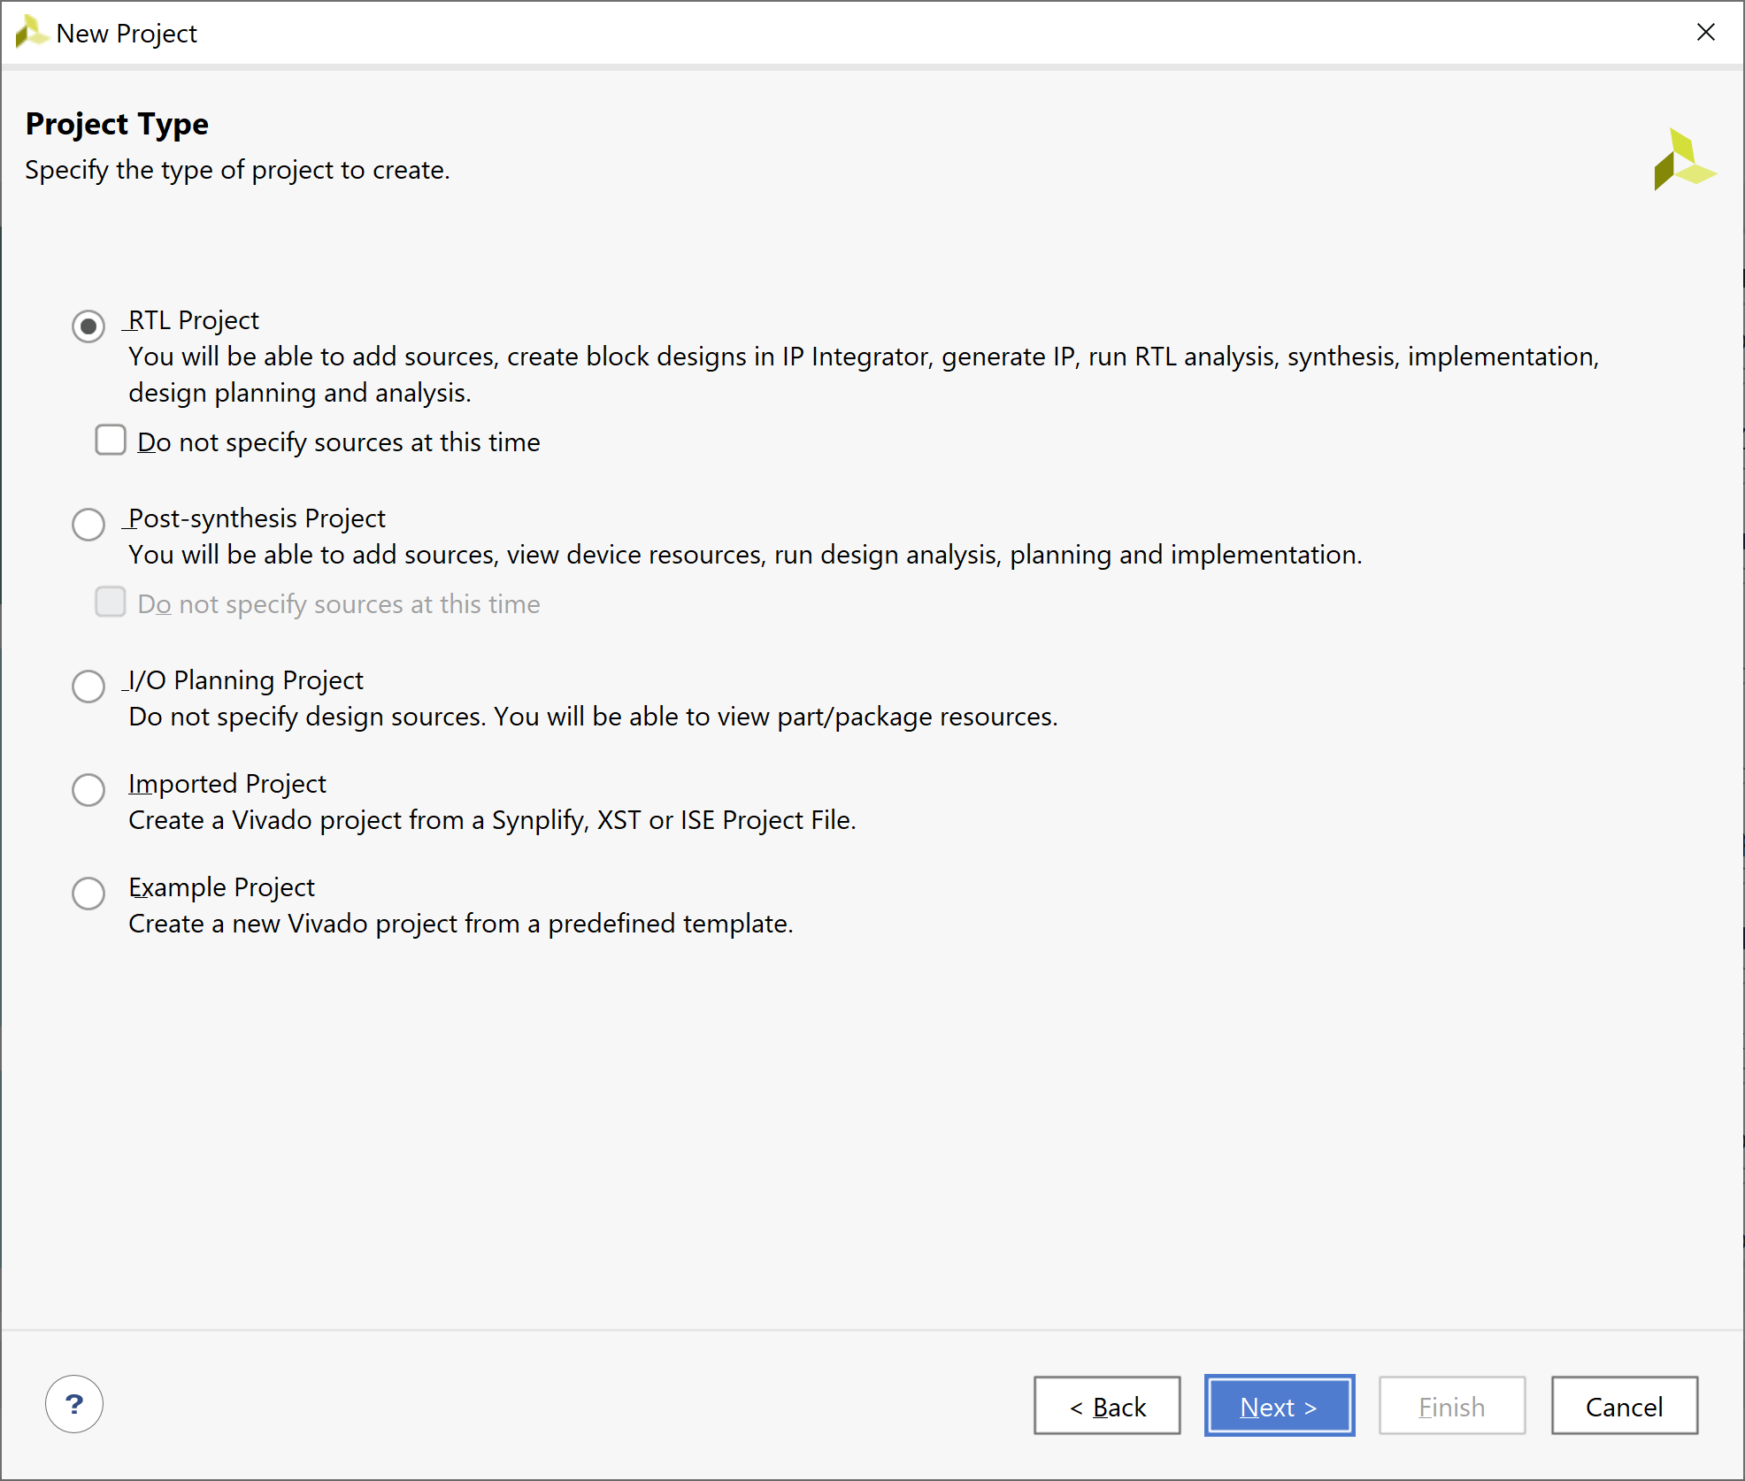

1. On the next page click next – we have no sources to add

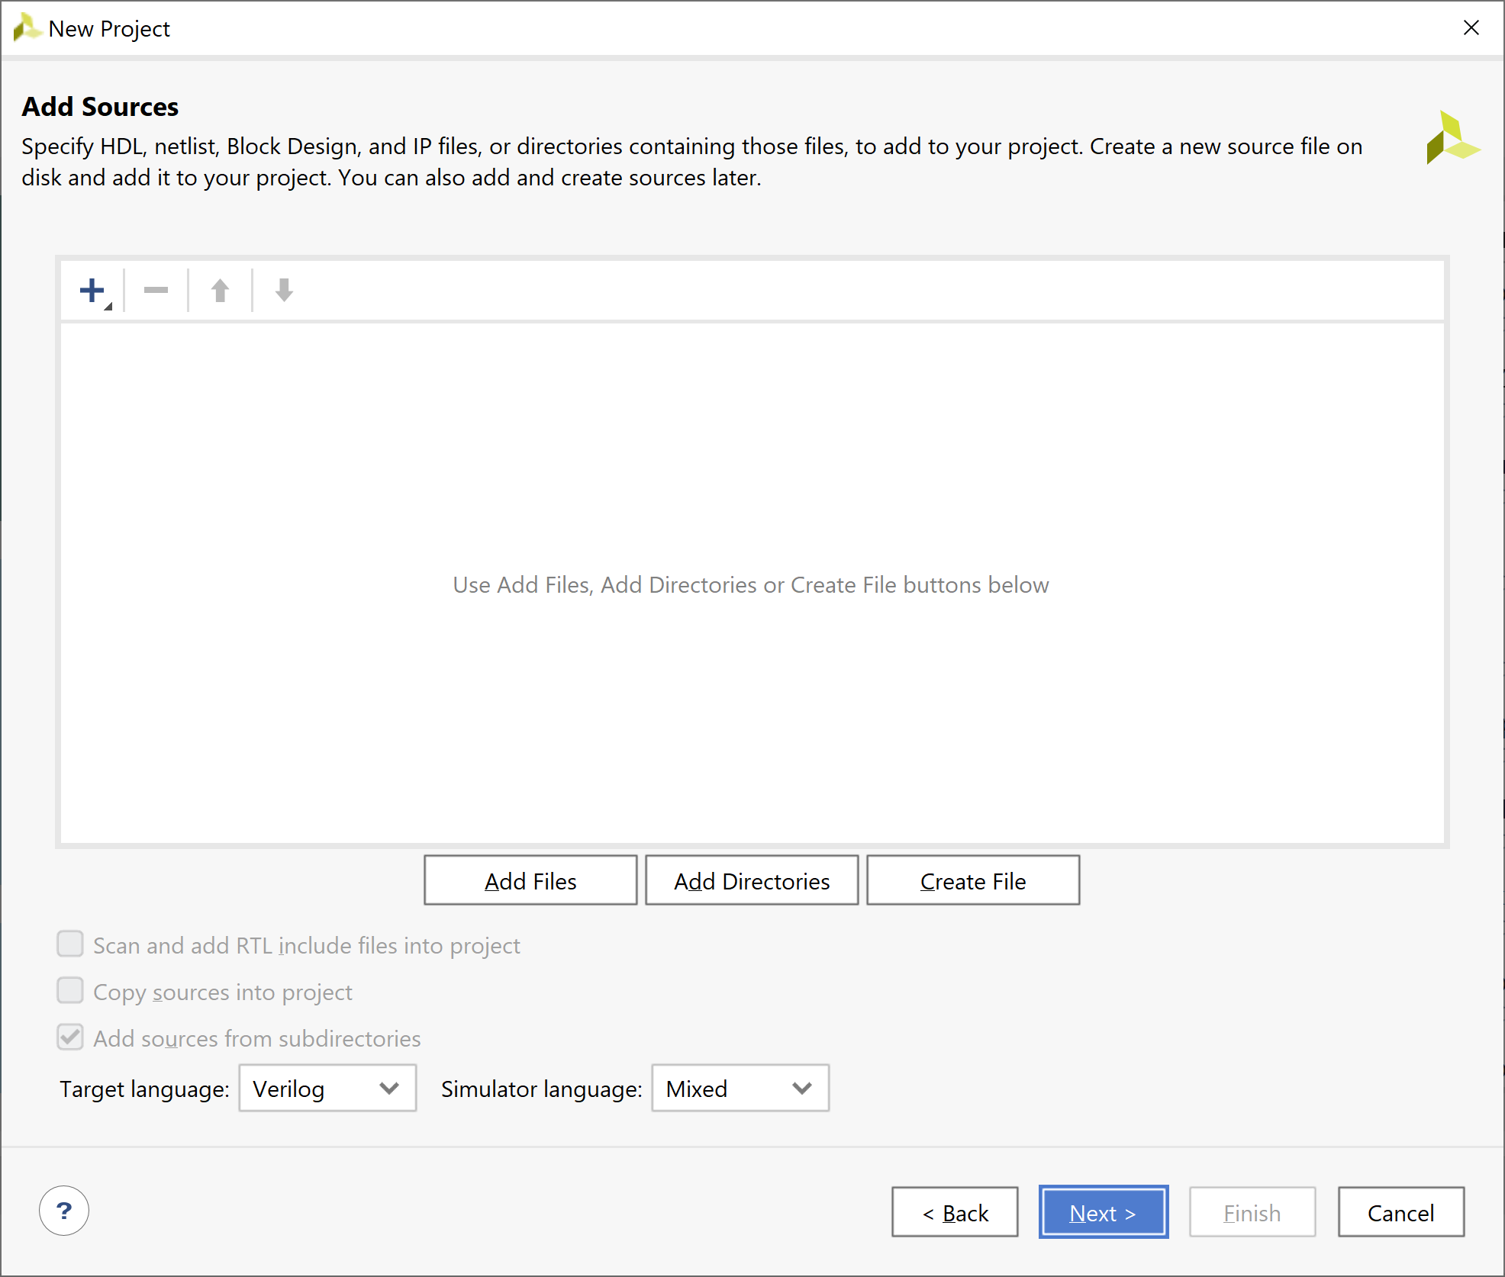

1. On the next page click next – we have no constraints to add

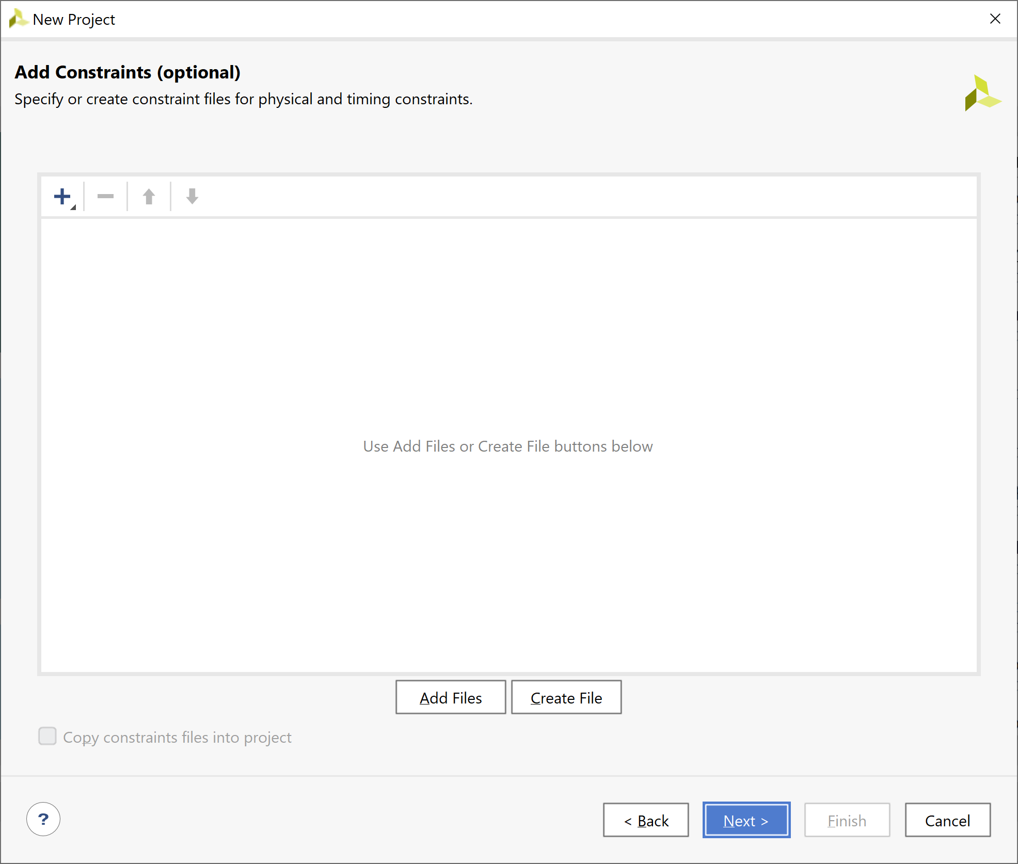

1. On the next dialog select the boards tab, TUL as the vendor and the Pynq-Z2 as the target board

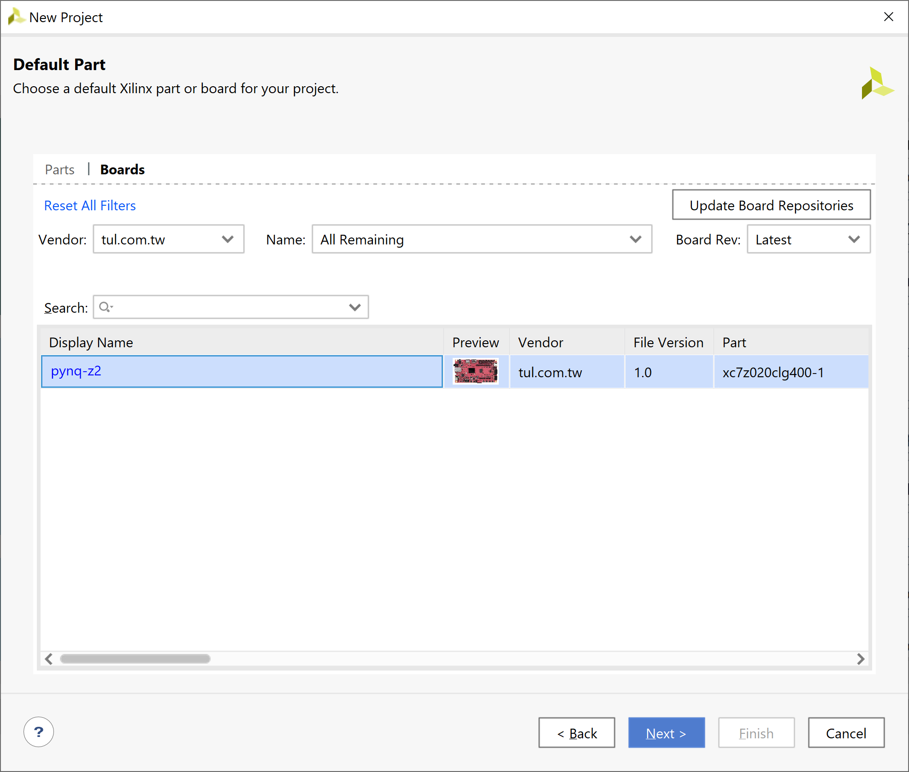

1. On the summary page select finish

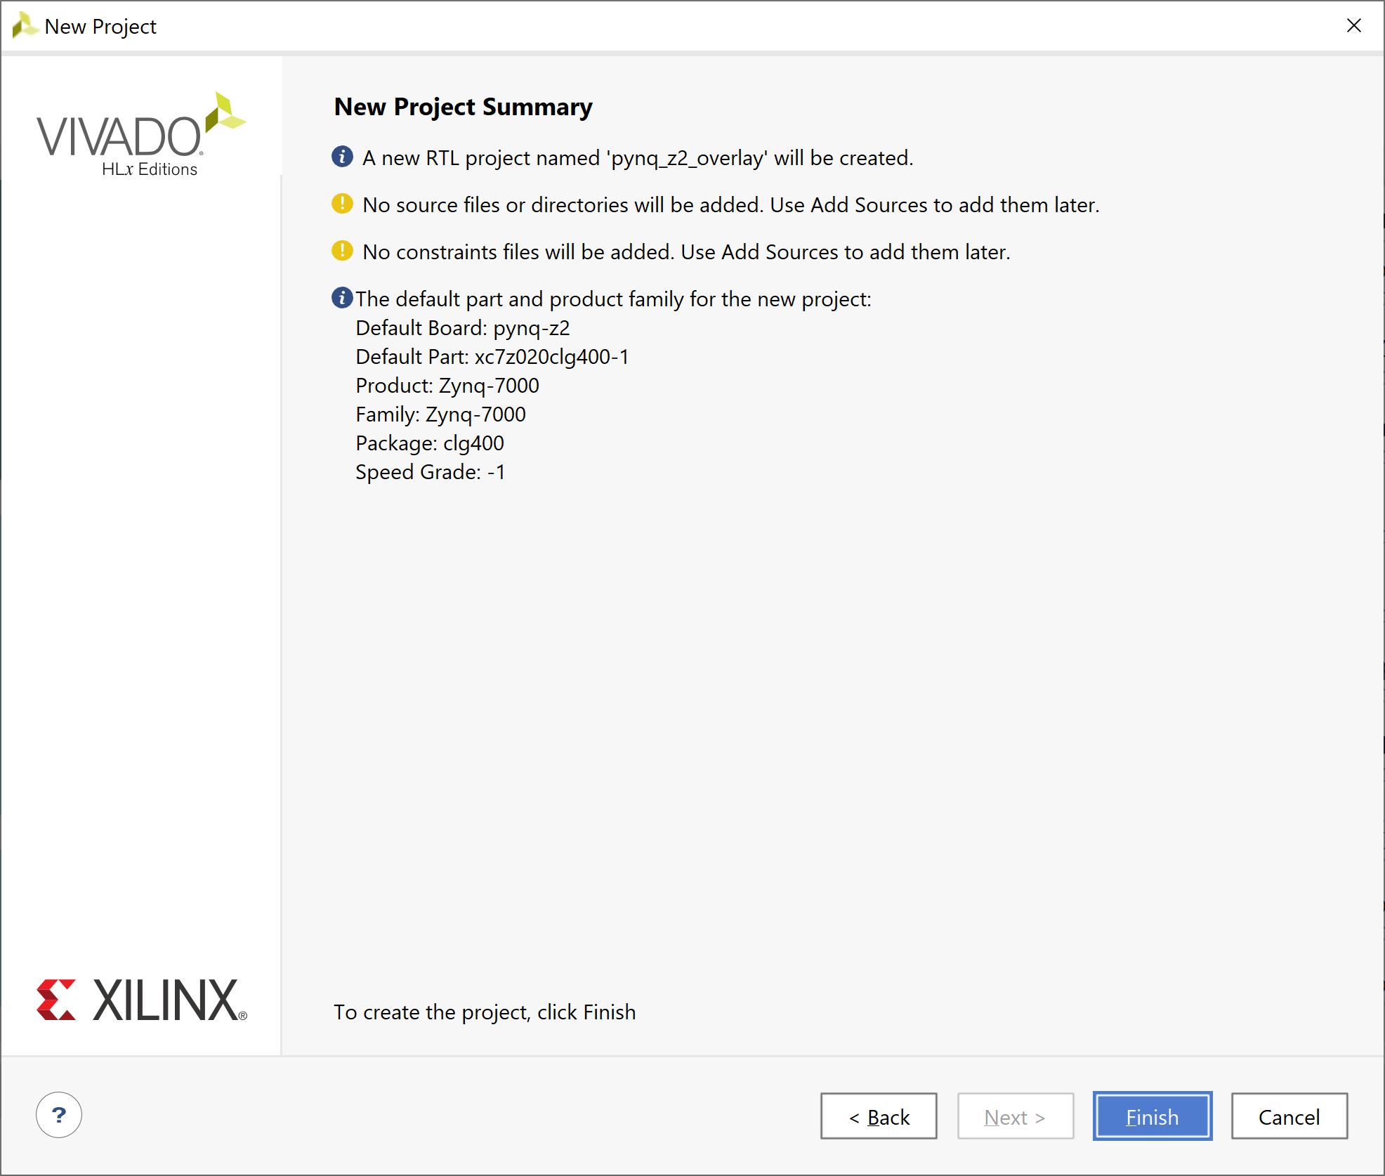

1. Once the project is open, click on create block diagram, leave the name as default

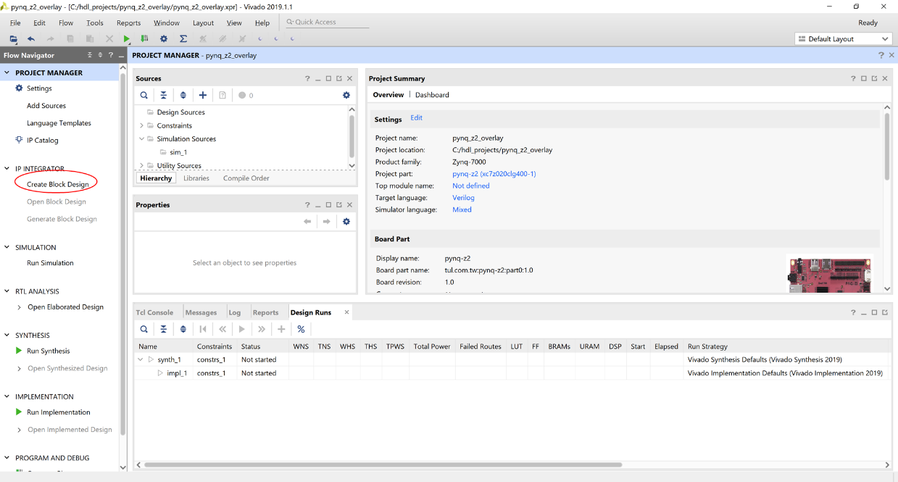

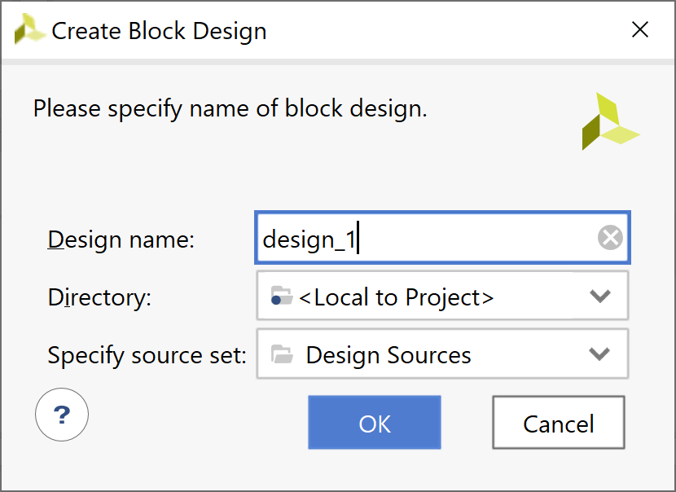

1. Once the block diagram is open click on the + symbol and add in a Zynq processing system

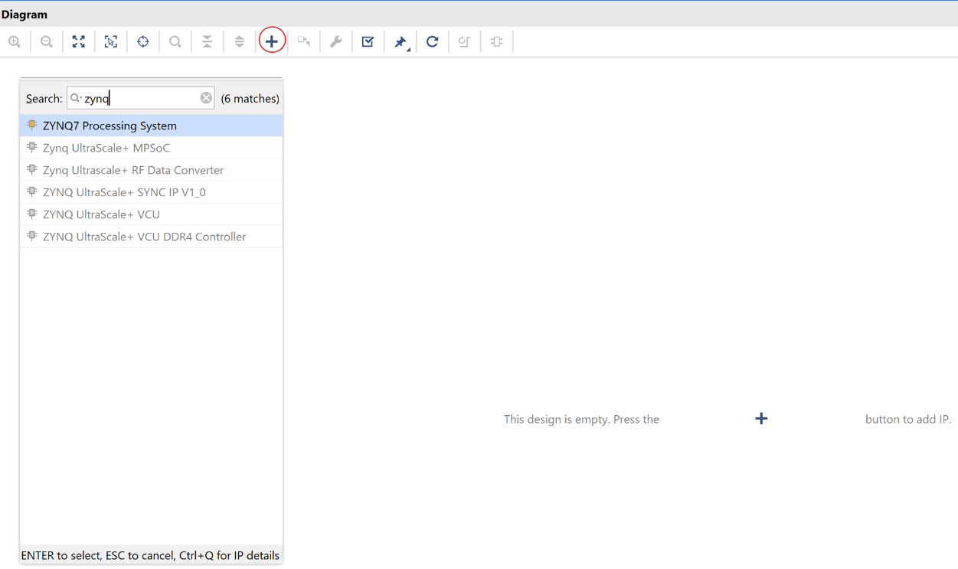

1. Once the Zynq PS is added to the block diagram, run the block automation the Zynq PS for the settings of the Pynq-Z2

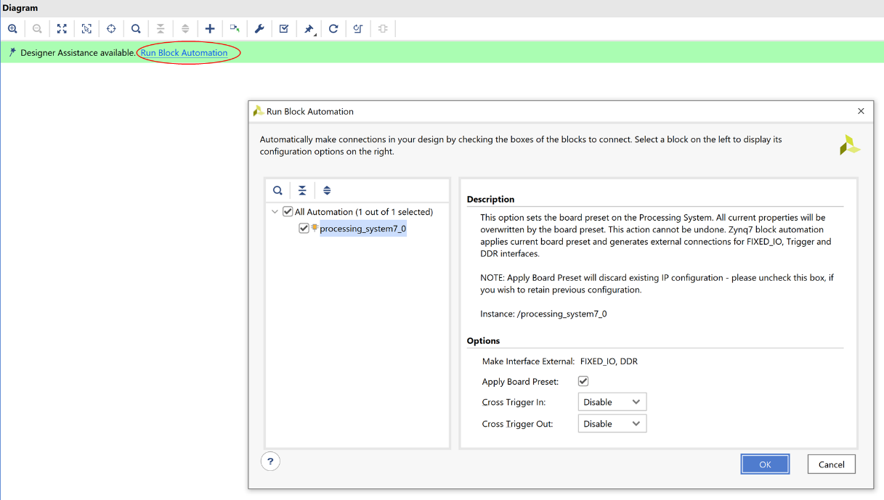

1. Click on OK and wait for the automation to complete. Once completed minimize Vivado
2. Open a web browser and navigate to [www.Pynq.io](http://www.Pynq.io)
3. Click on Source code

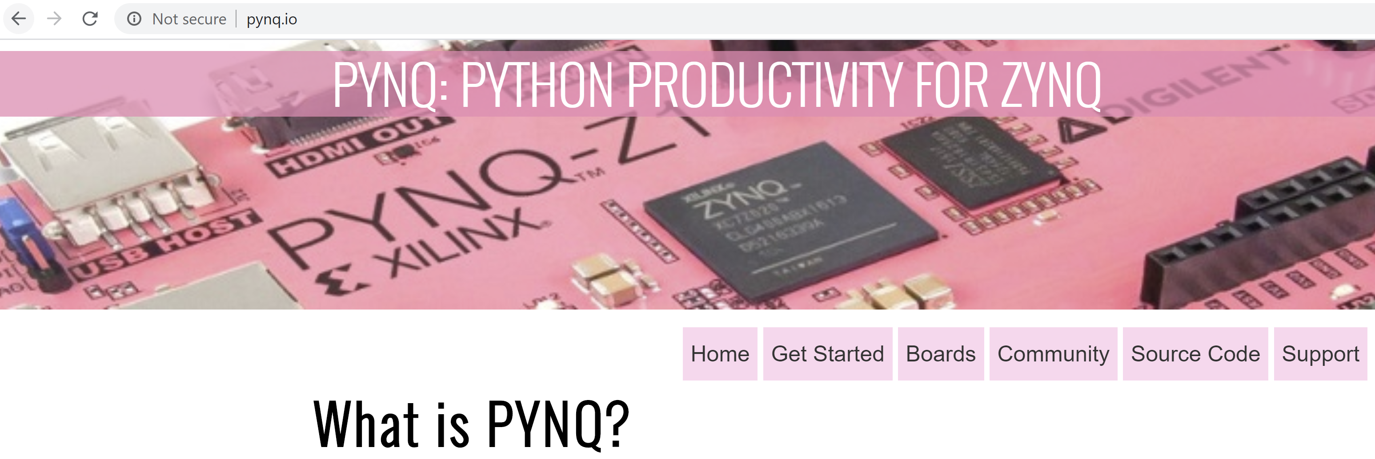

1. This will open a Xilinx Gut Hub page, select the option to download as a Zip file

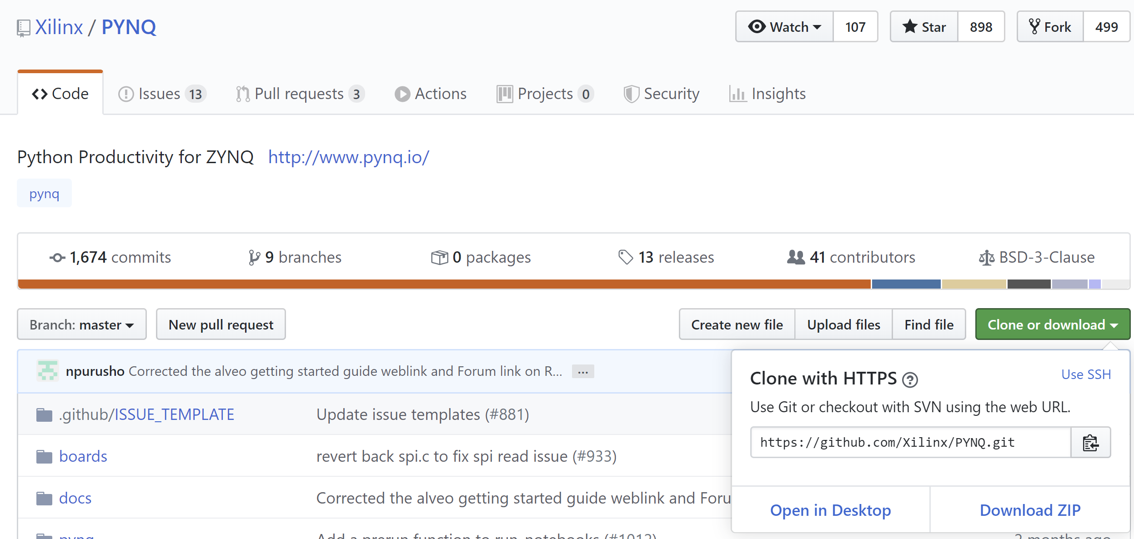

1. Download the zip to your computer, I saved mine within the Vivado project

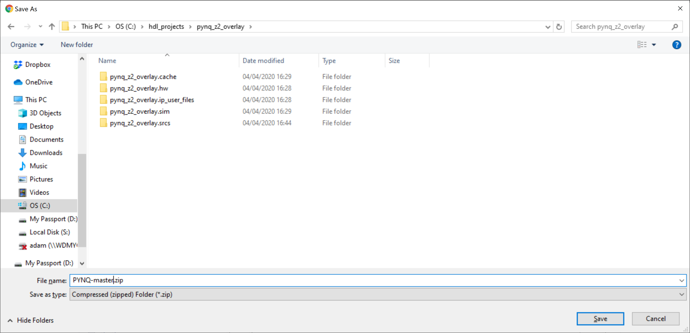

1. Extract the just downloaded zip file

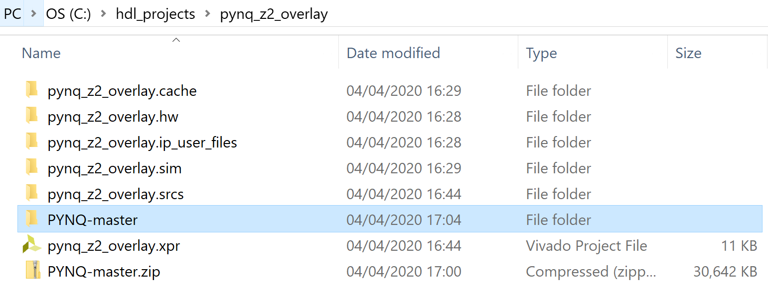

1. Open the PYNQ-Master folder and navigate to \PYNQ-master\boards\ip\hls

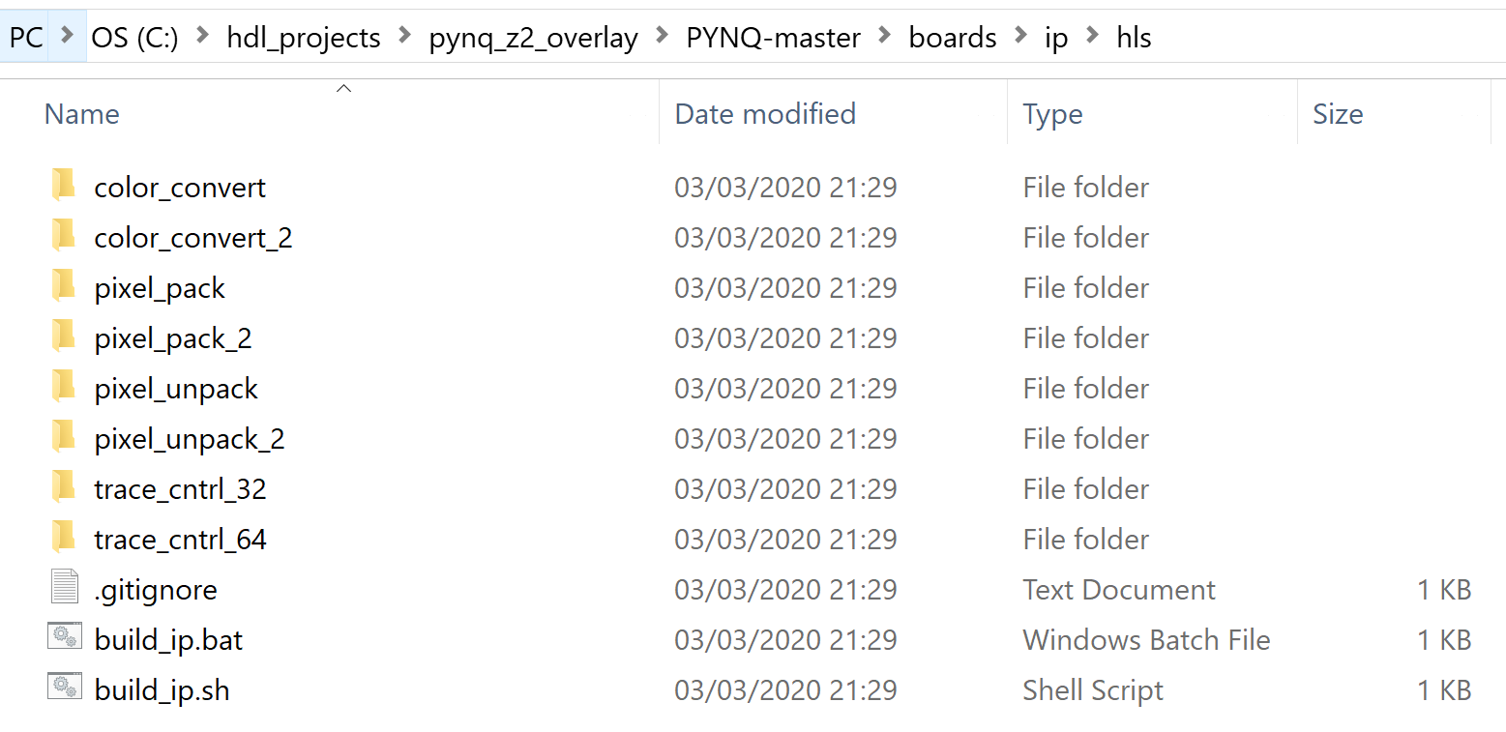

1. Double click on the build_ip.bat this will build the HLS IP we need to use in our project

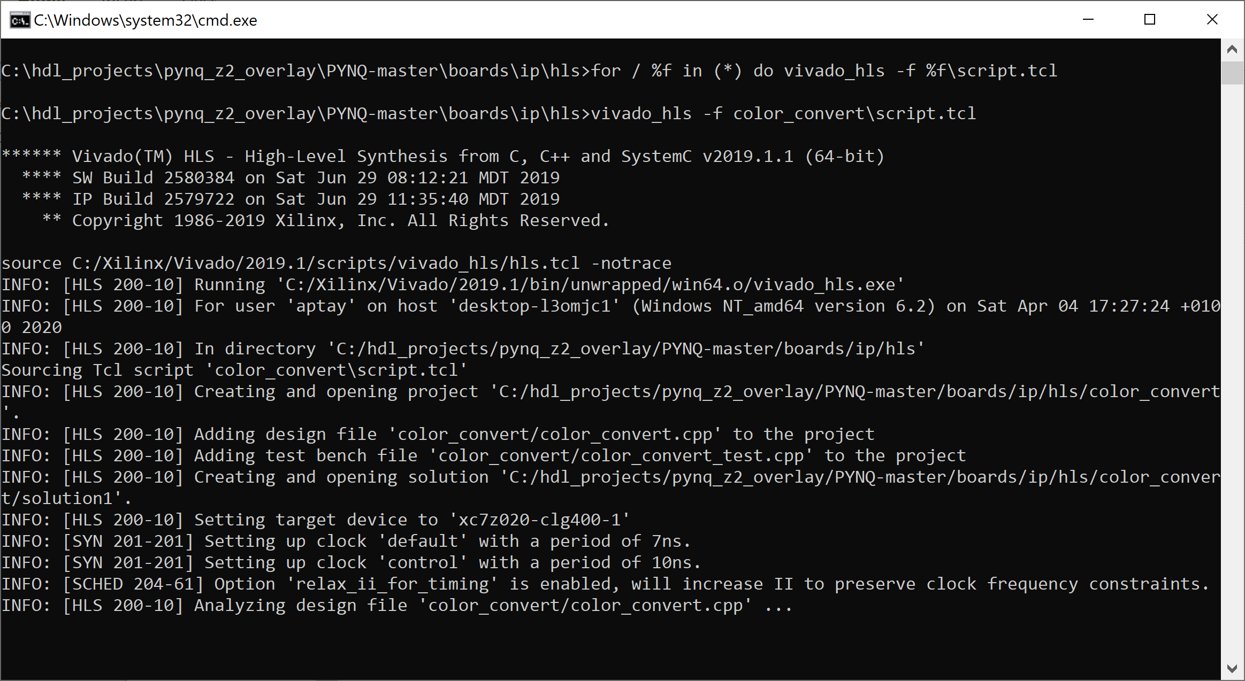

1. Once these IP have built we need to add in the IP created to our Vivado project so we can use it. Click on the settings tab and select IP repository

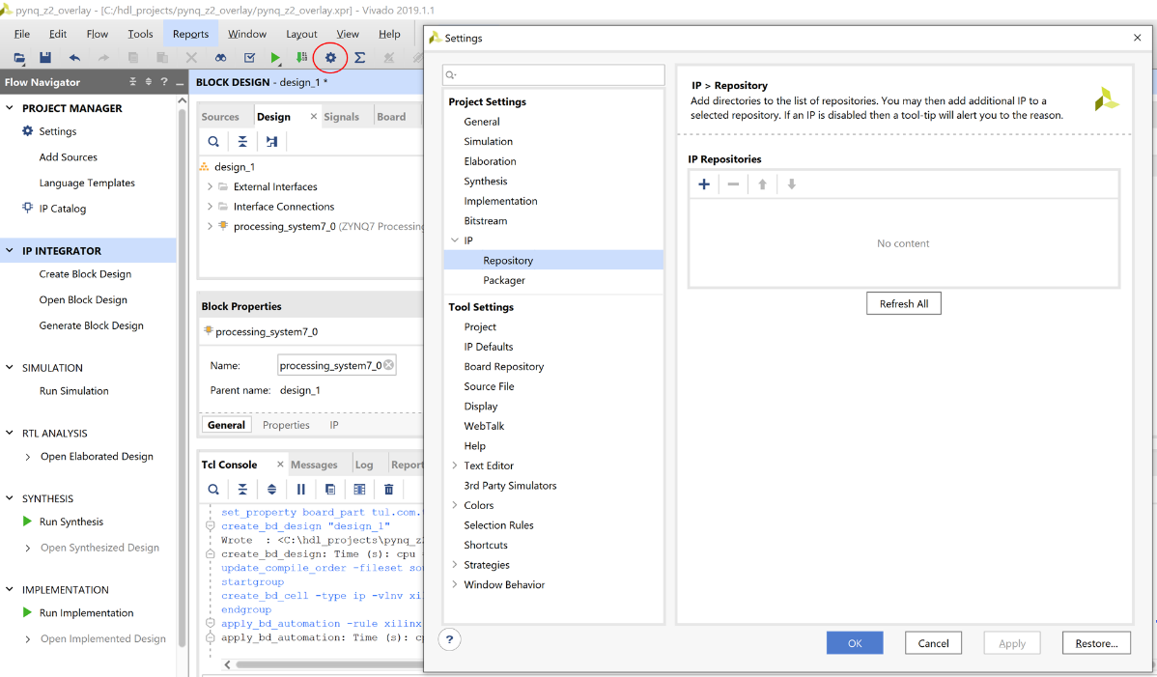

1. To add a new repository, select the + and add in the PYNQ IP repository

<save directory>pynq_z2_overlay\PYNQ-master\boards\ip

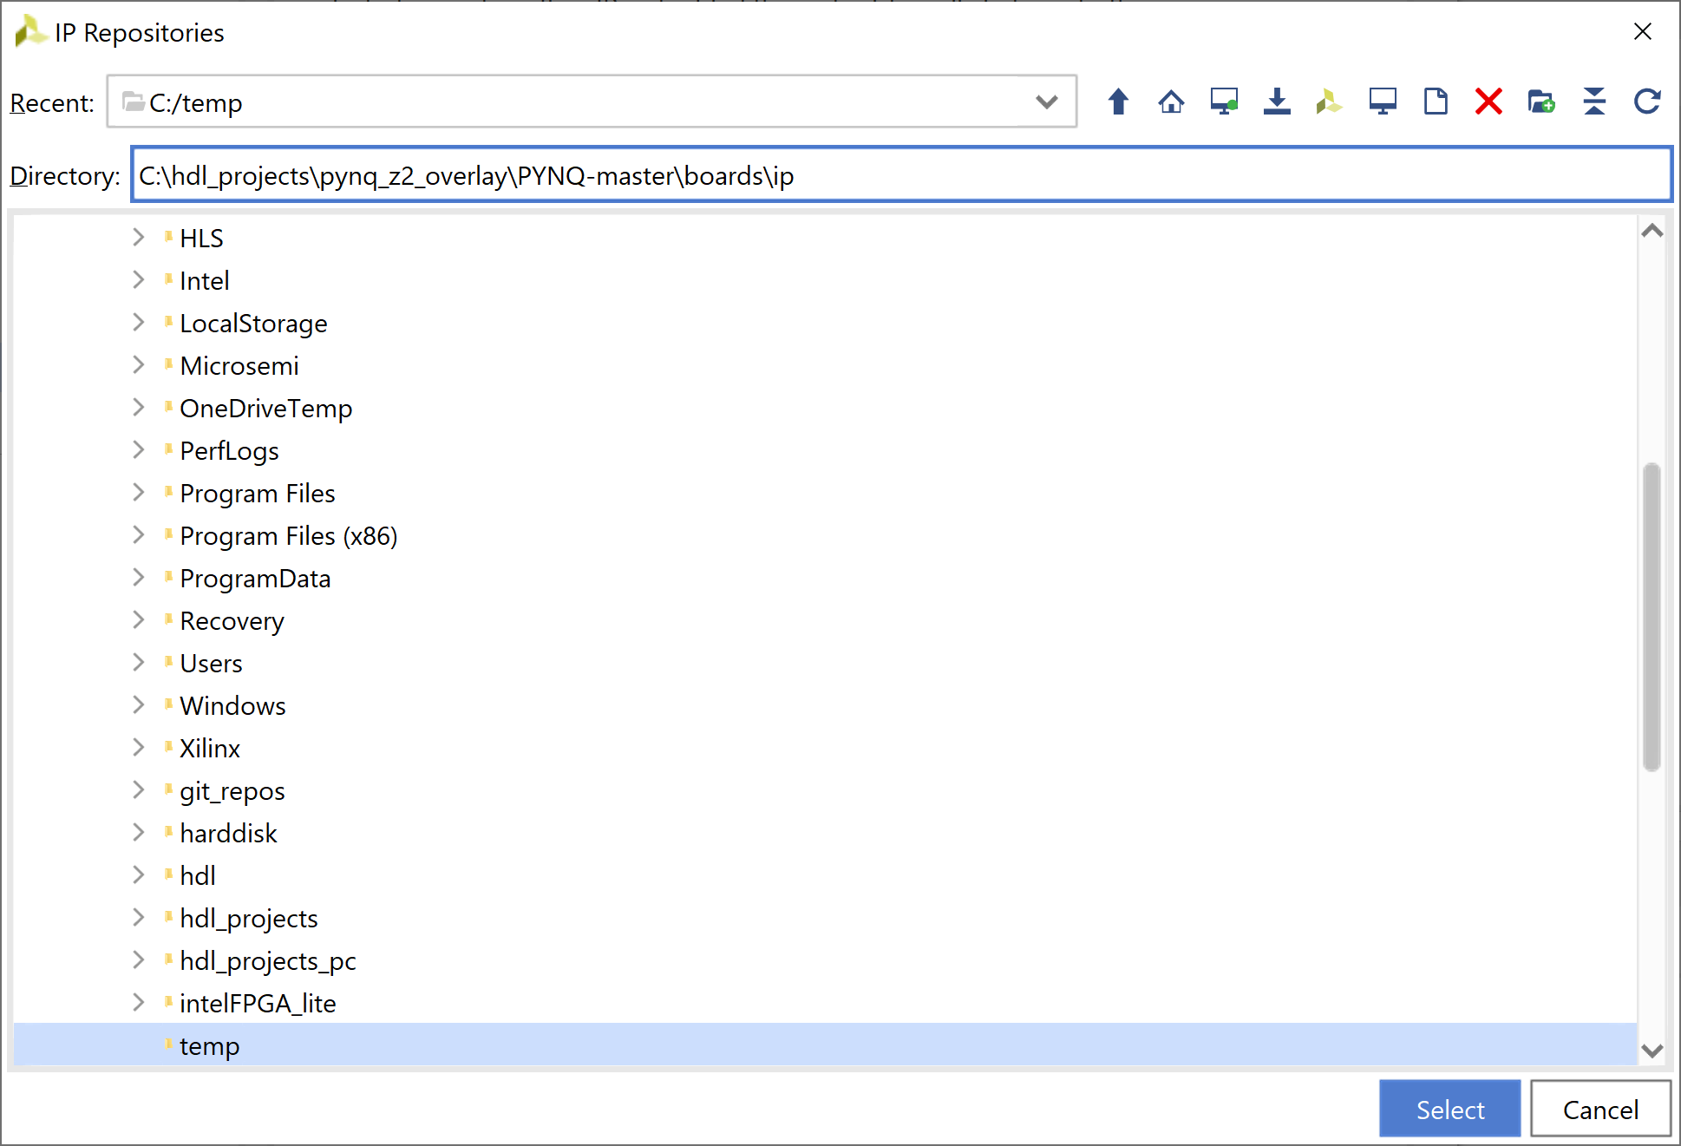

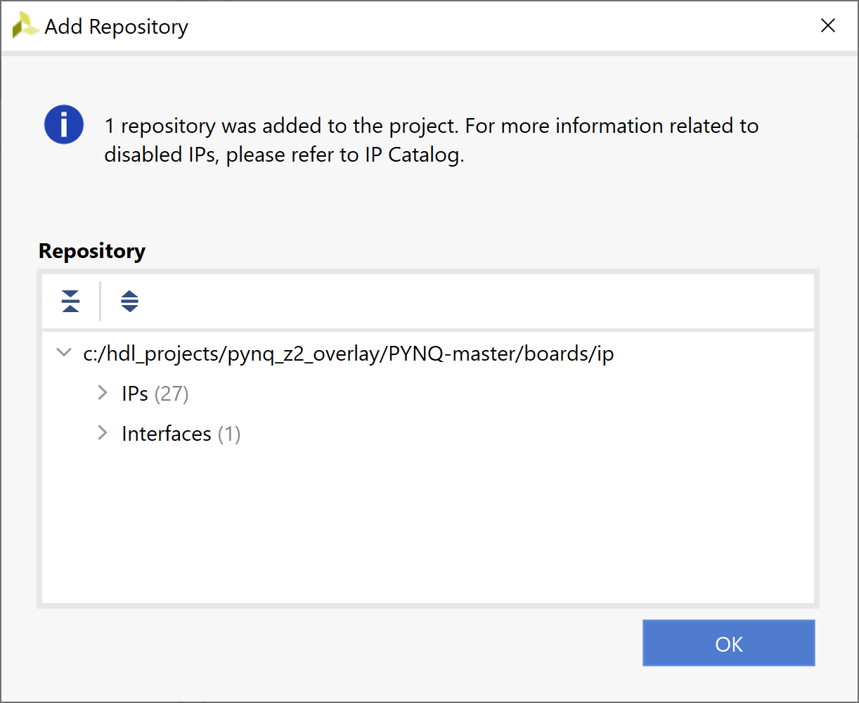

1. We are now able to add in PYNQ IP into our block diagram, add in the following IP
   1. Color Convert
   2. Pixel Pack
   3. VDMA
   4. Test Pattern Generator

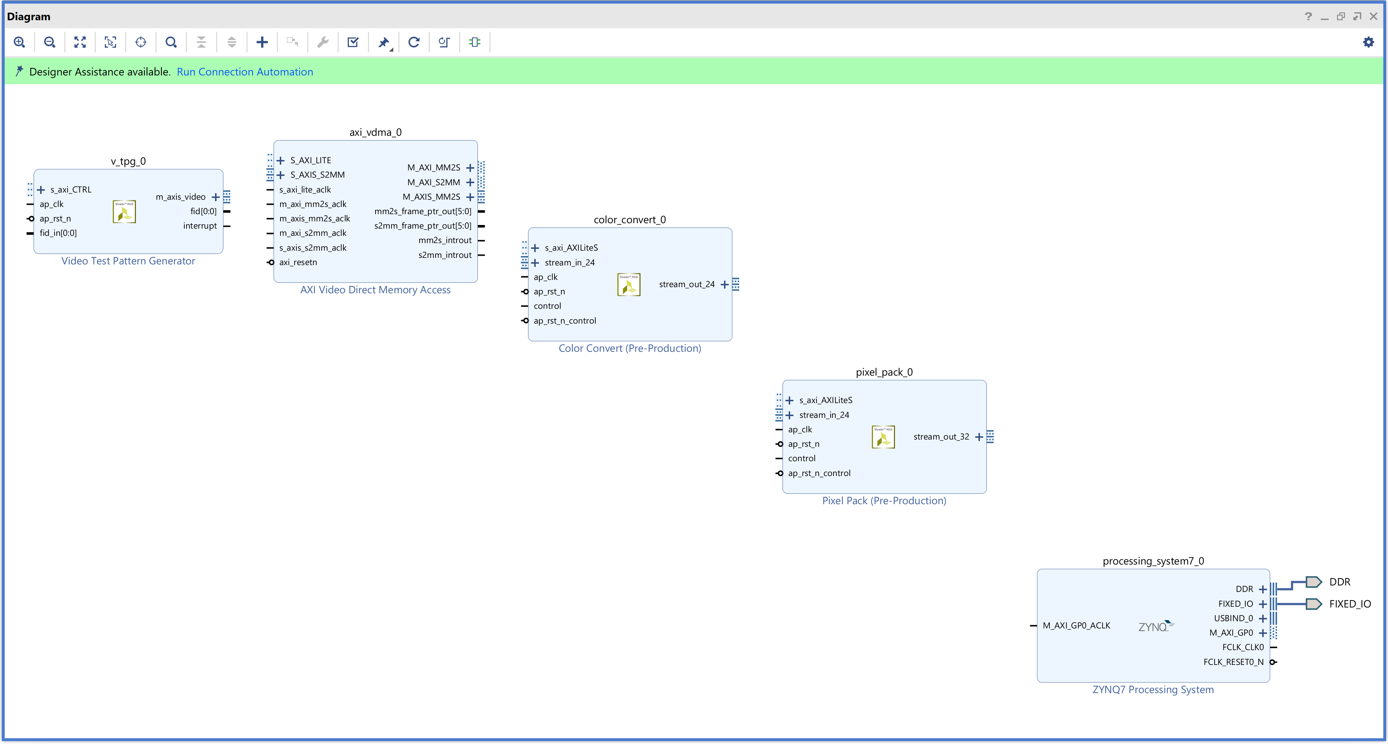

1. Click on the Run Connection Automation, in the dialog which opens select all for automation

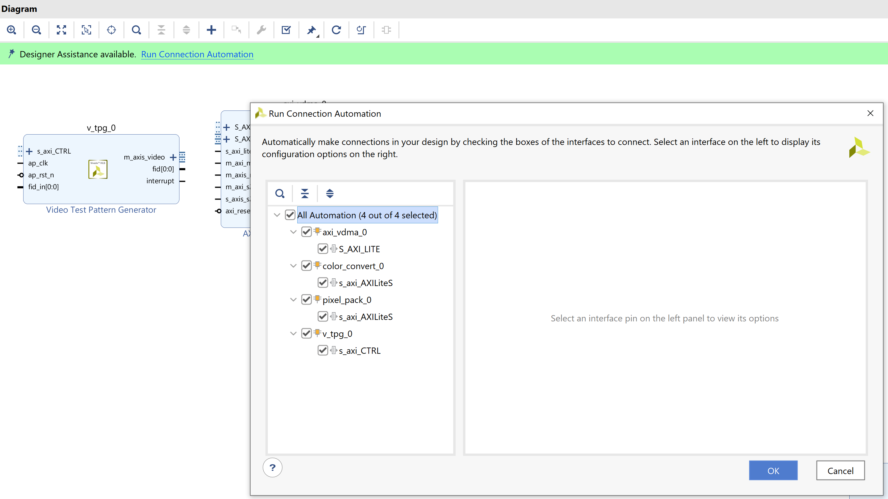

1. Double Click on the Zynq processing system for reconfiguration and select PS/PL interfaces, enable one of the slave interfaces.

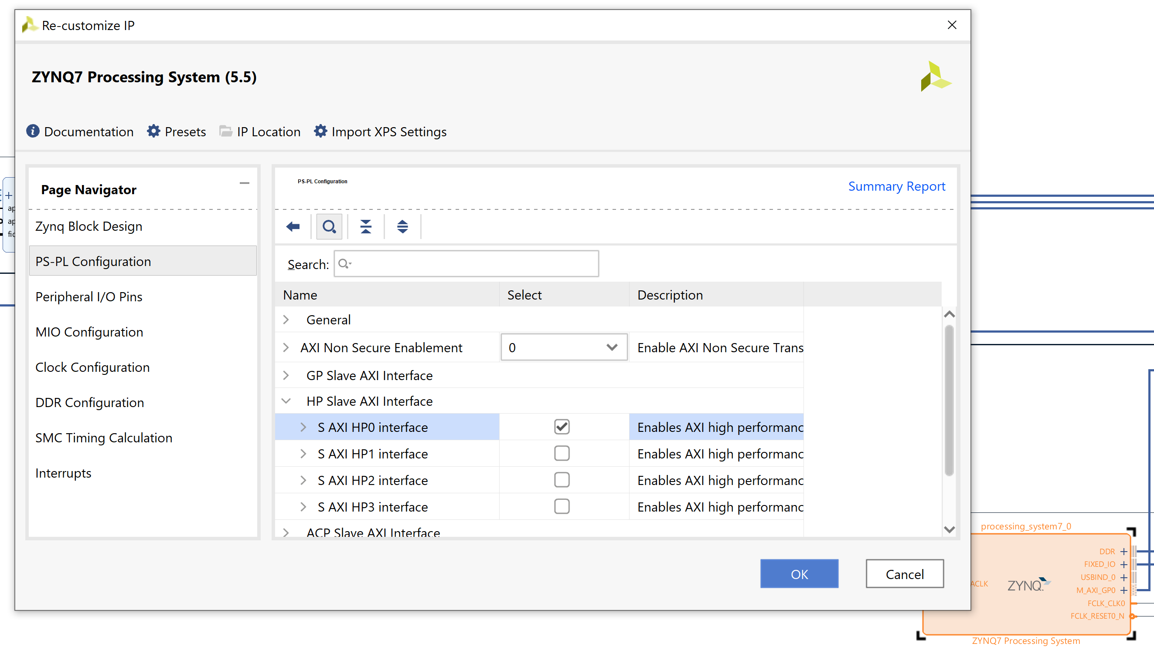

1. While here also select interrupts from the left handside and enable fabric interrupts, enable PL-PS IRQ_F2P[15:0]

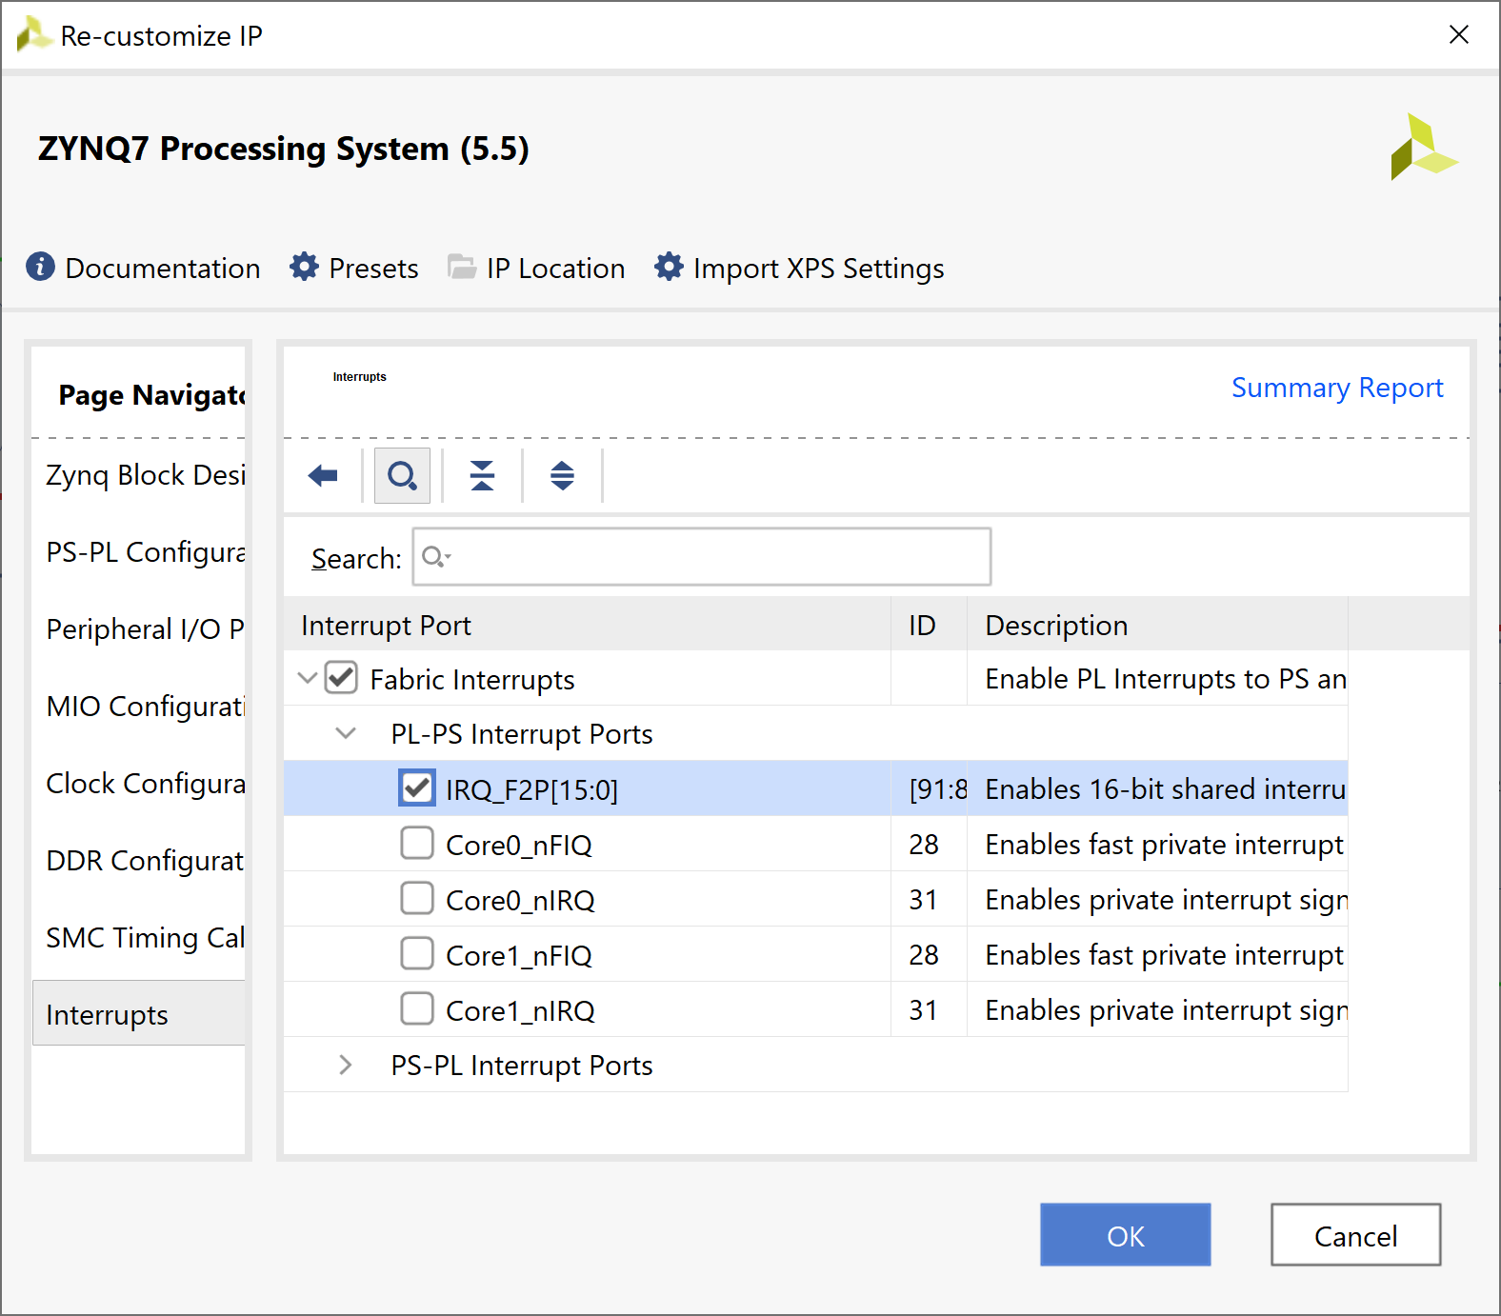

1. Run the connection automation again, select S_AXI_HP0 on the left hand side and select the master as axi_vdma_0/M_AXI_S2MM

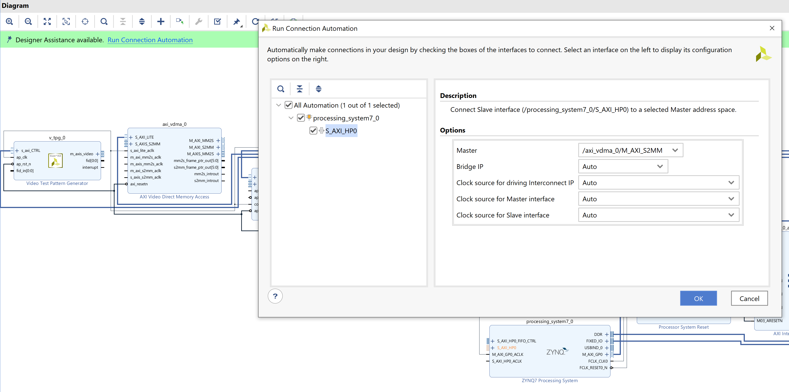

1. Double click on the VDMA to reconfigure the VDMA select 4 frame buffers and write and read burst sizes of 32.

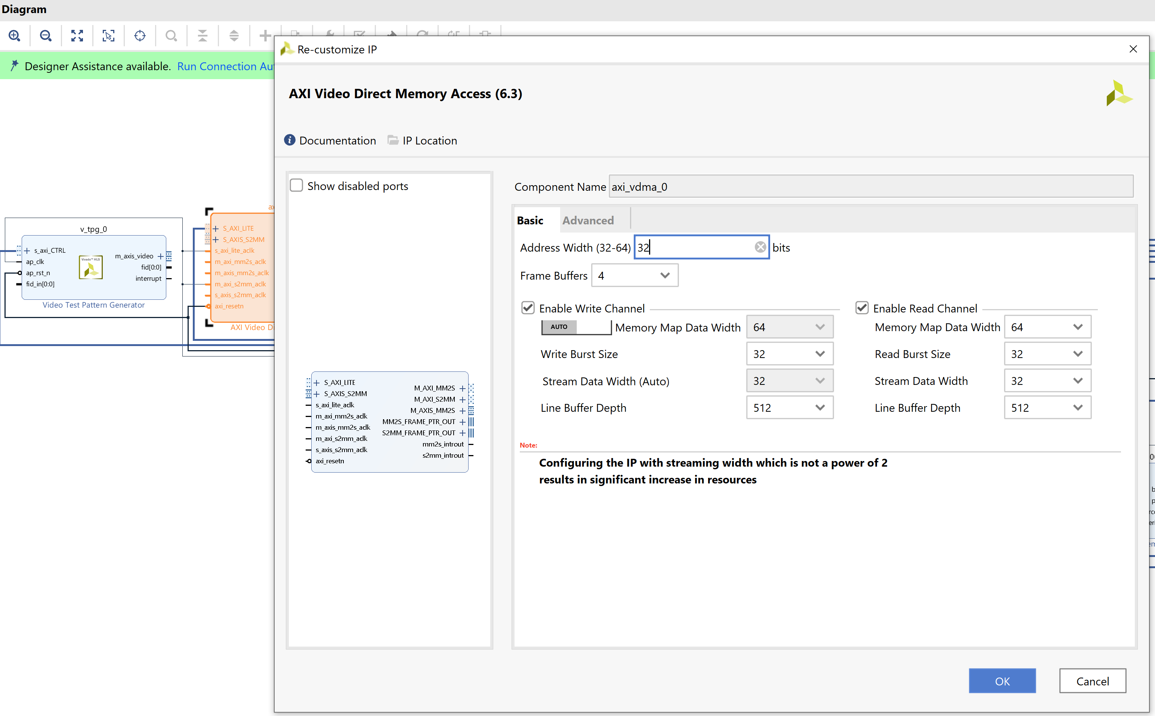

1. Double click on the Smart Interconnect and enable 2 slave ports

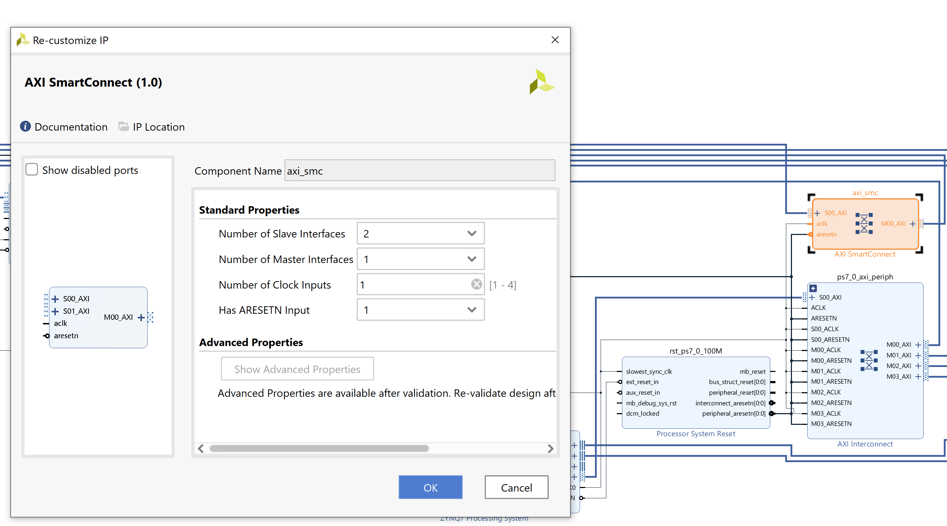

1. Connect the VDMA M_AXI_MM2S port to the S01_AXI on the Smart Interconnect

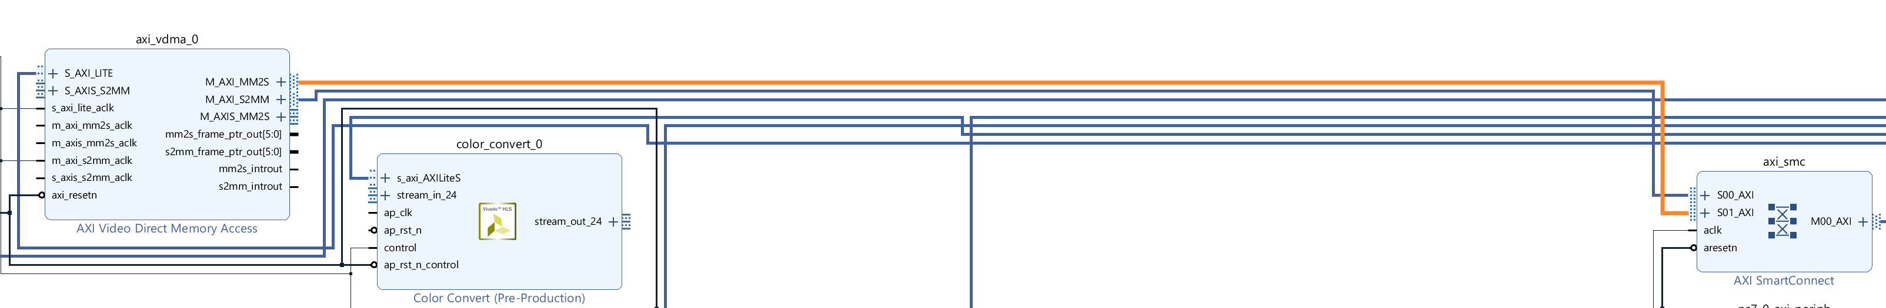

1. The next step is to connect the video stream together, connect the following
   1. (TPG) m_axis_video -> stream_in_24 (color convert)
   2. (color convert) stream_out_24 -> stream_in_24 (pixel pack)
   3. (pixel pack) stream_out32 -> S_AXIS_S2MM (VDMA)

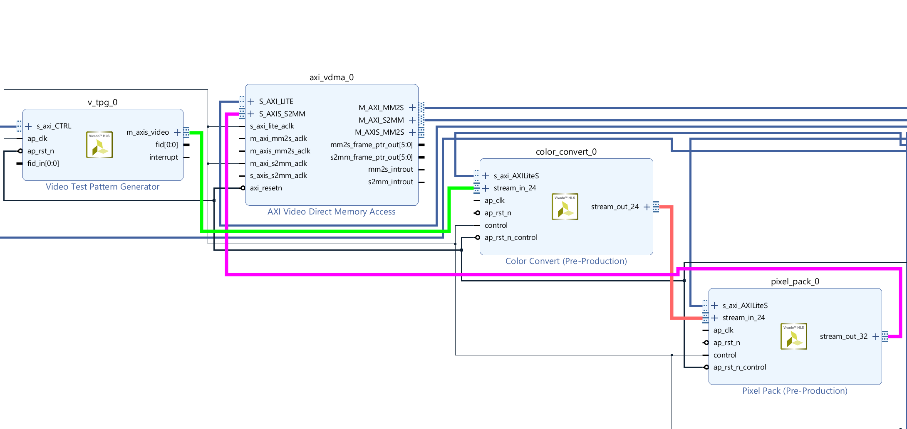

1. Connect the unconnected clock and reset on the color convert, pixel pack and vdma to the clock and reset already in the design

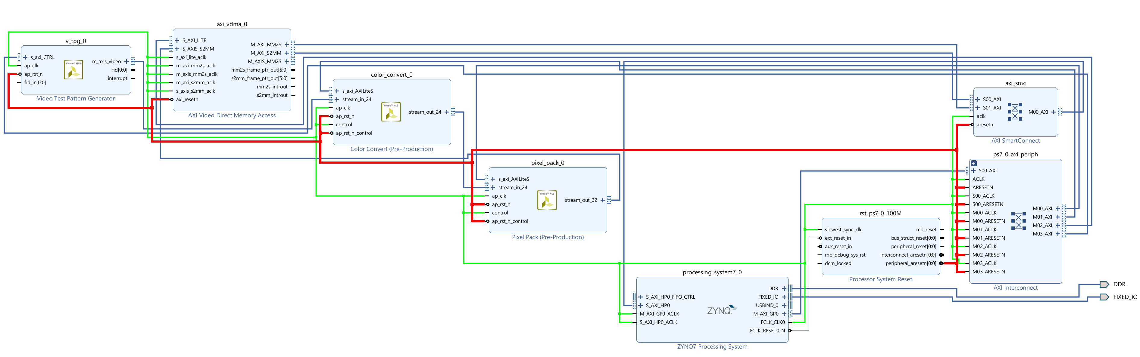

1. Click on the address tab and select auto assign addresses

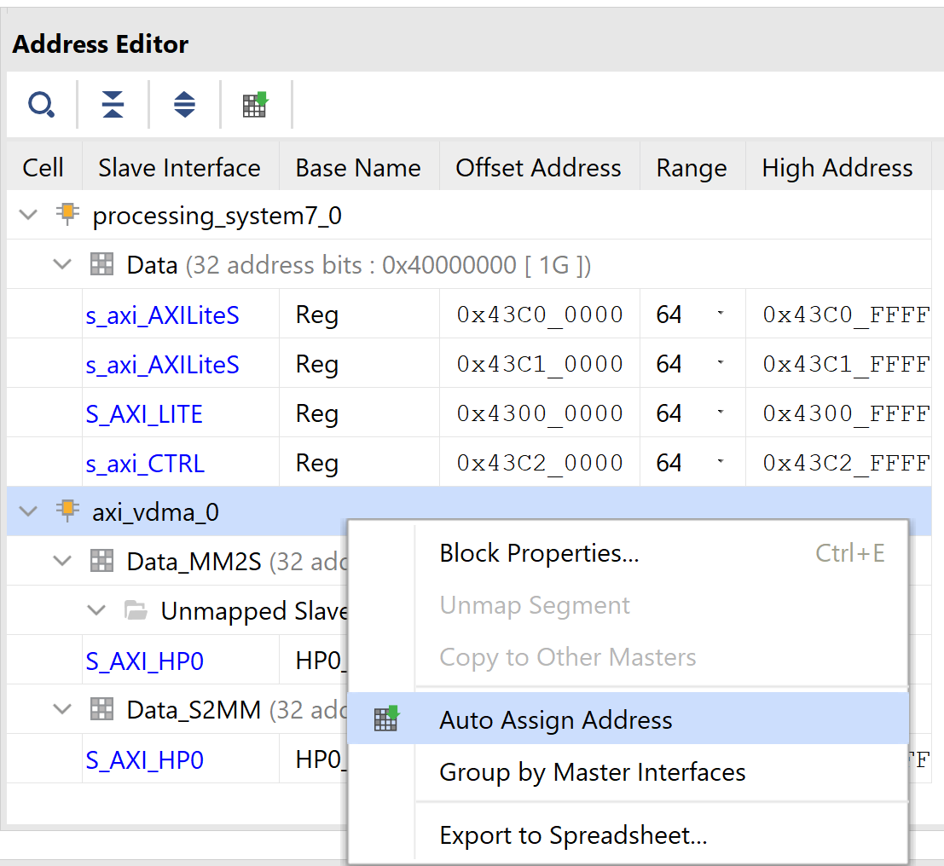

1. Using the add IP + button add in a AXI interrupt controller and run the connection automation to map it into the AXI Lite network

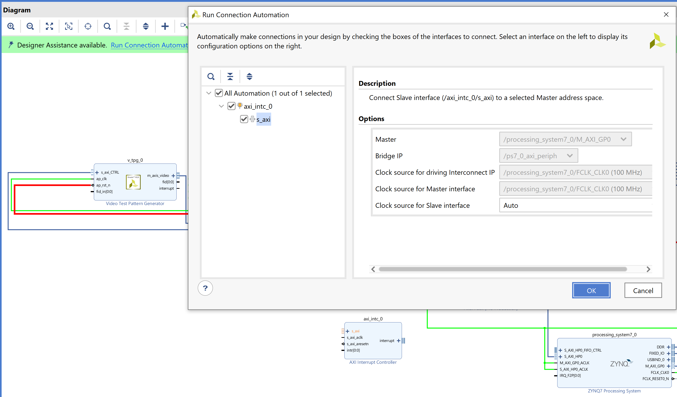

1. Add in a concat block from the add IP option – double click on it and select 3 input ports

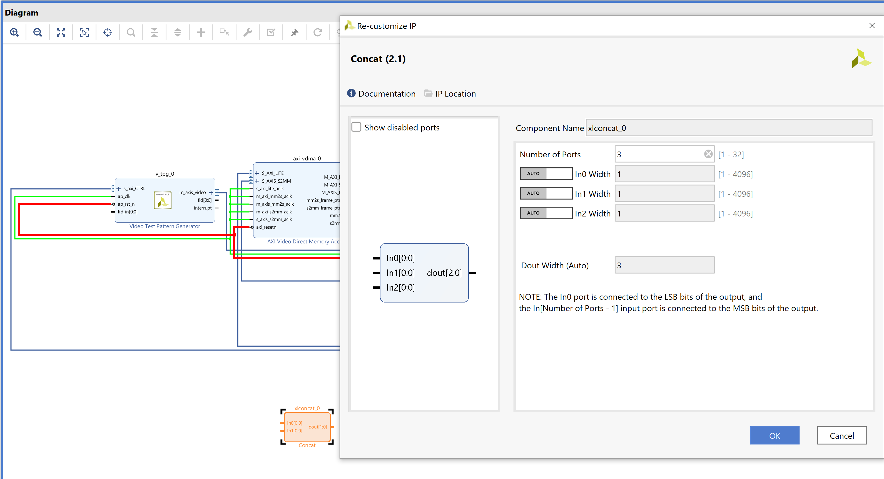

1. Connect the following signals to the Concat input blocks
   1. V_tpg Interupt
   2. Mm2s_introut
   3. S2mm_introut
2. Connect the output of the concat block to the interrupt input on the AXI Interrupt controller and connect the output of the AXI interrupt controller to the ZYNQ interrupt input.

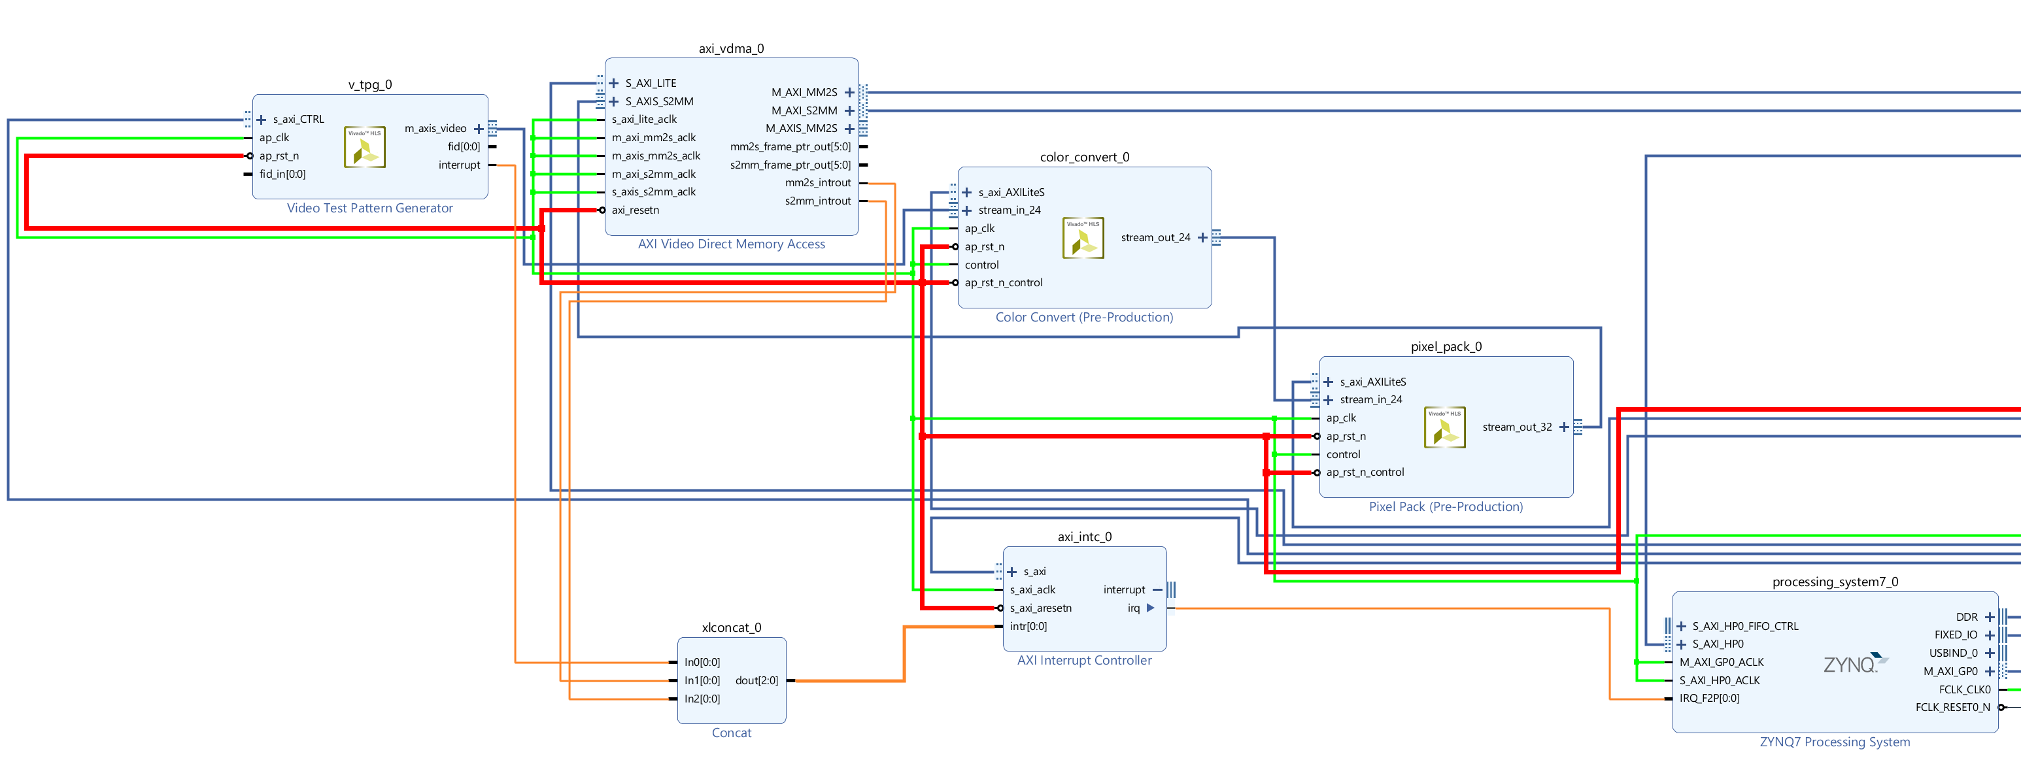

1. Validate the block diagram

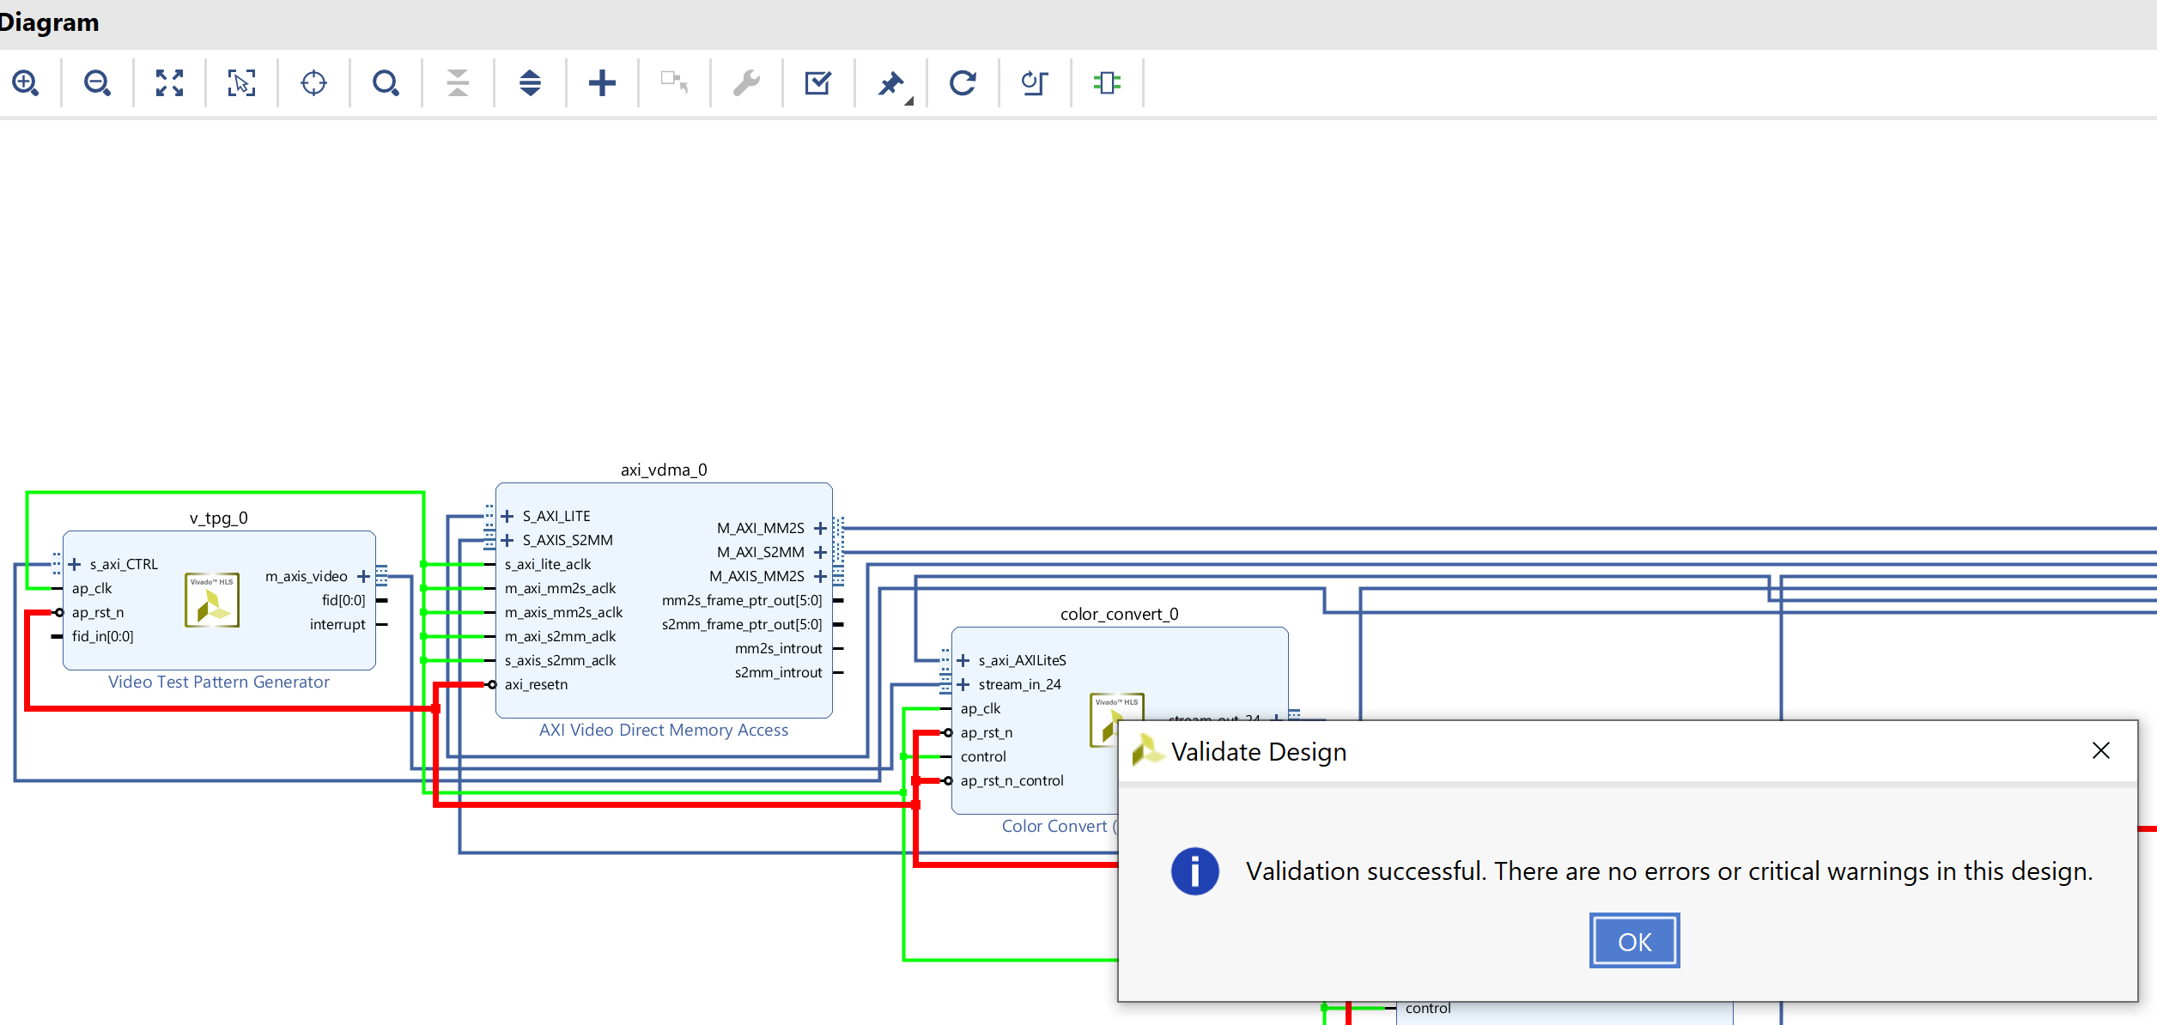

1. Save and close the block diagram, in the sources window right click on the block diagram and select create wrapper, when prompted let Vivado manage it.

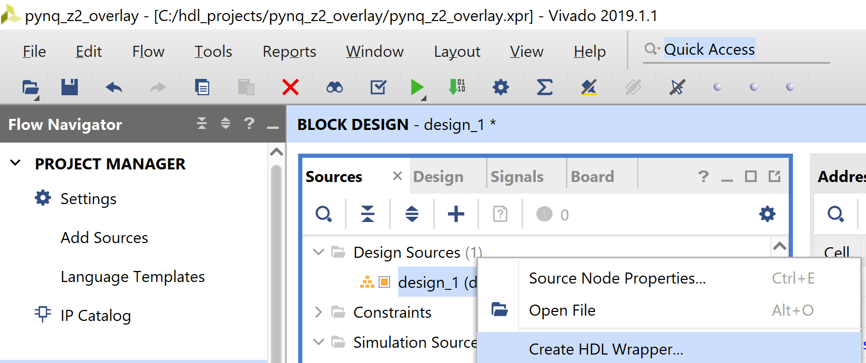

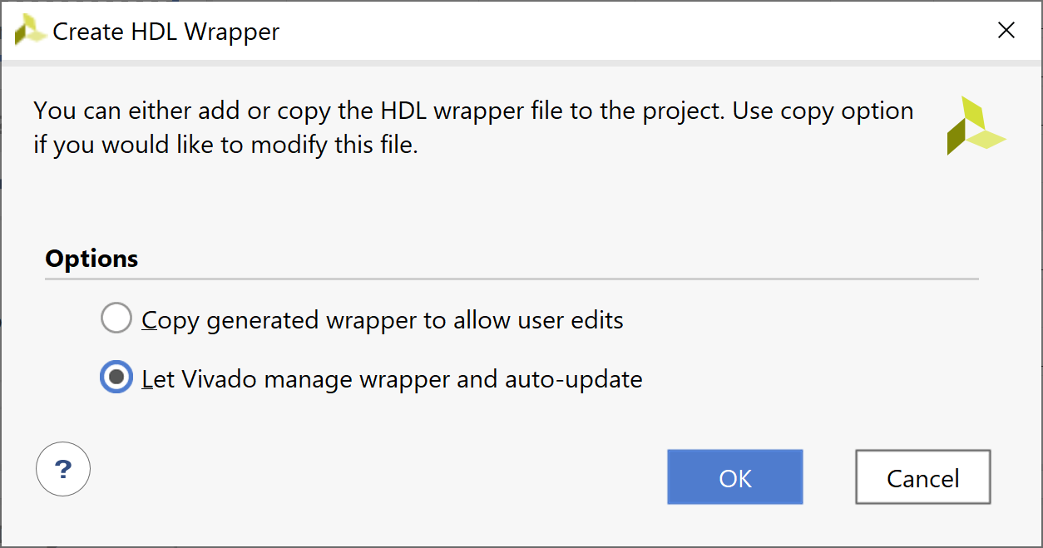

1. We can now built the design, click on generate bit stream – This may take a while

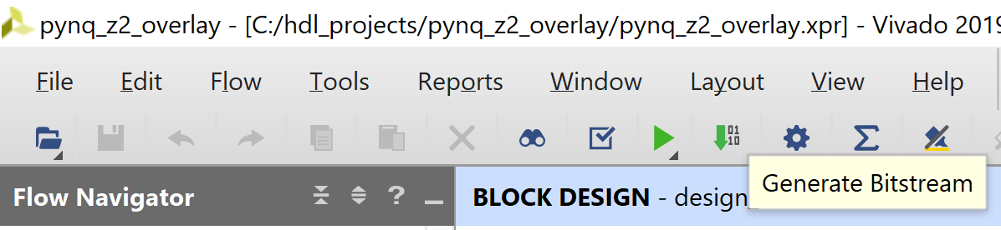

1. Wait until you see the Bit Stream Complete in Vivado

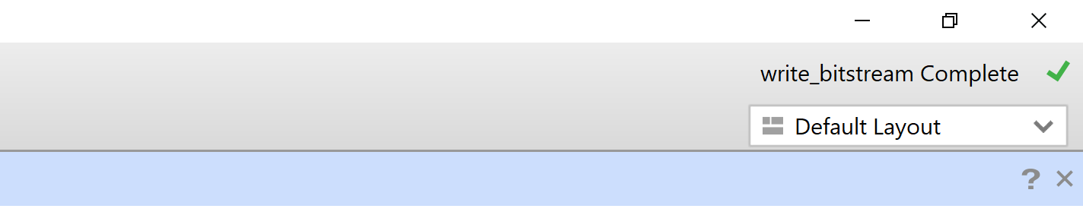

1. In the same directory as your Vivado project create a new directory called tpd_pynq

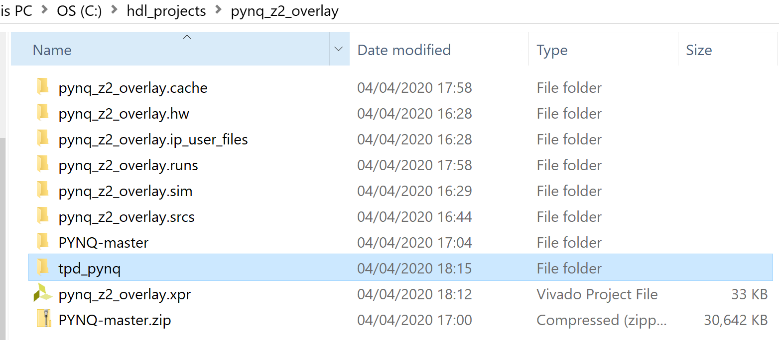

1. From the runs/implementation directory copy across the bit file into the directory just created

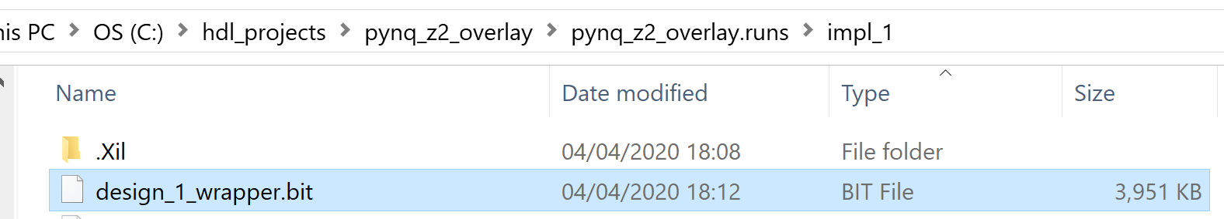

1. From under the sources hardware hand off directory copy across the tcl and hwh file into the new directory

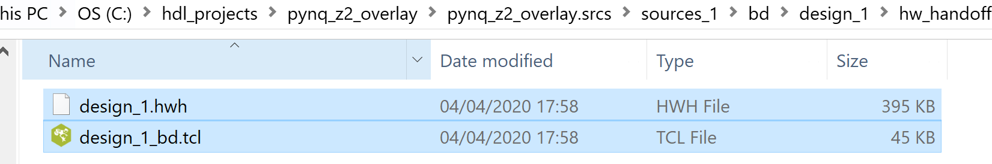

1. Rename the files in the tpd_pynq directory as tpd_pynq.***

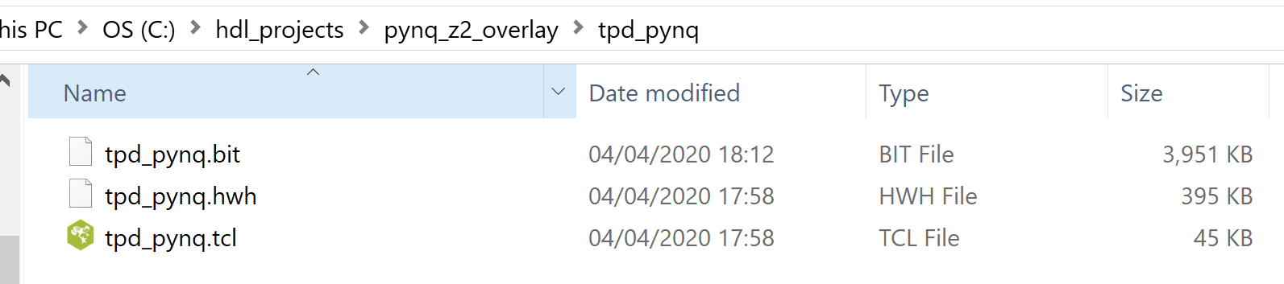

1. Create a new file in the tpd_pynw directory called tpg_pynq.py and copy in the code below

import pynq

from pynq import GPIO

__author__ = "Adam Taylor"

__copyright__ = "Copyright 2020, Adiuvo"

__email__ = "Adam@adiuvoengineering.com"

class tpd_pynqOverlay(pynq.Overlay):

""".

"""

def __init__(self, bitfile, **kwargs):

super().__init__(bitfile, **kwargs)

if self.is_loaded():

pass

1. Create a new file in the tpd_pynq directory called __init__.py copy in the code below

from .tpd_pynq import tpd_pynqOverlay

1. We are now ready upload the overlay to our PYNQ-Z2 power up the board and open WinSCP use the name of Pynq and the username and password of Xilinx

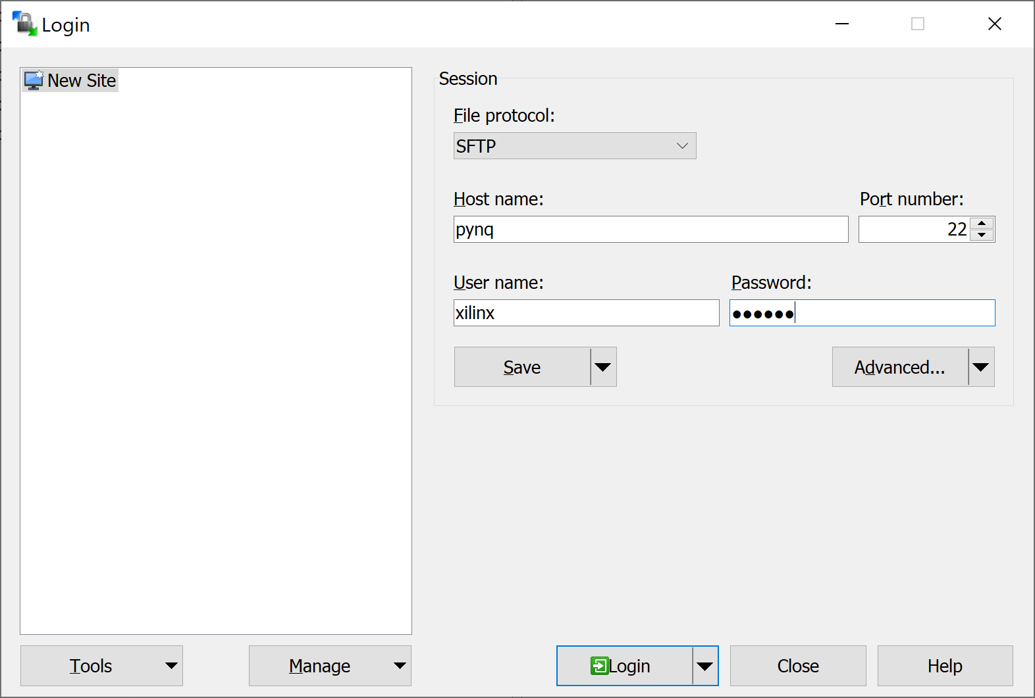

1. In WinSCP on your computer on the lefthand side select the tpd_pynq directory on the target navigate to the pynq/overlays upload the tpd_pynq directory

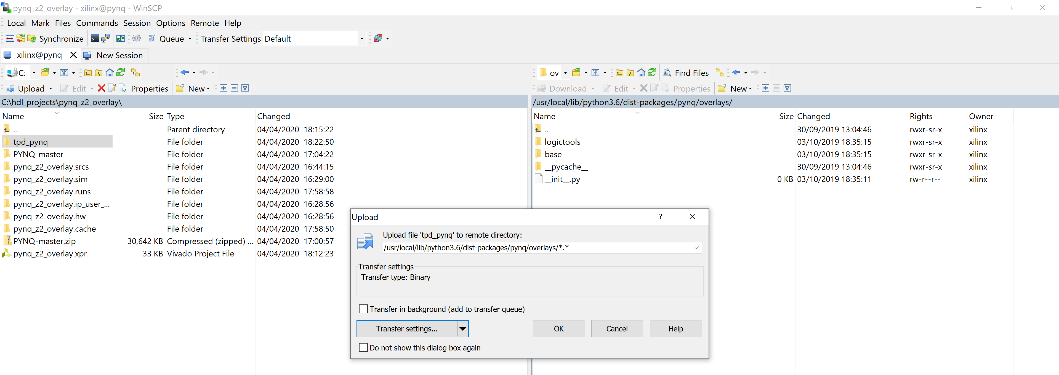

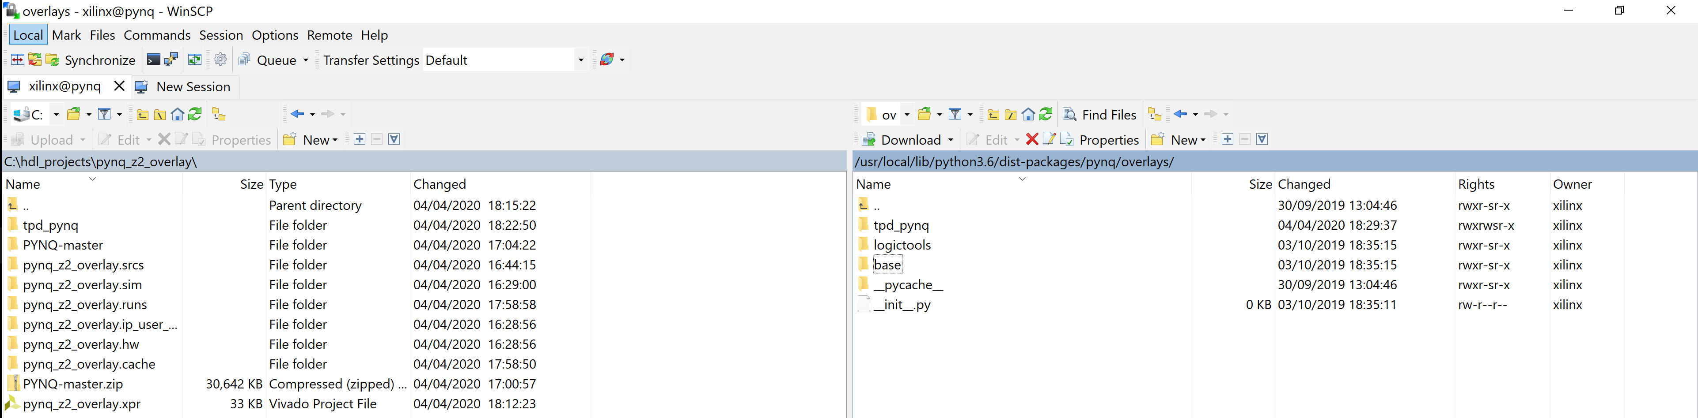

1. Using a browser open the Jupyter environment and on the home page create a new Python 3 notebook called tpd.ipynb Add in the code below

import time

from pynq.overlays.tpd_pynq import tpd_pynqOverlay

import numpy as np

from pynq import pl

from pynq import overlay

from pynq.lib.video import *

from pynq import Xlnk

import cv2

import matplotlib.pyplot as plt

overlay = tpd_pynqOverlay('tpd_pynq.bit')

pixel_in = overlay.pixel_pack_0

pixel_in.bits_per_pixel = 24

colourspace_in = overlay.color_convert_0

rgb2bgr = [0.0, 1.0, 0.0,

1.0, 0.0, 0.0,

0.0, 0.0, 1.0,

0.0, 0.0, 0.0]

colourspace_in.colorspace = rgb2bgr

cam_vdma = overlay.axi_vdma_0

lines = 512

framemode = VideoMode(640, lines, 24)

cam_vdma.readchannel.mode = framemode

cam_vdma.readchannel.start()

tpg = overlay.v_tpg_0

tpg.write(0x10,512)

tpg.write(0x18,640)

tpg.write(0x40,0)

tpg.write(0x30,0)

tpg.write(0x20,0xB)

tpg.write(0x00,0x81)

frame_camera = cam_vdma.readchannel.readframe()

frame_color=cv2.cvtColor(frame_camera,cv2.COLOR_BGR2RGB)

pixels = np.array(frame_color)

plt.imshow(pixels)

plt.show()

cam_vdma.readchannel.stop()

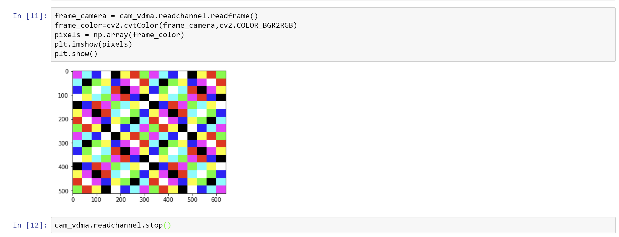

Now we know how to build our own overlay and work with it in PYNQ. In the next lab we will be updating this design to create a simple image processing application.

# Lab Three

1. Starting with he Vivado project we created in the last lab, select the clock connected to FCLK0 and delete it
2. Delete the Video Test Pattern Generator
3. Open the Zynq processing system and select the Clock Configuration tab, enable all of the PS-PL clocks and set the following frequencies
   1. FCLK0 = 100 MHz
   2. FCLK1 = 142 MHz
   3. FCLK2 = 200 MHz
   4. FCLK3 = 100 MHz

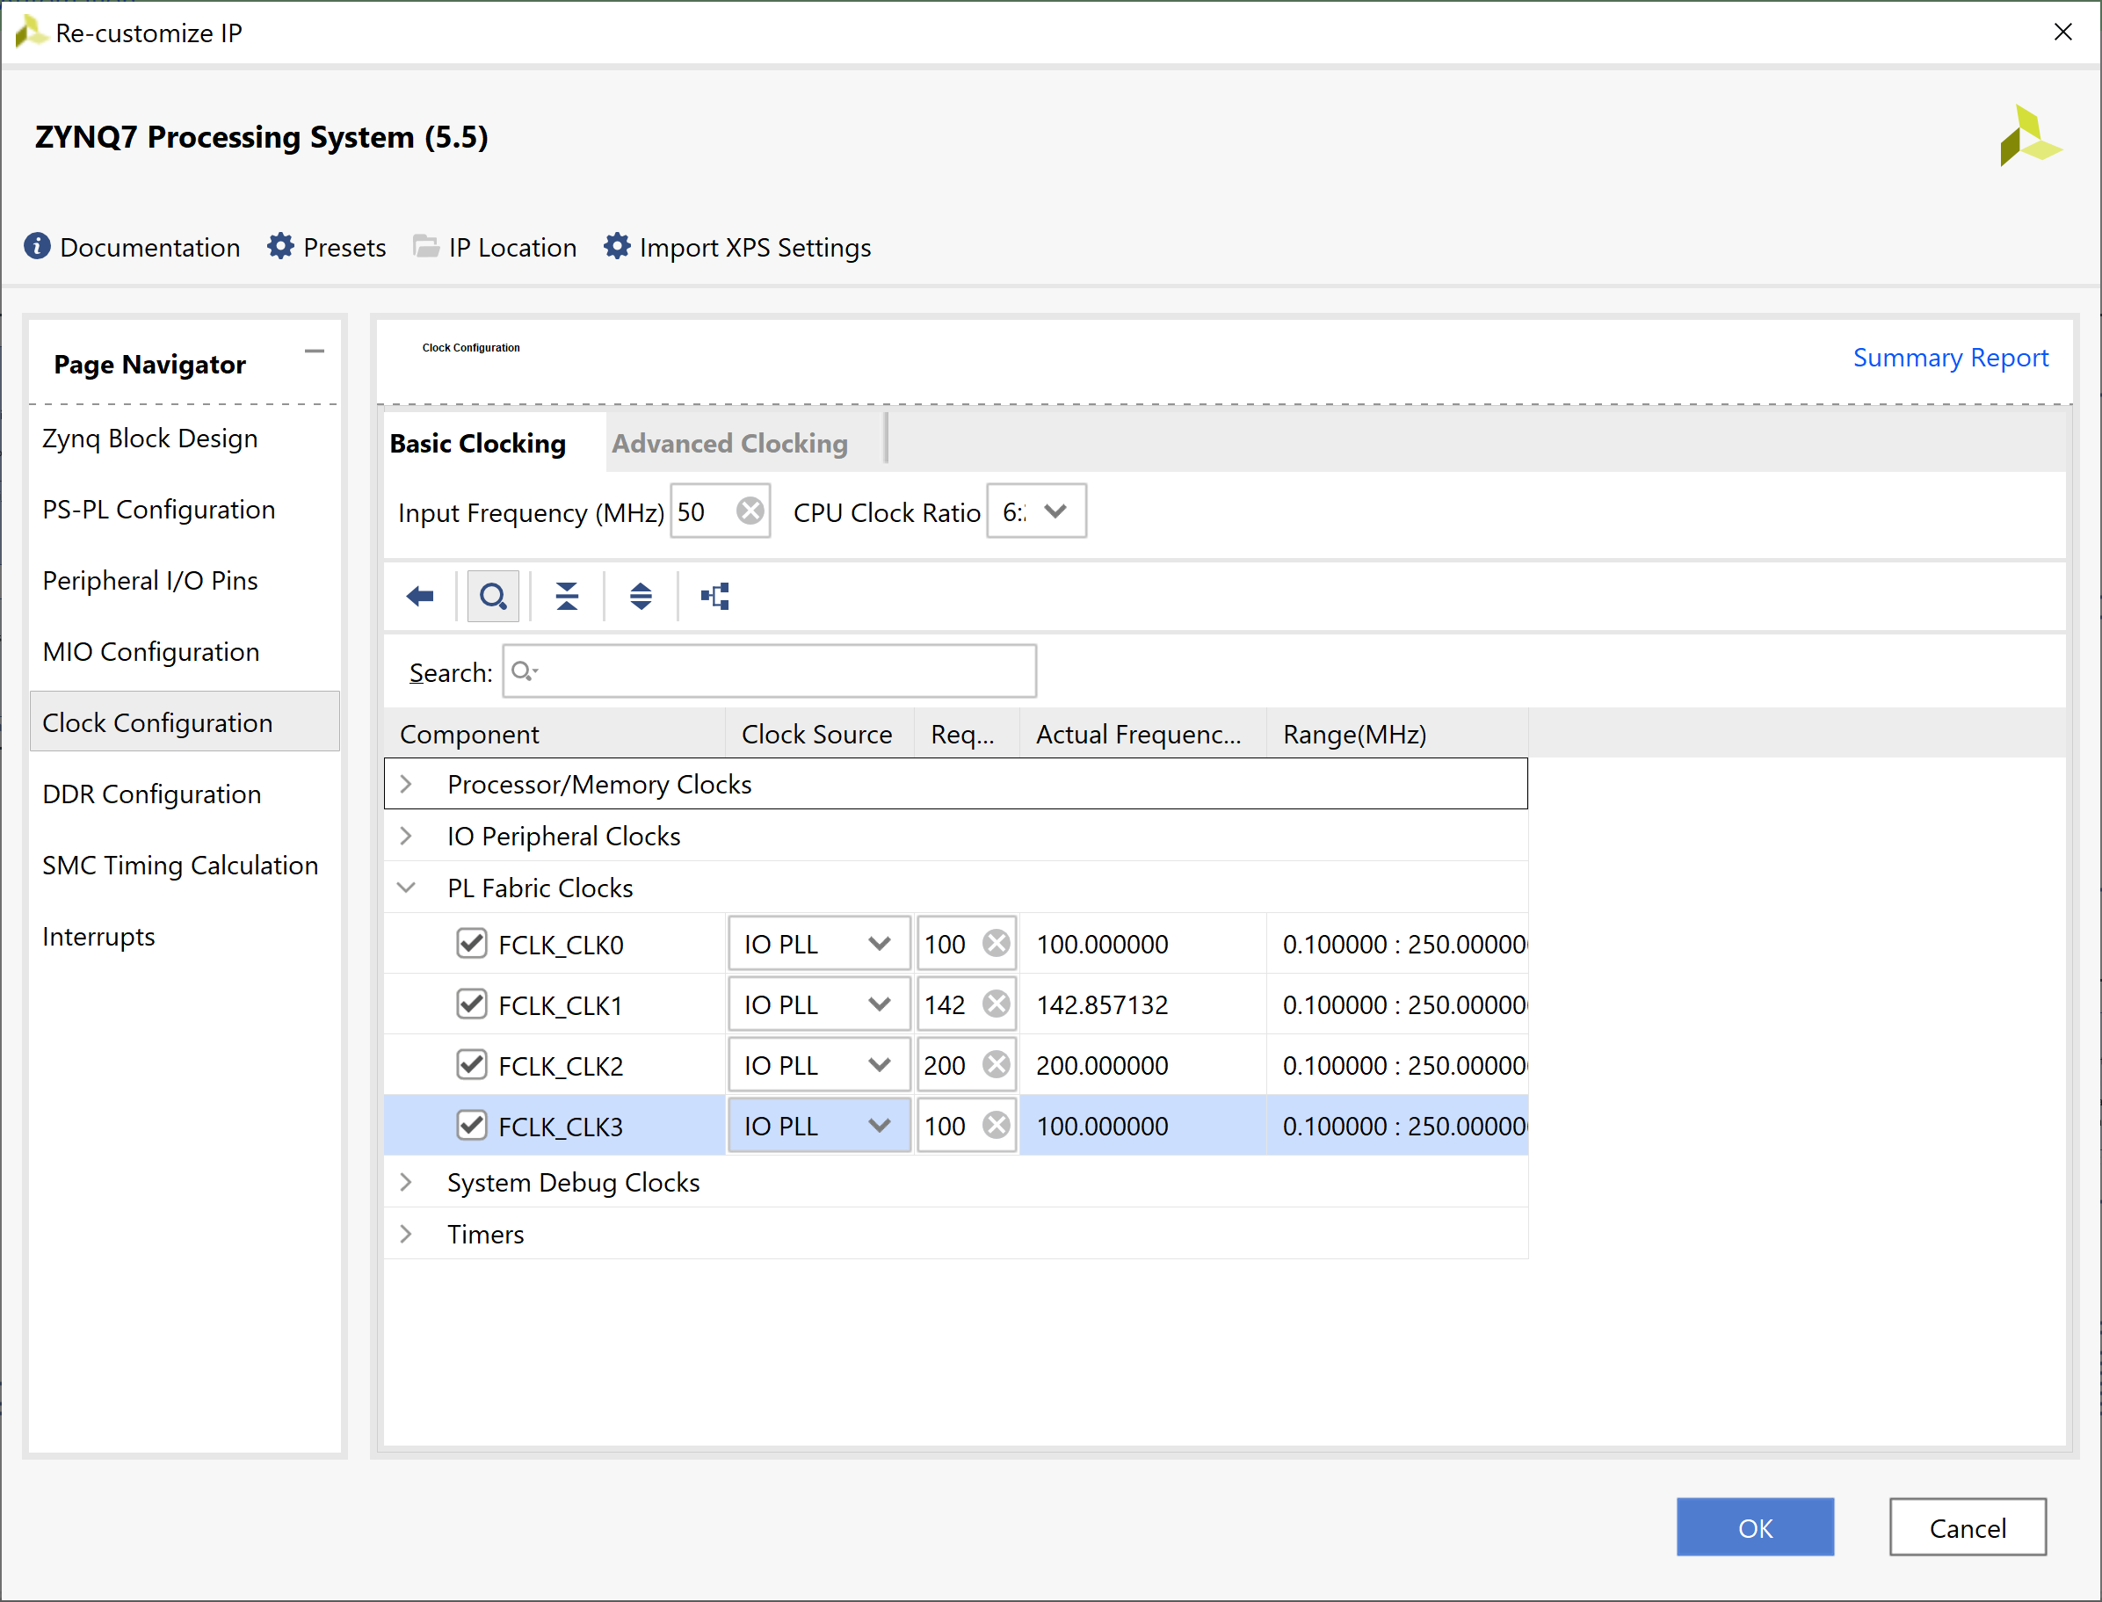

1. Change the directory in the Vivado TCL window to the project directory

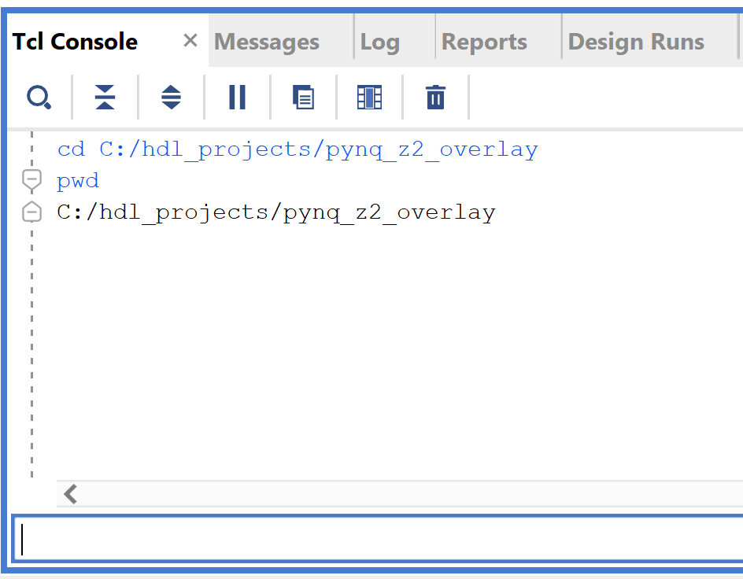

1. Copy the provided TCL file front_end.tcl into your project directory and source the file with the command. This will give us a new command which will create a TCL front end, it came from an extraction from the PYNQ-Z2 base design.

source front_end.tcl

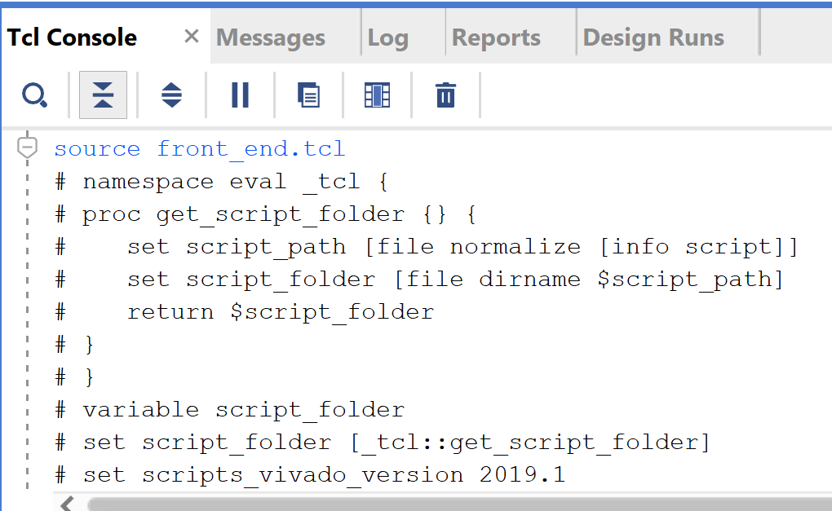

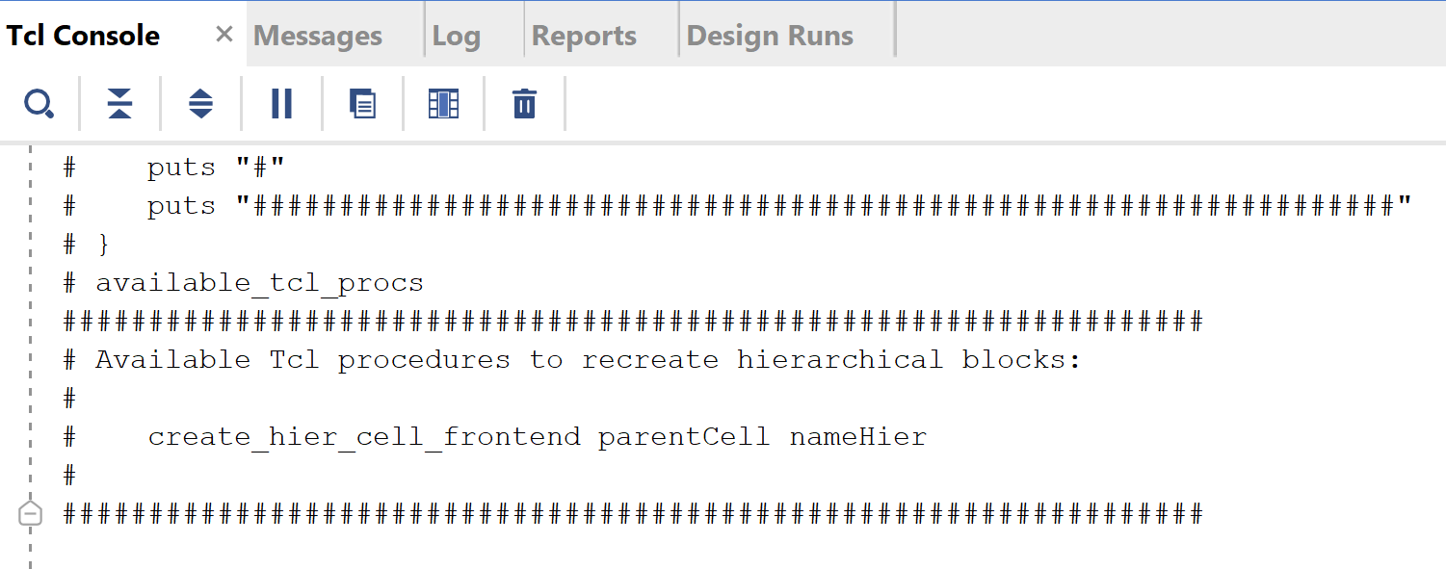

1. Call the new command to create the front end video module. This will put a new module on our block diagram.

create_hier_cell_frontend . frontend

1. Connect up the FCLK0 to our AXI network – this is the slow speed network so will be used for all the AXI Lite communications.

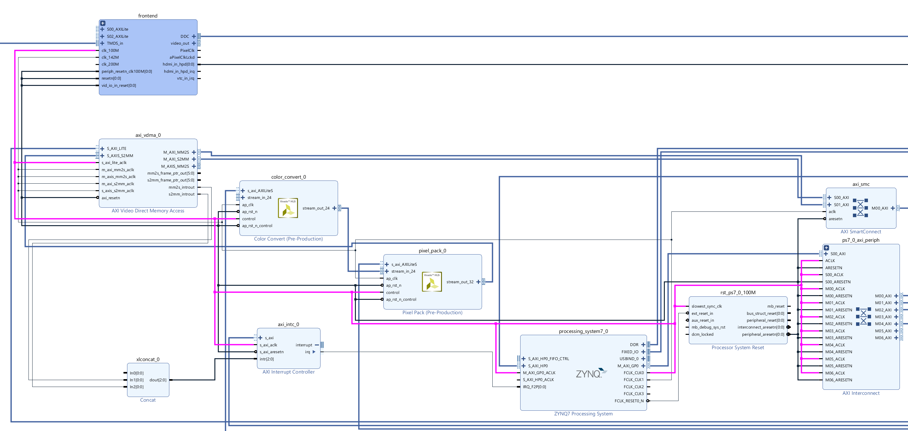

1. Connect FCLK1 as shown in the diagram below

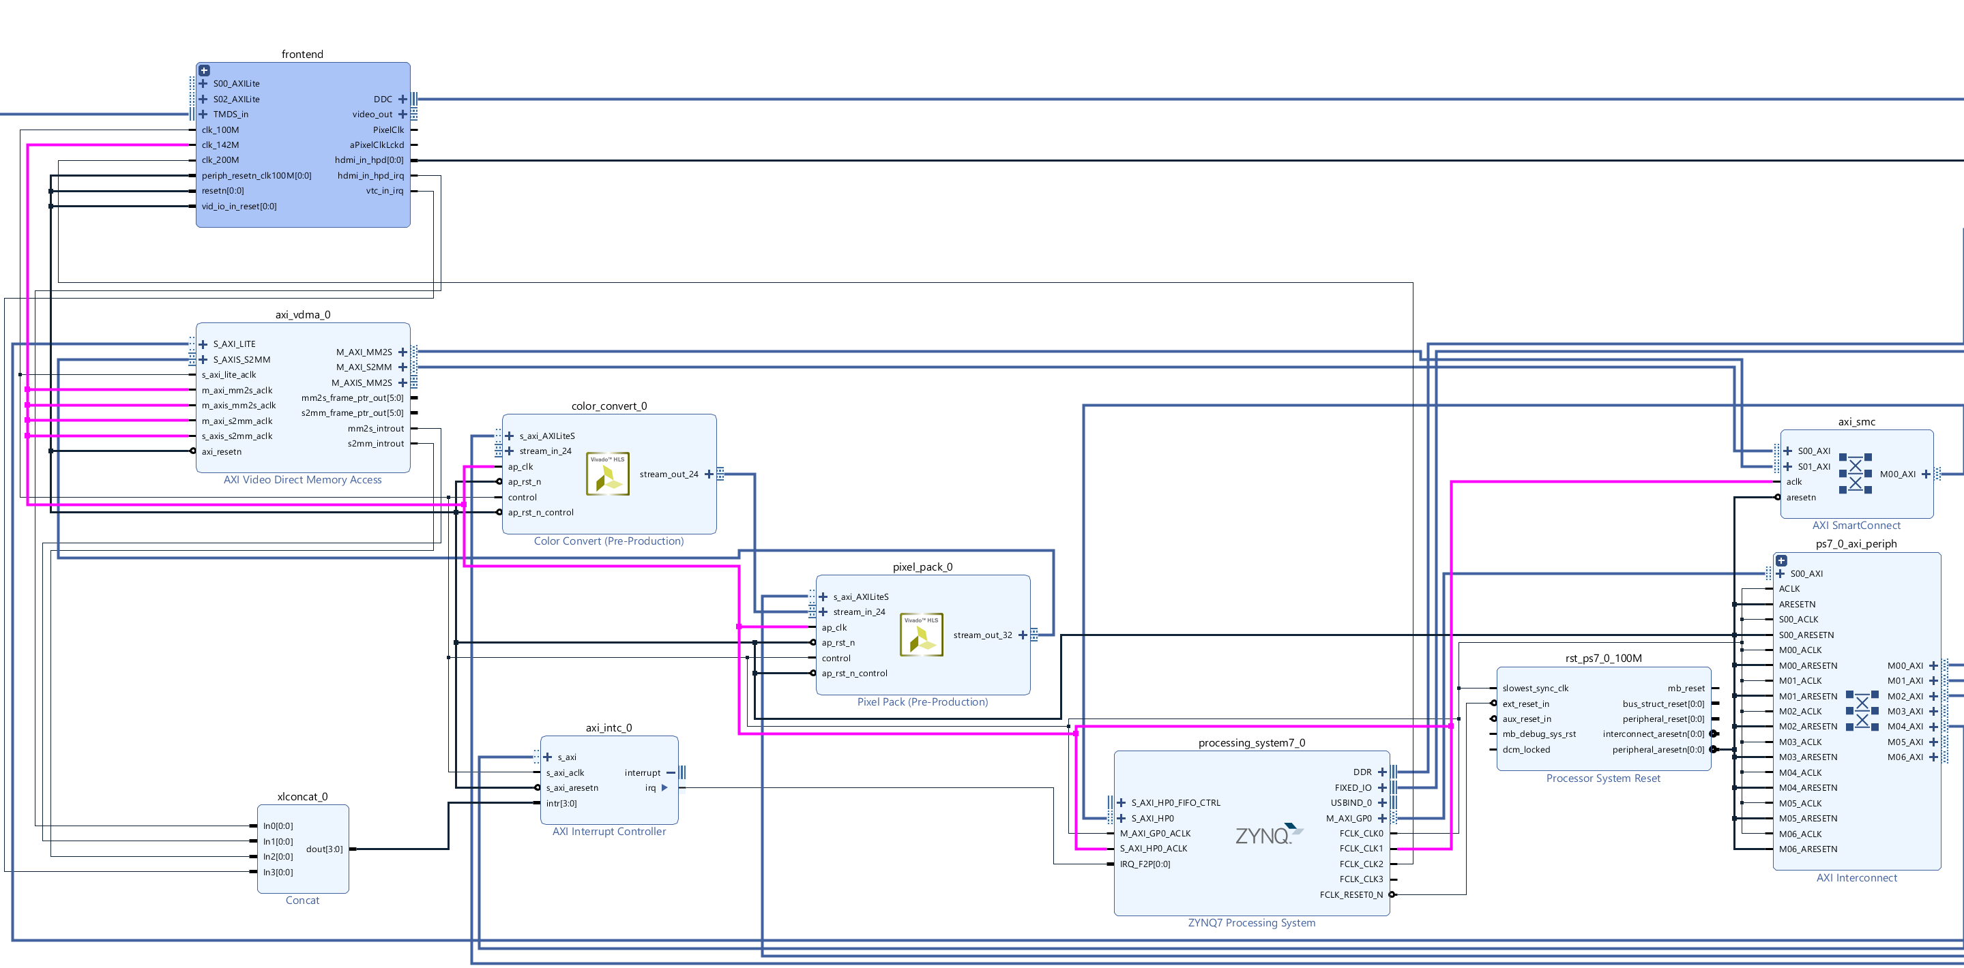

1. Connect the resets a shown

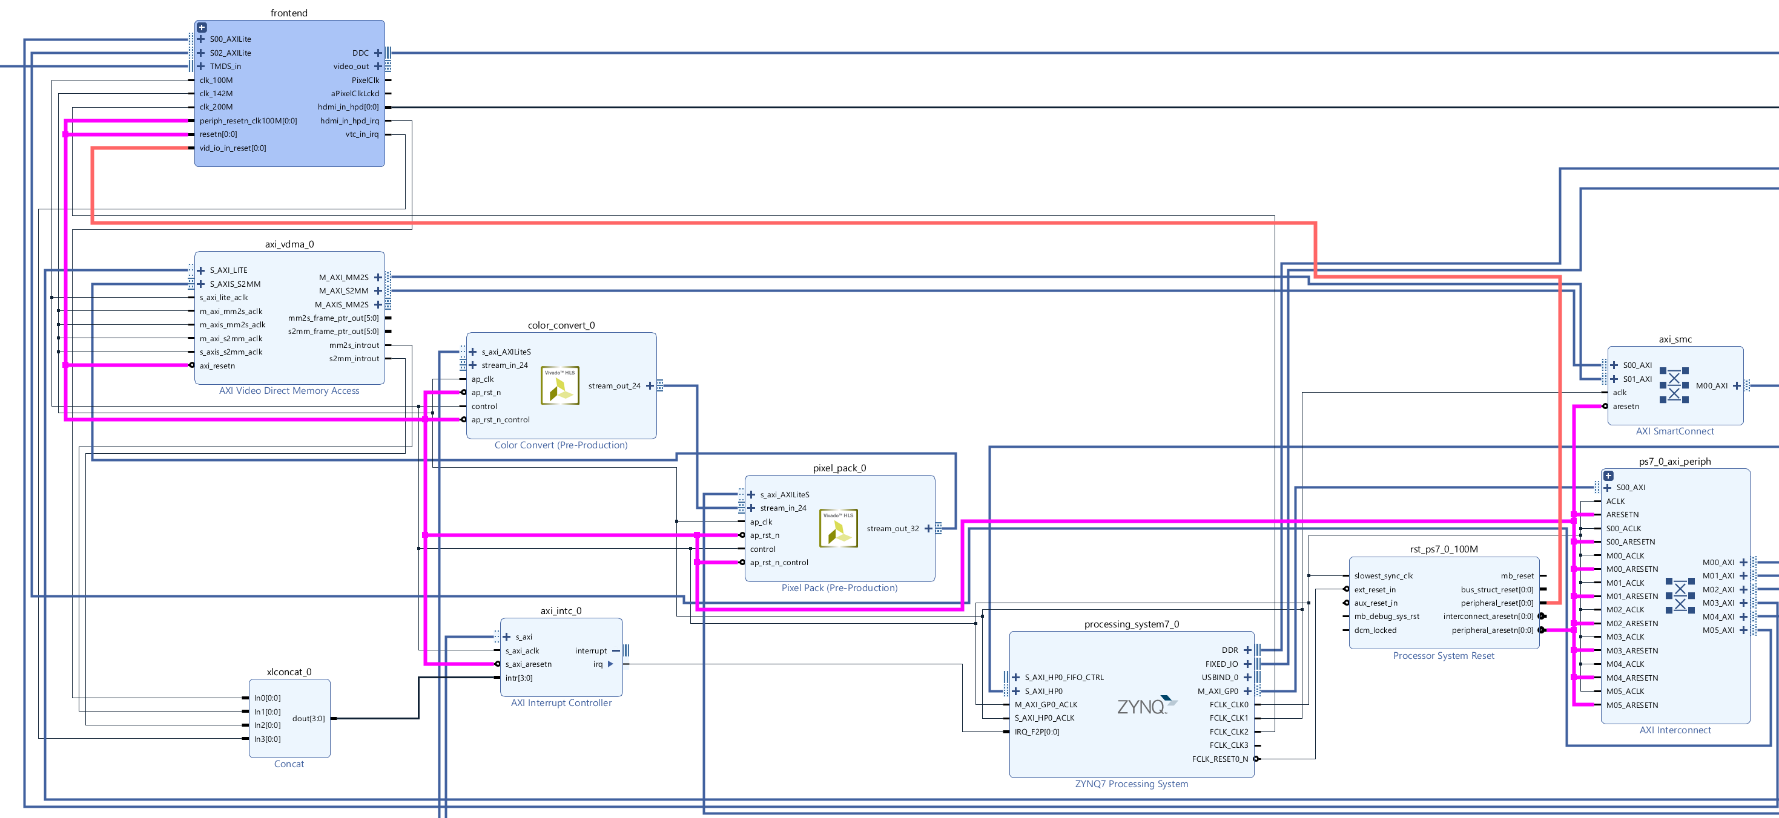

1. Connect the FCLK2 to the frontend 200 MHz clock input and the S_AXI_HP0_ACLK

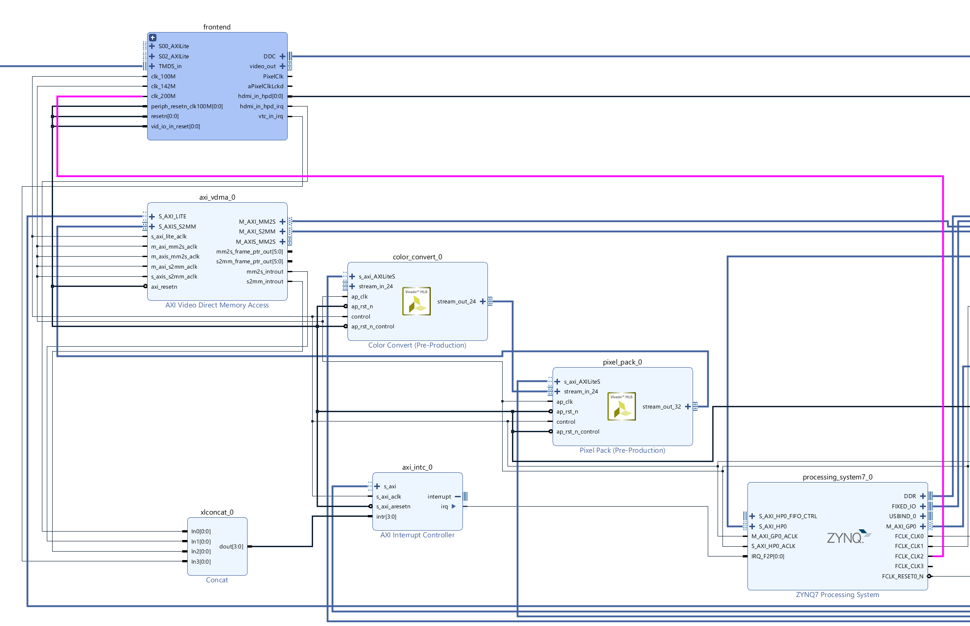

1. Re customize the AXI Interconnect to have 6 Master outputs

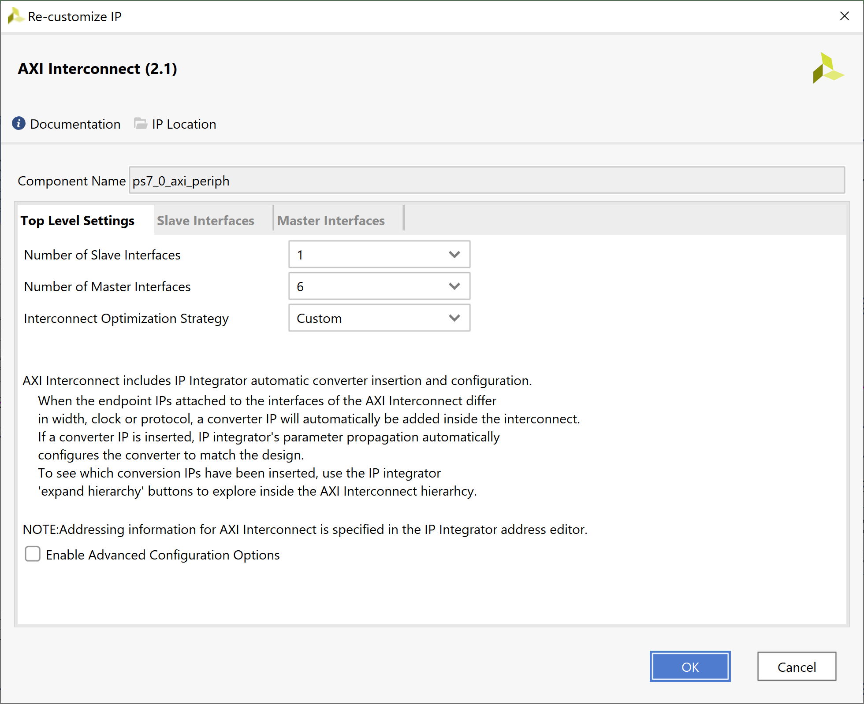

1. Connect the new master AXI ports on the AXI Interconnect to the Slave AXI interconnects on the frontend block

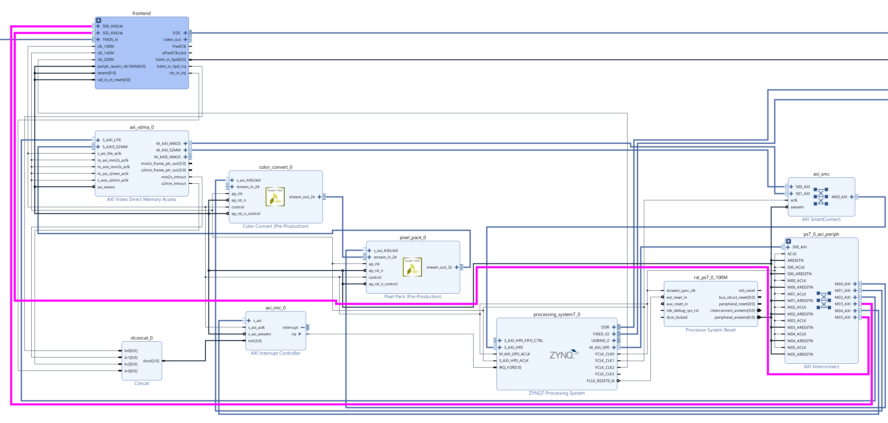

1. Connect the output from the frontend video to colour convert module

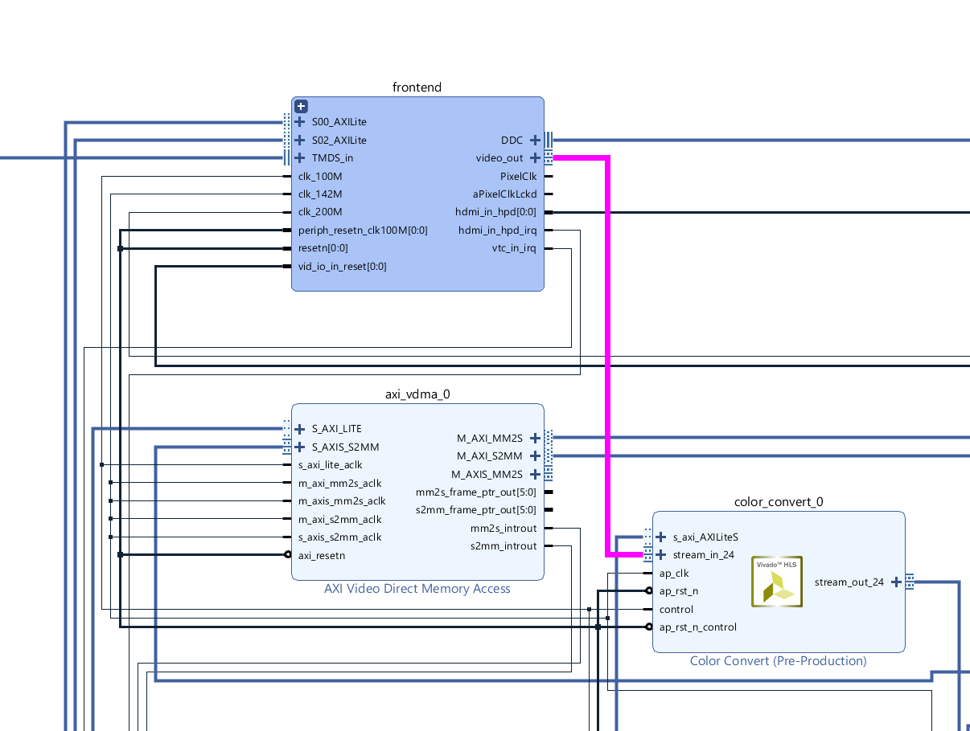

1. On the address editor tab, ensure all address are mapped by using the auto assign addresses

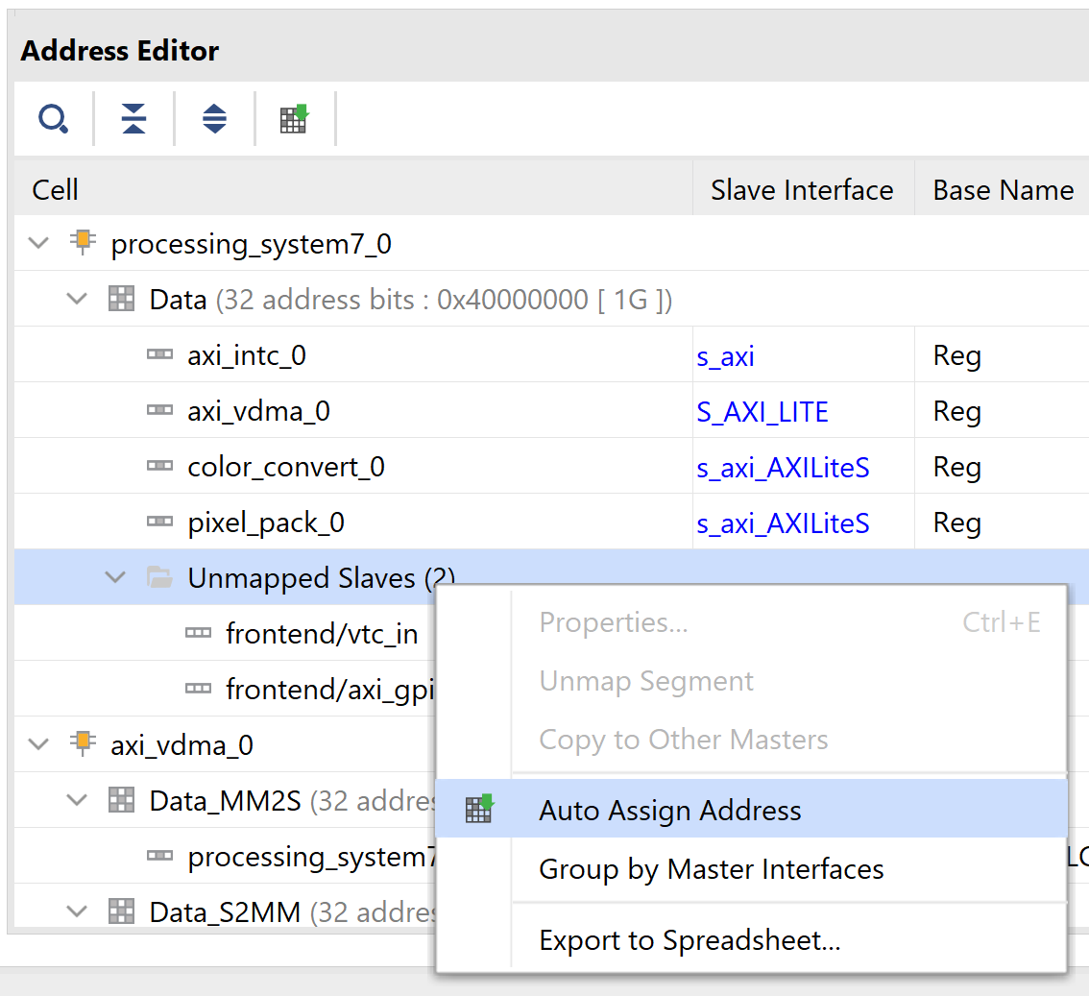

1. Right click on the DDC port and select make external, do the same for TMDS_in and HDMI_in_hpd[0:0]

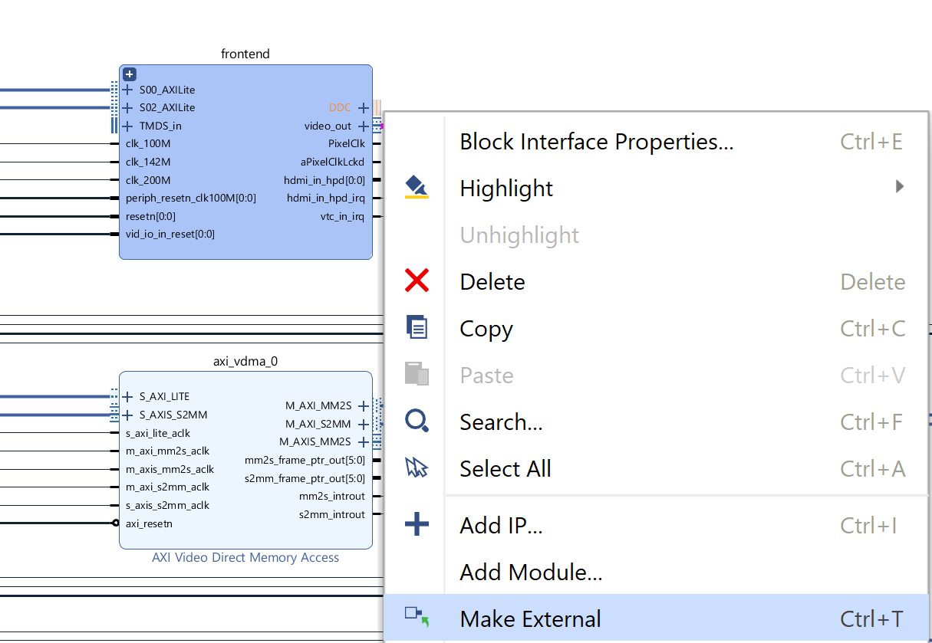

16 The next step is t add the constraints, select constraints and add sources.

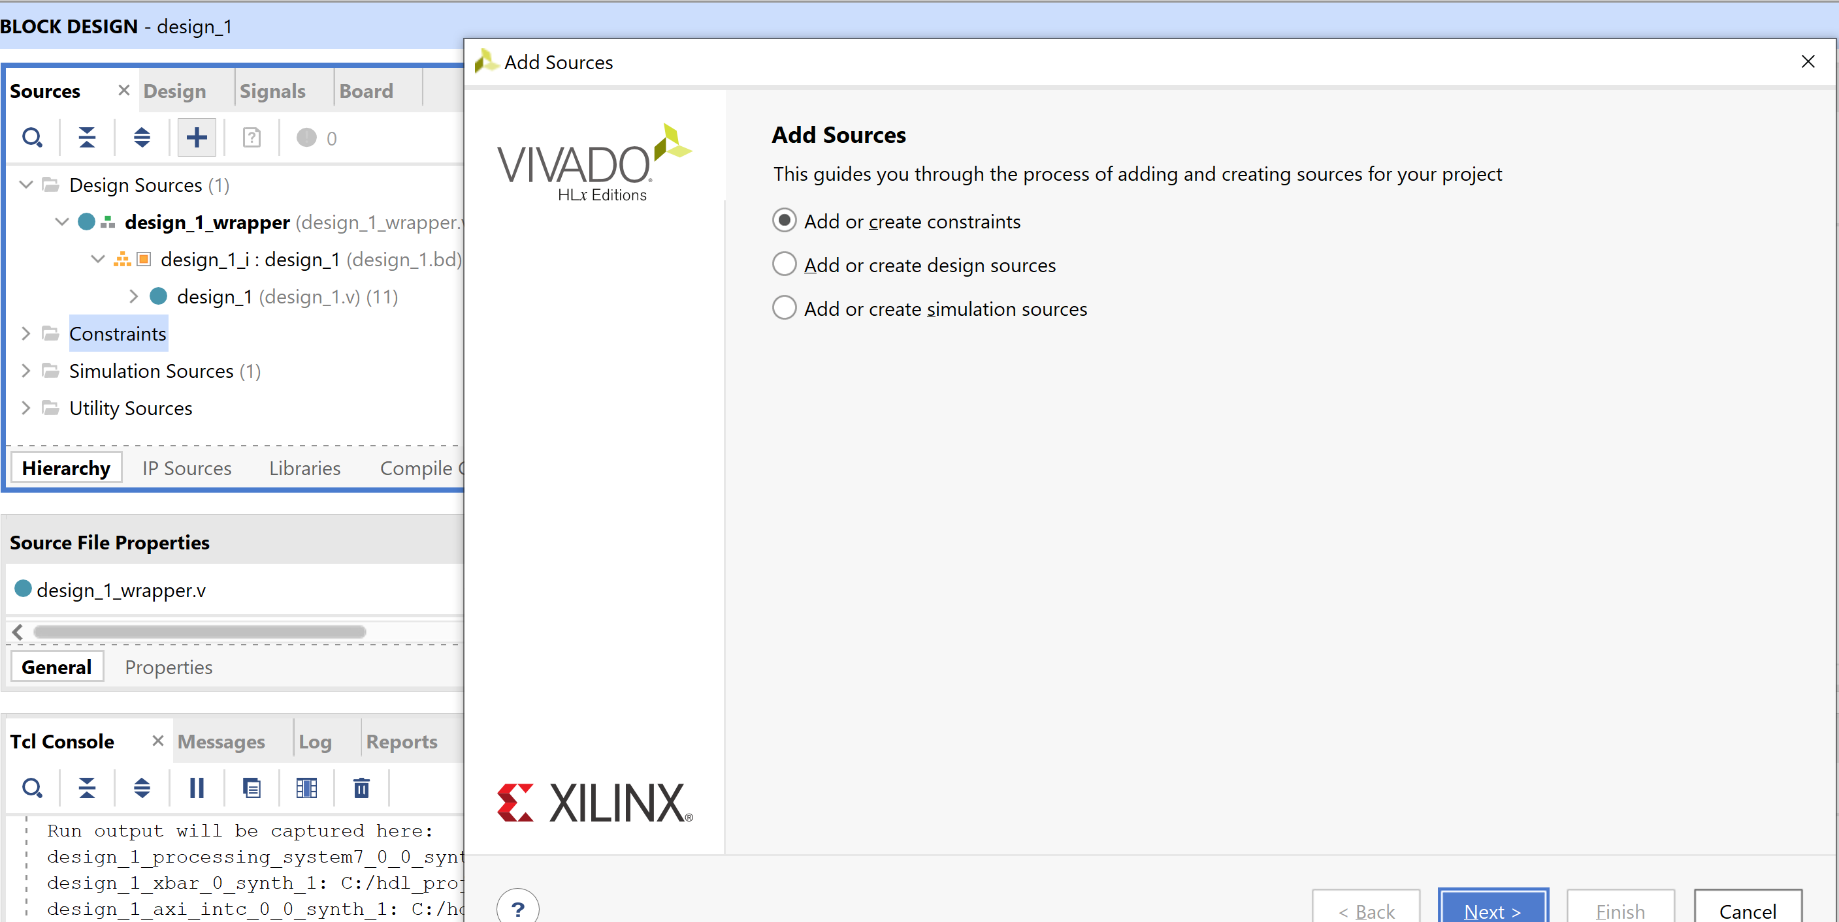

1. Select the provided IO_constraints.xdc file

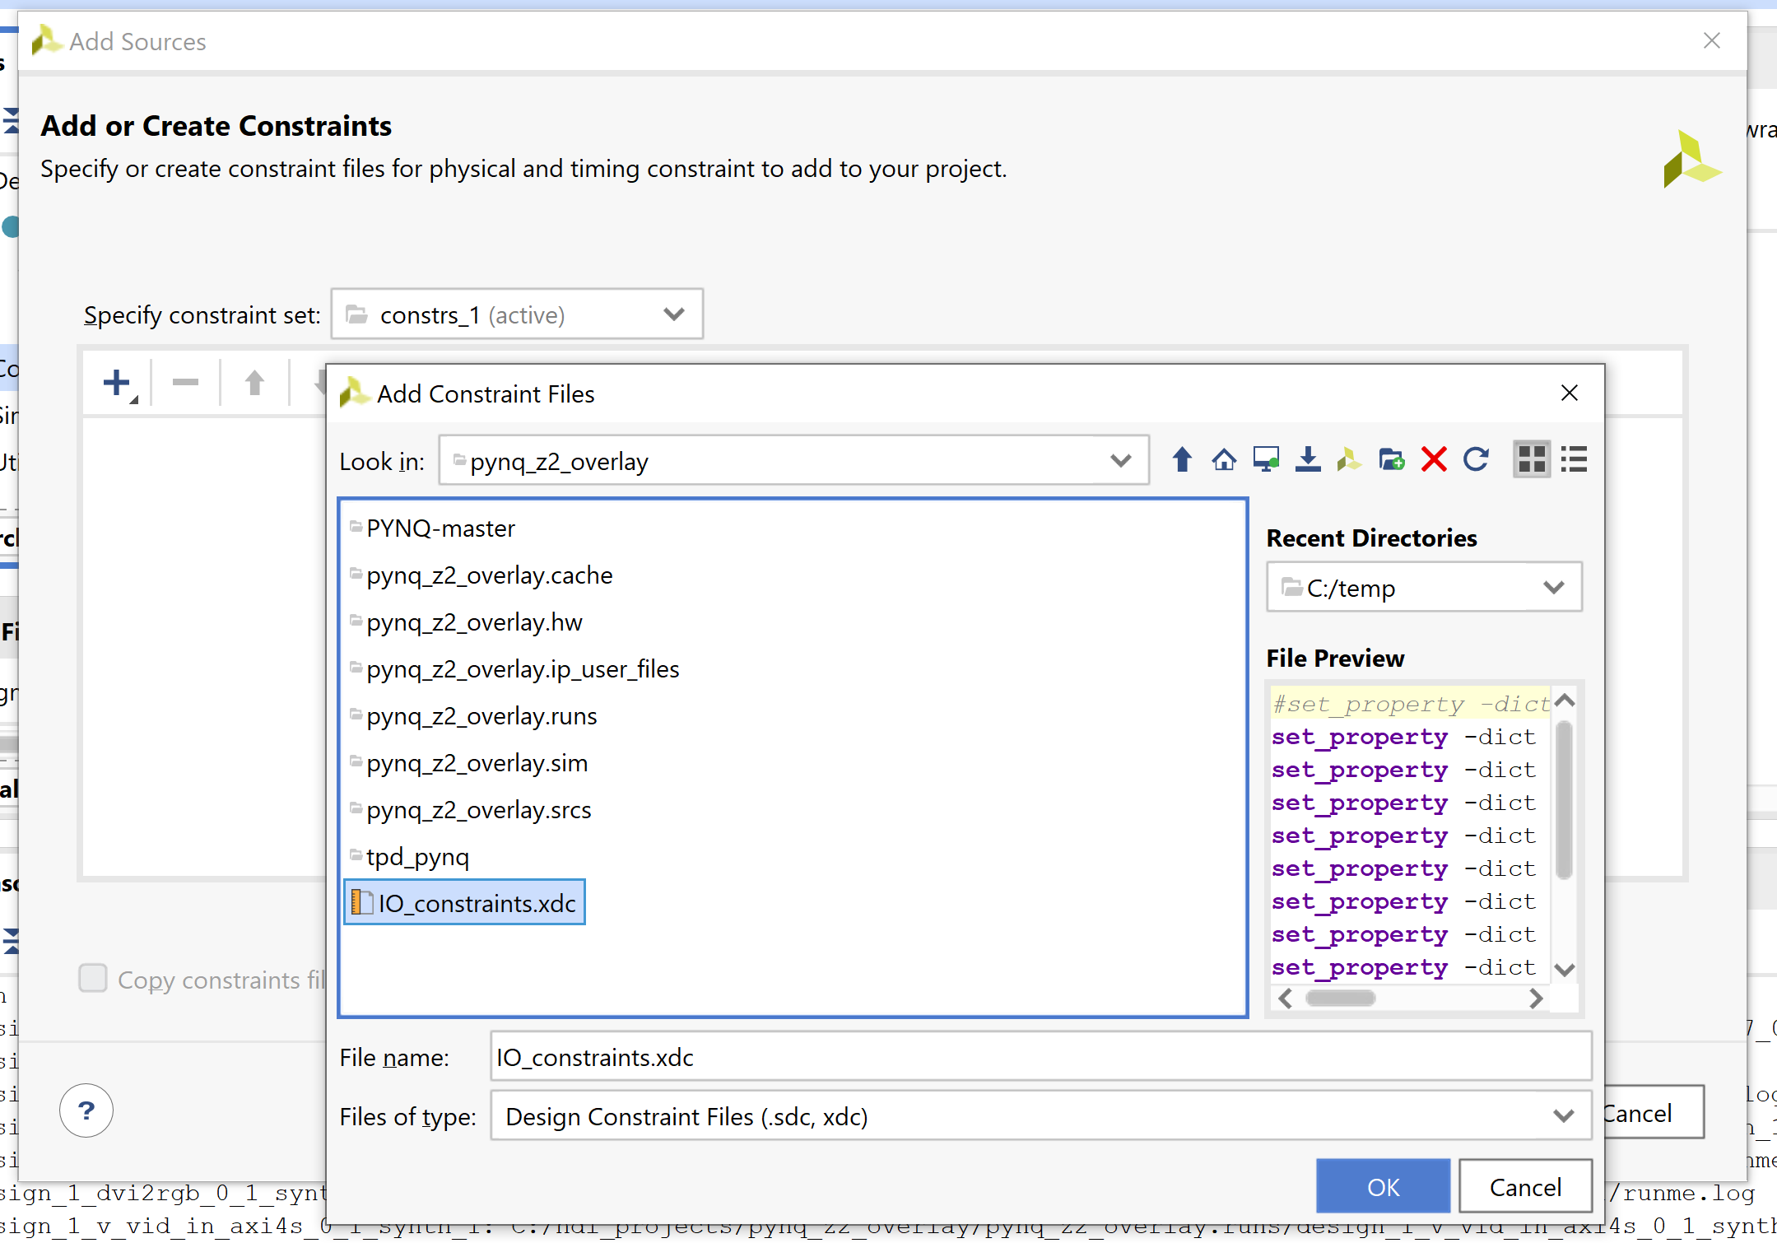

1. Validate and build the FPGA implementation

1. Connect the PYNQ_Z2 to the camera and power on the Pynq-Z2

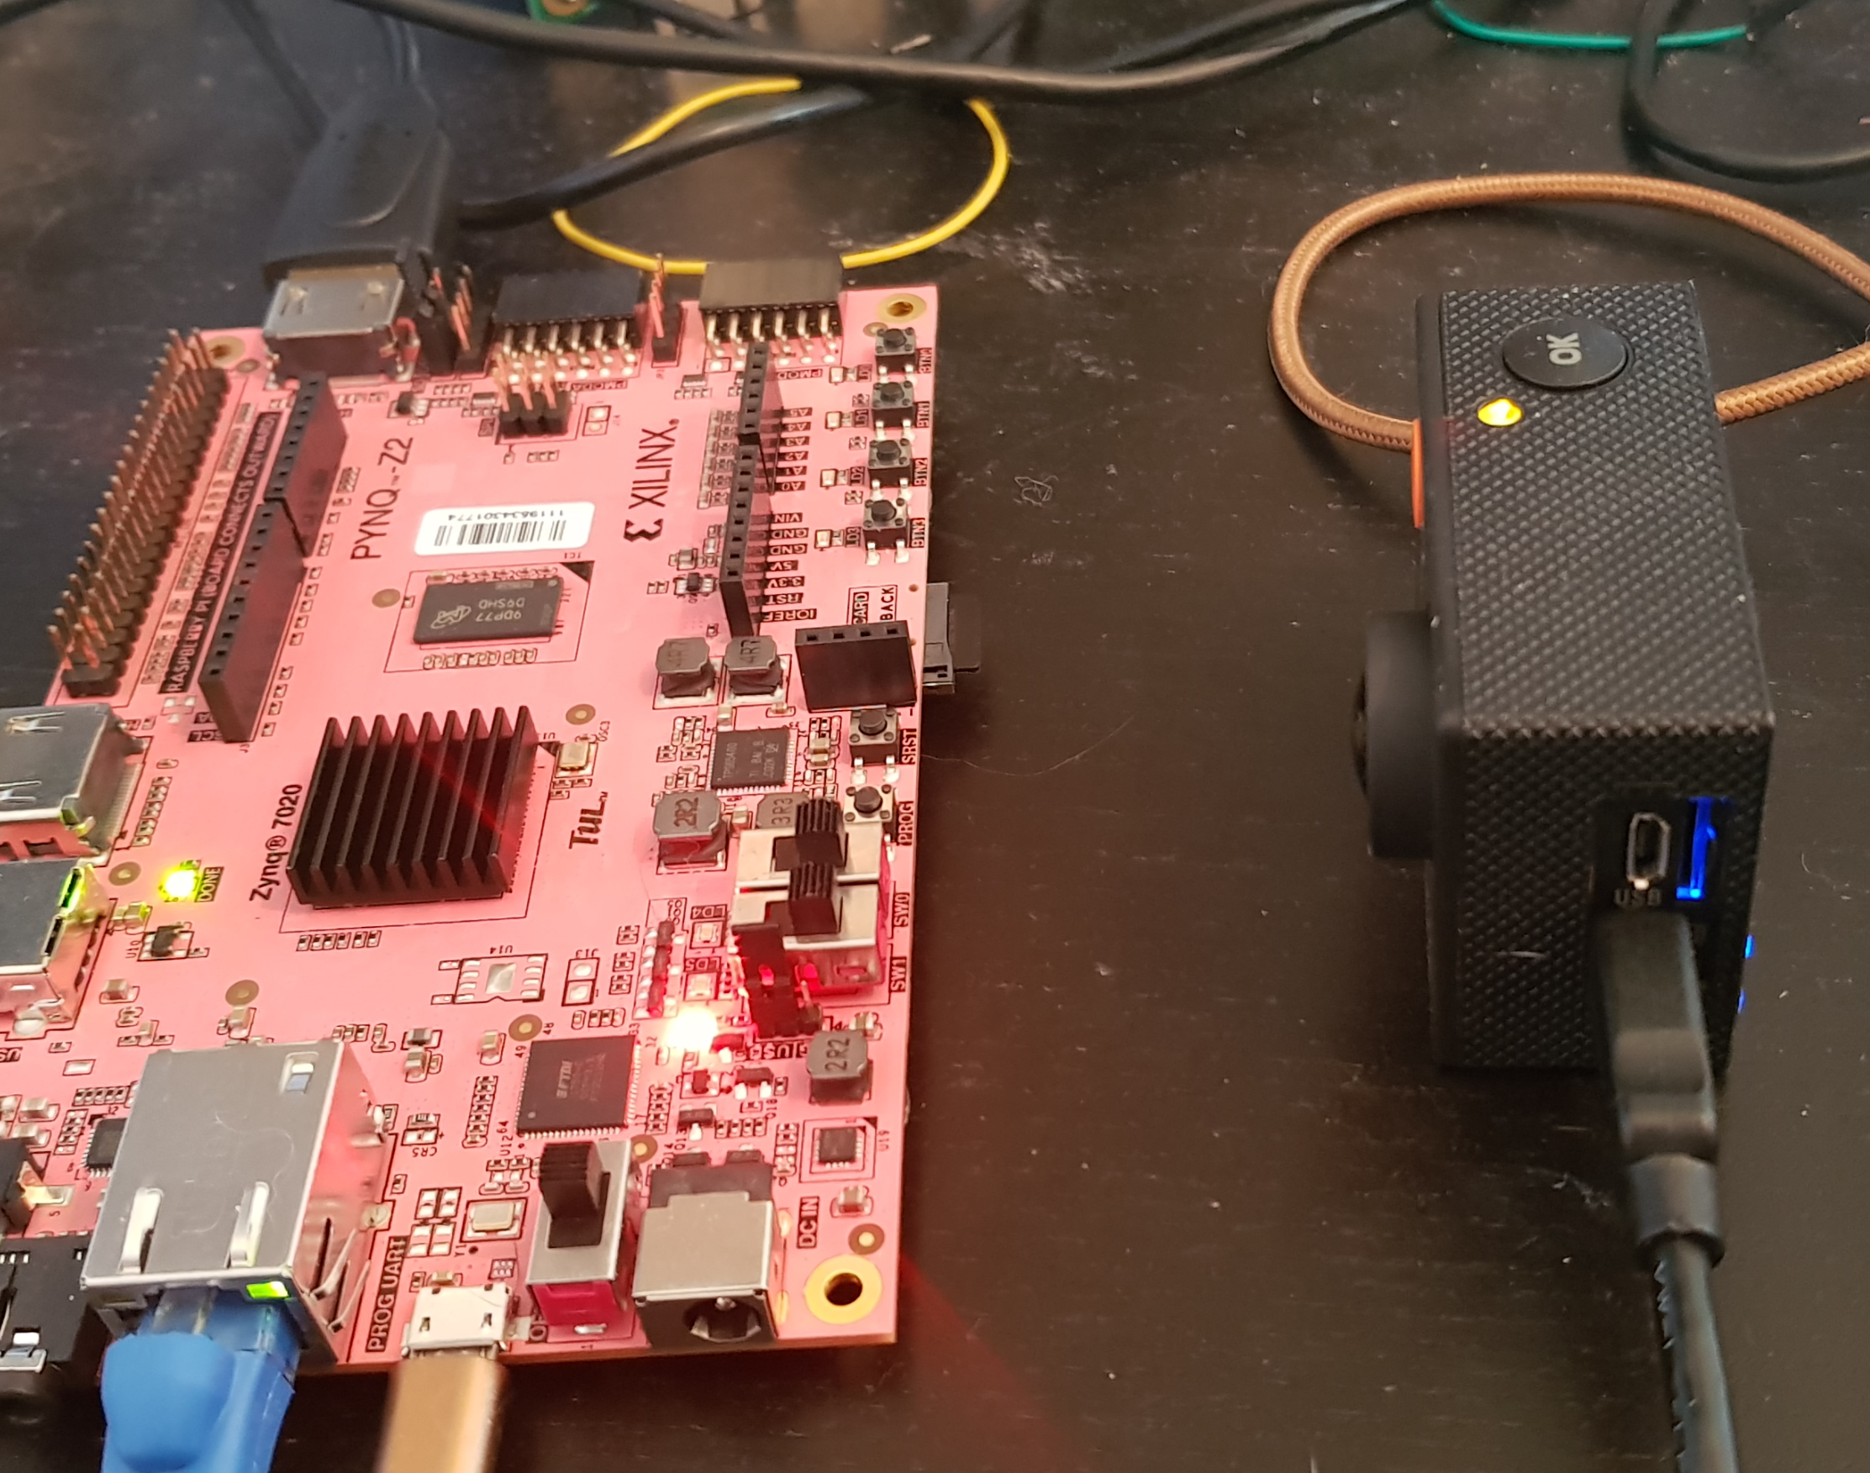

1. Copy the updated Bit file, tcl and HWH file from the build into the tpd_pynq directory. Once in the directory rename the files and use WinSCP to upload the updated application.

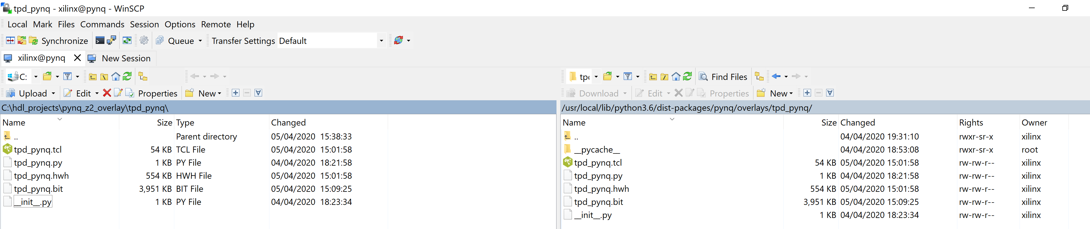

1. In Jupyter open a new terminal and install the following

sudo apt-get install libzbar0

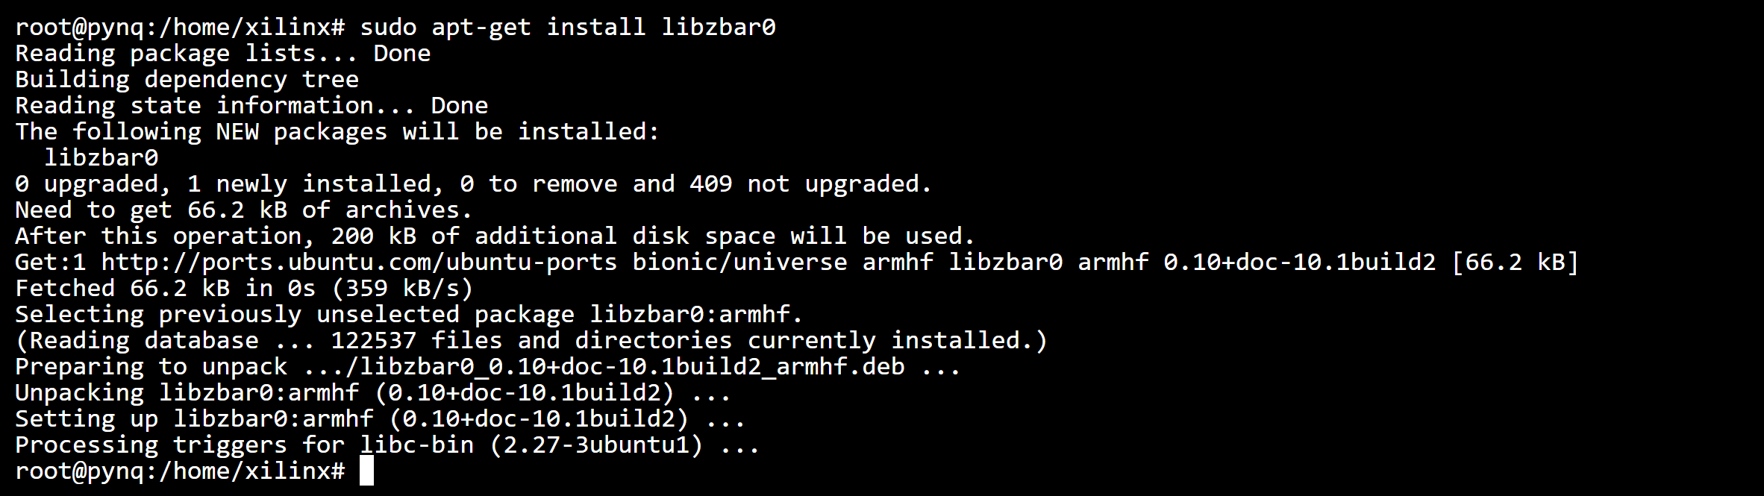

1. In the same terminal enter the command

pip3 install pyzbar



1. Open the tpd.ipynb and modify the code to contain the following, this will allow us to capture images and decode barcodes within the image.

import time

from pynq.overlays.tpd_pynq import tpd_pynqOverlay

import numpy as np

from pynq import pl

from pynq import overlay

from pynq.lib.video import *

from pynq import Xlnk

from pynq.lib.video import *

import cv2

import matplotlib.pyplot as plt

overlay = tpd_pynqOverlay('tpd_pynq.bit')

hdmiin_frontend = overlay.frontend

hdmiin_frontend.start()

hdmiin_frontend.mode

pixel_in = overlay.pixel_pack_0

pixel_in.bits_per_pixel = 24

colourspace_in = overlay.color_convert_0

rgb2bgr = [0.0, 1.0, 0.0,

1.0, 0.0, 0.0,

0.0, 0.0, 1.0,

0.0, 0.0, 0.0]

colourspace_in.colorspace = rgb2bgr

cam_vdma = overlay.axi_vdma_0

lines = 480

framemode = VideoMode(640, lines, 24)

cam_vdma.readchannel.mode = framemode

cam_vdma.readchannel.start()

frame_camera = cam_vdma.readchannel.readframe()

frame_color=cv2.cvtColor(frame_camera,cv2.COLOR_BGR2RGB)

#frame_color = frame_camera

pixels = np.array(frame_color)

plt.imshow(pixels)

plt.show()

cv2.imwrite('img.jpg', frame_color)

from pyzbar import pyzbar

from pyzbar.pyzbar import decode

image = cv2.imread("img.jpg")

image =cv2.cvtColor(image,cv2.COLOR_BGR2GRAY)

cv2.imwrite('gray.jpg', image)

ret,thresh1 = cv2.threshold(image,100,255,cv2.THRESH_BINARY)

blur = cv2.GaussianBlur(thresh1,(5,5),0)

cv2.imwrite('thres.jpg', blur)

barcodes = decode(blur)

# loop over the detected barcodes

for barcode in barcodes:

# extract the bounding box location of the barcode and draw the

# bounding box surrounding the barcode on the image

(x, y, w, h) = barcode.rect

cv2.rectangle(image, (x, y), (x + w, y + h), (0, 0, 255), 2)

# the barcode data is a bytes object so if we want to draw it on

# our output image we need to convert it to a string first

barcodeData = barcode.data.decode("utf-8")

barcodeType = barcode.type

# draw the barcode data and barcode type on the image

text = "{} ({})".format(barcodeData, barcodeType)

cv2.putText(image, text, (x, y - 10), cv2.FONT_HERSHEY_SIMPLEX,

0.5, (0, 0, 255), 2)

# print the barcode type and data to the terminal

print("[INFO] Found {} barcode: {}".format(barcodeType, barcodeData))

# show the output image

#cv2.imshow("Image", image)

cv2.imwrite('final.jpg', image)

barcodes

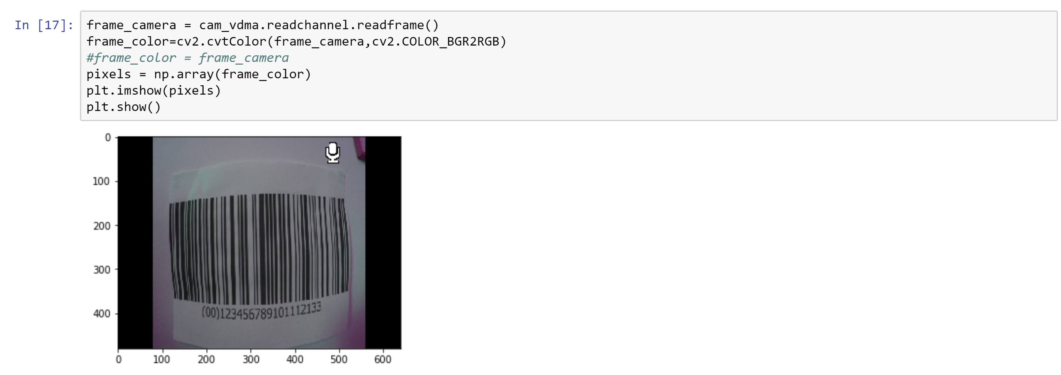

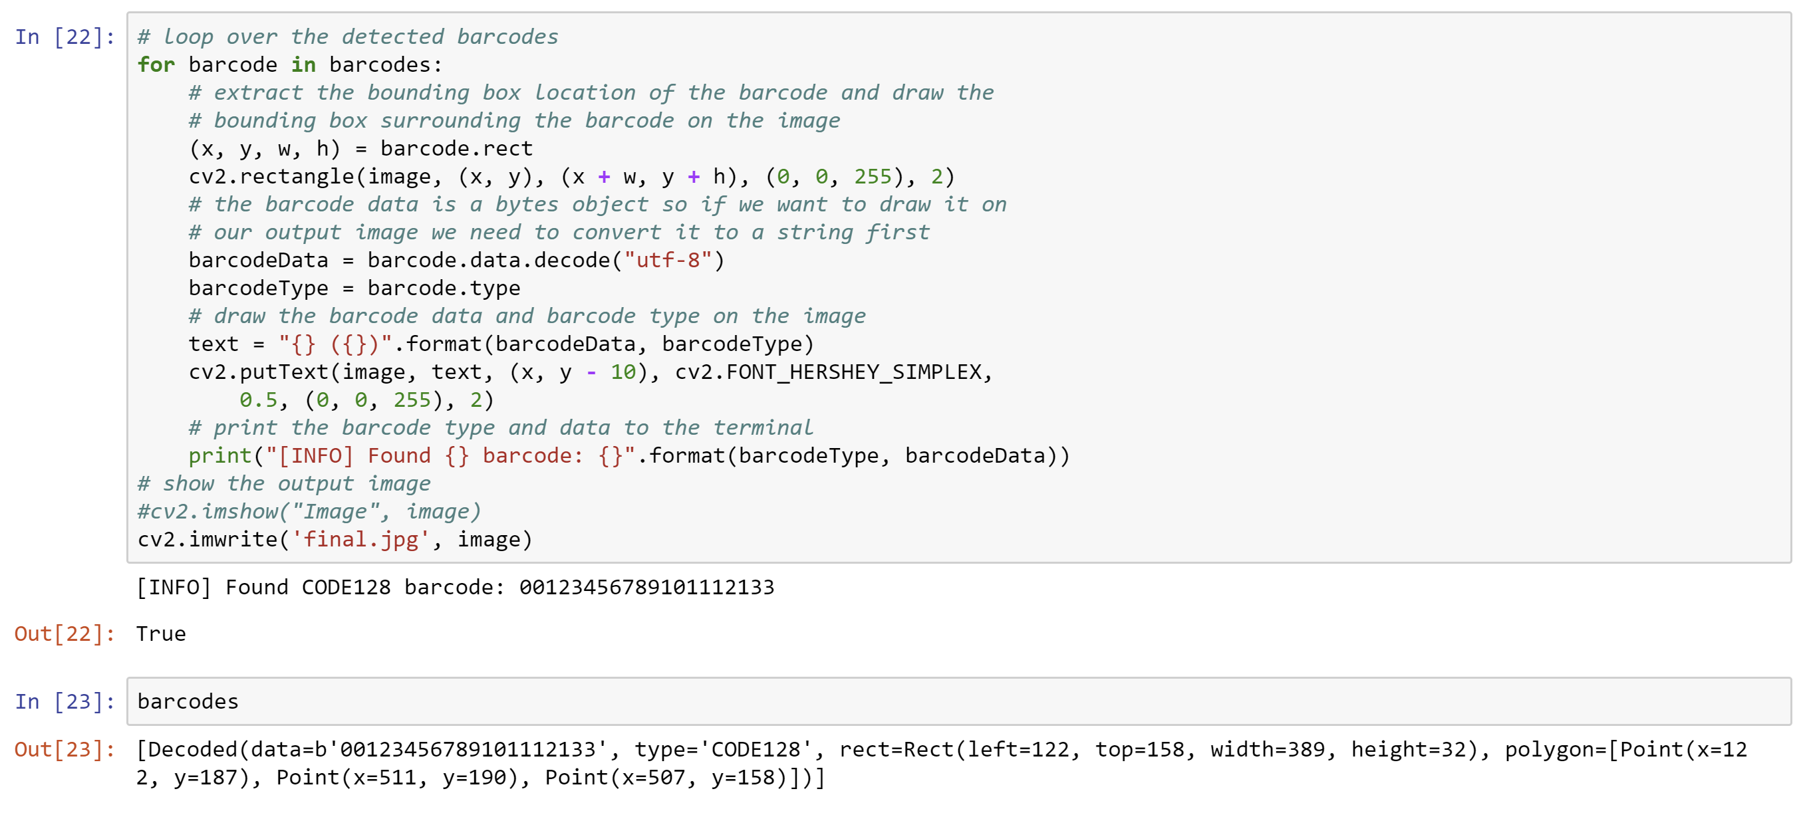

1. On the Jupyter note book home page you should see a number of image files, including final.jpg which will show the decoded barcode imposed on the image and the location of the bar code.

